**Name:**

**De Lisle preparing for A Level Biology 2022**

|  |  |  |  |
| --- | --- | --- | --- |
| **Threshold Concept** | **Description** | **Task title** | **Mastery level**  **(RAG)** |
| **1** | Circulatory system | * Common prefixes * Heart structure * Key terminology * Practice questions |  |
| **2** | Methods of transport | * Transport practice questions |  |
| **3** | Microscopes | * Calculating magnification |  |
| **4** | Enzymes | * Structure & action * Factors affecting rate * Calculating rates |  |
| **5** | Genetics | * Key terminology * Punnet squares |  |
| **6** | DNA & protein synthesis | * DNA structure * Protein synthesis |  |

**Resources to use:**

* **Head start to A level Biology -** <https://www.amazon.co.uk/dp/B00VE2NIOI/ref=cm_sw_r_oth_api_i_0u4FEbF4BVKJ8>
* **Seneca online learning –** GCSE & A level - <https://app.senecalearning.com/dashboard/join-class/yjf5vsj3pp>
* **GCSE revision guides & class notes alongside GCSE bitesize**

In order to confidently approach your A Level Biology studies there are certain fundamental concepts that you need to understand. Ensuring you have a secure foundation of GCSE knowledge to build upon will help to make the transition from GCSE to A level smoother and maximise your chances of success.

1. Heart & circulatory system

|  |  |
| --- | --- |
| **Topic 1- Lifestyle, Health and Risk** | **9 - 1 GCSE** |
| 1.3 Understand how the structures of blood vessels (capillaries, arteries and veins) relate to their functions. | 8.7 Explain how the structure of the blood vessels is related to their function |
| 1.4 i) Know the cardiac cycle (atrial systole, ventricular systole and cardiac diastole) and relate the structure and operation of the mammalian heart, including the major blood vessels, to its function.  ii) Know how the relationship between heart structure and function can be investigated practically. | 8.8 Explain how the structure of the heart and circulatory system is related to its function, including the role of the major blood vessels, the valves and the relative thickness of chamber walls |
| 1.6 Understand the blood-clotting process (thromboplastin release, conversion of prothrombin to thrombin and fibrinogen to fibrin) and its role in cardiovascular disease (CVD). | * 1. Explain how the structure of the blood is related to its function:      1. red blood cells (erythrocytes)      2. white blood cells (phagocytes and lymphocytes)      3. plasma      4. platelets |

## Summary sheet 1: Heart and lungs

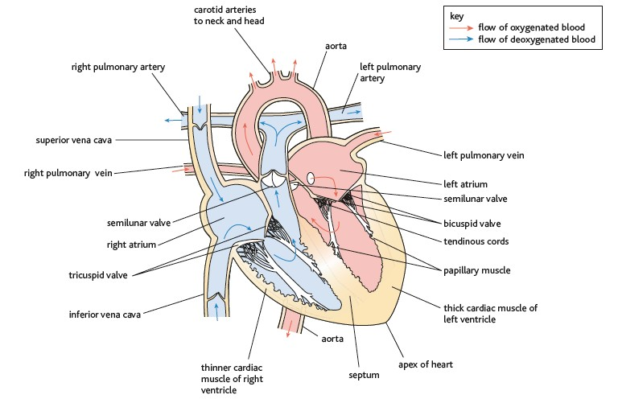The left side of the heart pumps oxygenated blood from the lungs around the body. The blood enters the left atrium from the pulmonary vein. It flows through the atrioventicular or bicuspid valve to the left ventricle.

The blood is then pumped into the aorta, through a semi-lunar valve, and around the body.

The right side of the heart pumps deoxygenated blood from the body back to the lungs. The blood returns from the body to the right atrium via the vena cava. It flows through the atrioventicular or tricuspid valve to the right ventricle. The blood is then pumped into the pulmonary artery, through a semi-lunar valve, and to the lungs.

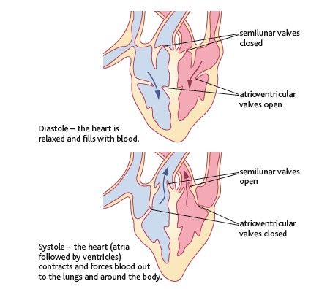The atrioventricular valves between the atrium and ventricles open to allow blood to flow from the atrium into the ventricles and close when the pressure in the ventricles rises to prevent back flow.

The semi-lunar valves in the aorta and pulmonary artery open to allow blood from the ventricles to flow into the arteries. They close to prevent backflow into the ventricles as the heart relaxes.

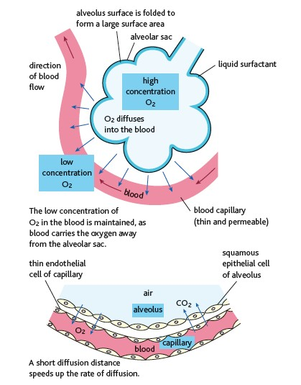

Oxygen enters the blood in the alveoli of the lungs. Oxygen in the alveolus is at a high concentration and it diffuses down the concentration gradient into the blood which has a low concentration of oxygen. This low concentration is maintained because the blood is moving and carries the oxygen away.

The walls of the alveolus and capillaries are only one cell thick. This creates a short diffusion distance between the alveolus and the blood allowing a high rate of diffusion.

## Summary sheet 1b: Circulatory system

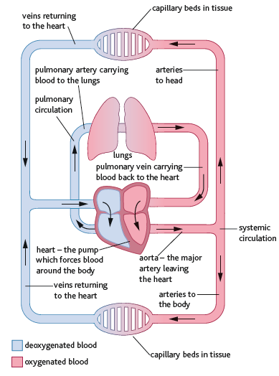

Blood flows around the body via a network of arteries, veins and capillaries.

The double circulation system of mammals means that blood flows through the heart twice in one complete cycle of the body.

The pulmonary system pumps blood around the lungs and the systemic system pumps blood around the rest of the body.

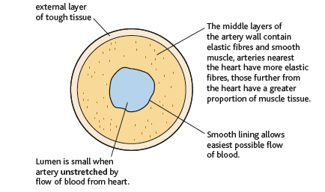

Arteries carry blood away from the heart. The vessel walls are thick and muscular with elastic fibres to withstand the high pressure generated by the heart.

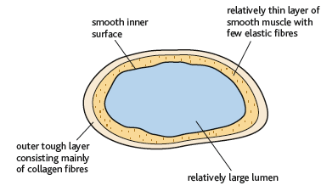

Veins carry blood from capillary beds back to the heart. The blood is at low pressure and the walls of the vessels are relatively thin with less elastic fibre. The contraction of muscles help push the blood though veins and the vessels have valves to prevent backflow.

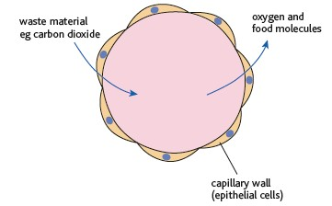

Capillaries are thin vessels that form capillary networks around tissues. They allow the exchange of substances such as oxygen, glucose and waste materials between cells and the blood.

## Worksheet 1: Prefixes

Scientific terms use common prefixes. Find out the definition/meaning of the prefixes shown in the table.

|  |  |
| --- | --- |
| **Word/prefix** | **Definition/meaning** |
| **endo** |  |
| **exo** |  |
| **pulmonary** |  |
| **cardiac** |  |
| **hepatic** |  |
| **mono** |  |
| **di** |  |
| **photo** |  |
| **haem** |  |
| **bio** |  |
| **chemo** |  |

## Worksheet 2: Heart structure

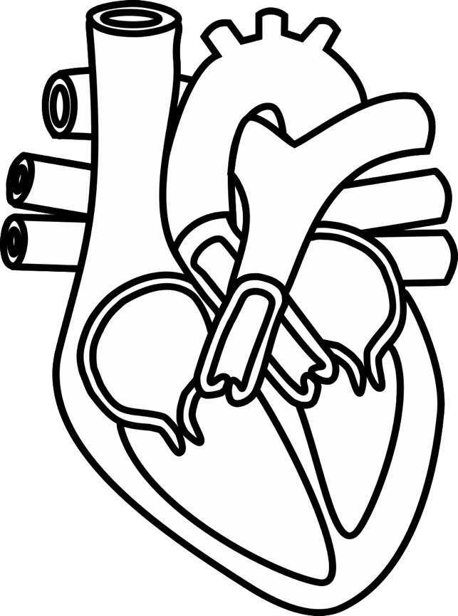

1. Label the heart

1. Draw the path the blood takes through the heart



1. What does the aorta do?
2. What does the vena cava do?
3. What does the pulmonary artery do?
4. What does pulmonary vein do?
5. What is natural resting heart rate?
6. Why may you need an artificial pacemaker?
7. What do red blood cells do?
8. What do white blood cells do?
9. What do platelets do?
10. What does plasma do?
11. What is cardiovascular disease?
12. What lifestyle factors can affect health?

## Worksheet 3: Key terminology

**Candidates frequently lose marks in examinations because they do not use sufficient key words in detailed responses.**

Read the responses to the questions below. Using the keywords from the box write improved answers to the questions.

concentration

capillaries

vein

diffusion

thin

semi-lunar

right

pulmonary

valve

gradient

atrioventricular

left

aorta

vena cava

artery

thick

osmosis

1. Explain how oxygen enters the blood at the alveoli.

In the alveolus oxygen from the air moves into the blood vessels through the walls of the alveolus. The blood is moving so there is always a low concentration in the blood.

1. Describe the route blood takes from the lungs to the body.

Blood from the lungs blood travels through a vein to the atrium. The blood is pumped from the atrium into the ventricle and then into the aorta.

## Practice questions

**1 a** Write a definition for each key word. If possible, give a structural feature for each key word.

atria:

ventricles:

aorta:

vena cava:

pulmonary artery:

pulmonary vein:

atrioventricular valves:

septum:

semi-lunar valves:

diastole:

systole:

1. Label this diagram of the heart using as many of the key words from **1 a**

as possible.

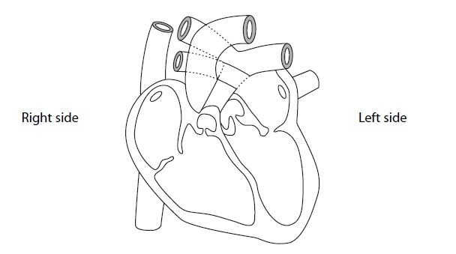

Use the keywords from **1 a** in your answers to the following questions.

* 1. Explain why the left ventricles has thicker chamber walls than the right ventricle and the atriums.
  2. Describe the role of the atrioventricular valves.

1. This flow diagram shows the part of the circulation system in a mammal.

**Lungs**

Blood vessel B

**Heart**

Blood vessel A

Blood vessel C

i Complete a table to show conditions of blood vessel A, B and C.

|  |  |  |  |  |  |
| --- | --- | --- | --- | --- | --- |
| **Blood vessel** | **Type of vessel** | **Level of oxygen saturation** | **Relative pressure of the blood** | **Valves present in the vessel** | **Thickness of blood vessel walls** |
| A |  |  |  |  |  |
| B |  |  |  |  |  |
| C |  |  |  |  |  |

2. Transport

|  |  |
| --- | --- |
| **Topic 2 – Genes and health** | **9 - 1 GCSE** |
| i) Know the properties of gas exchange surfaces in living organisms (large surface area to volume ratio, thickness of surface, difference in concentration).   * + 1. Understand how the rate of diffusion is dependent on these properties and can be calculated using Fick’s Law of Diffusion.     2. Understand how the structure of the mammalian lung is adapted for rapid gaseous exchange. | * 1. Explain the need for exchange surfaces and a transport system in multicellular organisms including the calculation of surface area : volume ratio   2. Explain how alveoli are adapted for gas exchange by diffusion between air in the lungs and blood in capillaries   3. Describe the factors affecting the rate of diffusion, including surface area, concentration gradient and diffusion distance |
| 2.3 Understand what is meant by osmosis in terms of the movement of free water molecules through a partially permeable membrane (consideration of water potential is not required). | 1.15 Explain how substances are transported into and out of cells, including by diffusion, osmosis and active transport  *1.16 Core practical: Investigate osmosis in potatoes*  1.17 Calculate percentage gain and loss of mass in osmosis |
| 2.4 i) Understand what is meant by passive transport (diffusion, facilitated diffusion), active transport (including the role of ATP as an immediate source of energy), endocytosis and exocytosis.  ii) Understand the involvement of carrier and channel proteins in membrane transport. | 1.15 Explain how substances are transported into and out of cells, including by diffusion, osmosis and active transport |

## 

## Summary sheet 2: Diffusion, osmosis and active transport

#### Diffusion

Liquid and gas particles are constantly moving which causes particles to move from an area of high concentration to an area of low concentration.

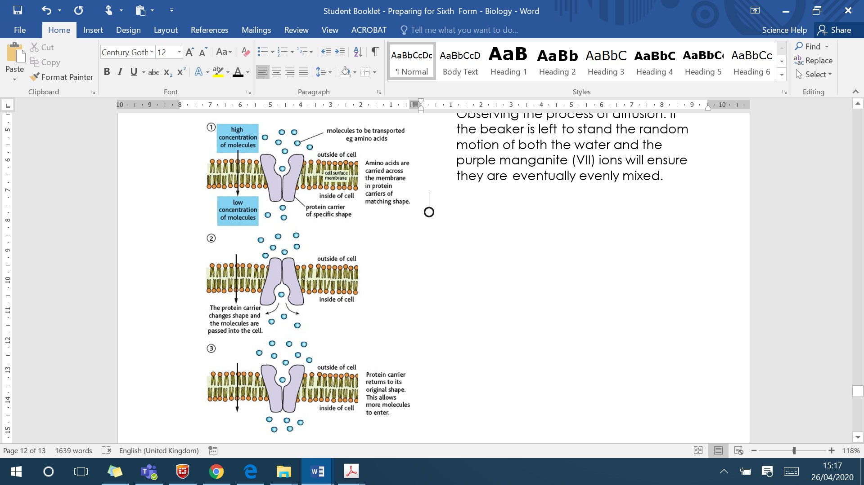Observing the process of diffusion. If the beaker is left to stand the random motion of both the water and the purple manganite (VII) ions will ensure they are eventually evenly mixed.

Small particles can diffuse across cell membranes and no energy is required. Some molecules, such as glucose, are too large to diffuse across the cell membrane so they must be helped by carrier proteins. Each molecule has its own carrier protein that allows the molecule through the cell membrane without the need for energy.

This is known as facilitated diffusion.

**Osmosis**

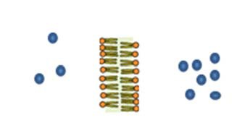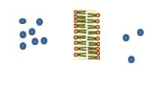

Osmosis is the diffusion of water molecules from an area of higher concentration of water molecules to an area of lower concentration of water molecules across a partially permeable membrane.

#### Active transport

Active transport uses energy to transport substances across membranes from an area of lower concentration to an area of higher concentration

## Practice questions

Substances can be transported into cells through diffusion, osmosis and active transport.

Write a definition for diffusion, osmosis and active transport.

Diffusion:

Osmosis:

Active transport:

Cells were placed in a solution containing solute X and solute Y.

The diagram below represents the concentration of the two solutes inside and outside one of the cells, when this cell was placed in the solution and then after 30 minutes.

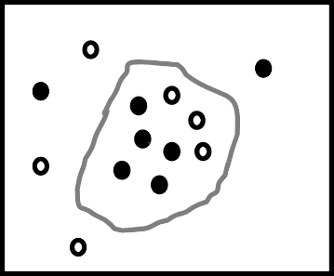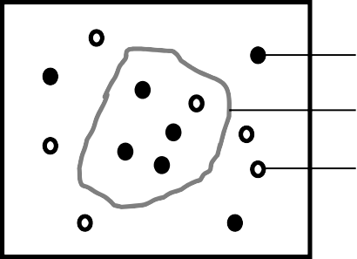solute X cell solute Y

Initial concentration After 30 minutes

Explain the movement of solute X and solute Y into the cell.

A red blood cell was placed in a solution of distilled water. Explain the effect on the red blood cell of being placed in a solution of distilled water.

Explain the key word ‘isotonic’.

**Calculating percentage change**

A student took 15 identical sized potato chips. The mass of each chip was recorded and the chips were placed in 4 salt solutions (0.1M, 0.2M, 0.3M and 0.4M) and pure water for 30 minutes. The chips were dried and the mass recorded. Calculate the change in mass and % change in mass.

|  |  |  |  |  |
| --- | --- | --- | --- | --- |
| Concentration of solution (M) | Initial mass (g) | Final mass (g) | Change in mass (g) | % change in mass |
| 0.0 | 1.50 | 1.95 |  |  |
| 0.1 | 1.60 | 1.70 |  |  |
| 0.2 | 1.50 | 1.55 |  |  |
| 0.3 | 1.40 | 1.20 |  |  |
| 0.4 | 1.60 | 0.90 |  |  |

Using the results you have calculated, estimate the concentration of the cell contents.

3. Microscopy

## Summary sheet 3: Microscopy

Magnification is how much bigger the image is than the specimen on the microscope slide. The size of the specimen can be calculated using the formula:

length of the specimen =

length of the image magnification

With a light microscope the magnification is the combination of the magnification of the objective lens and the eye piece lens.

For example a 40× objective lens and a 10× eye piece lens produce a total magnification of 400×.

When you are doing magnification calculations you must have all the lengths in the same units.

|  |  |
| --- | --- |
| 1 cm | 10 mm |
| 1 mm | 1000 µm |
| 1 µm | 1000 nm |

#### Calculation

Calculate the actual size of a cell with a diameter of 8 mm using 100× magnification.

Actual size =

8

100

= 0.08 mm or = 80 µm

Resolution is a measure of how easy it is to distinguish between two points that are close together i.e. how much detail can be distinguished. Electron microscopes have a better resolution than light microscopes so they can see more detail.

**Worksheet: Calculating magnification**

**Worked Example -** In Biology class, Judy drew a diagram of a worm. The actual length of the worm is 10cm but Judy drew it 15cm long. Using this information work out the magnification of her drawing.

* Magnification = Image / Actual
* Image= 15cm
* Actual= 10 cm
* Magnification = 15cm/ 10 cm
* Magnification = x1.5

**Practice questions- you must show your working out!**

1) The actual size of a woodlouse is 0.4mm but Robert drew is 5mm long. What is the magnification?

2) A plant cell in a photograph measures 15 mm across. If the actual size of the cell is 0.015 mm, what is the magnification in the photograph?

Magnification =

3) The nucleus in a photograph of a cell measures 3 mm across. If the magnification in the photograph is × 500, what is the actual size of the nucleus in µm ?

4) You are looking at onion cells under a microscope and want to know how big the cells really are. You measure the size of the cells as it appears and find out that is measures 20mm with a magnification of x1000. Work out the actual size of the cell.

5) What is the image size of a virus head, in the actual size is 6.8µm and it has been magnified x2500?

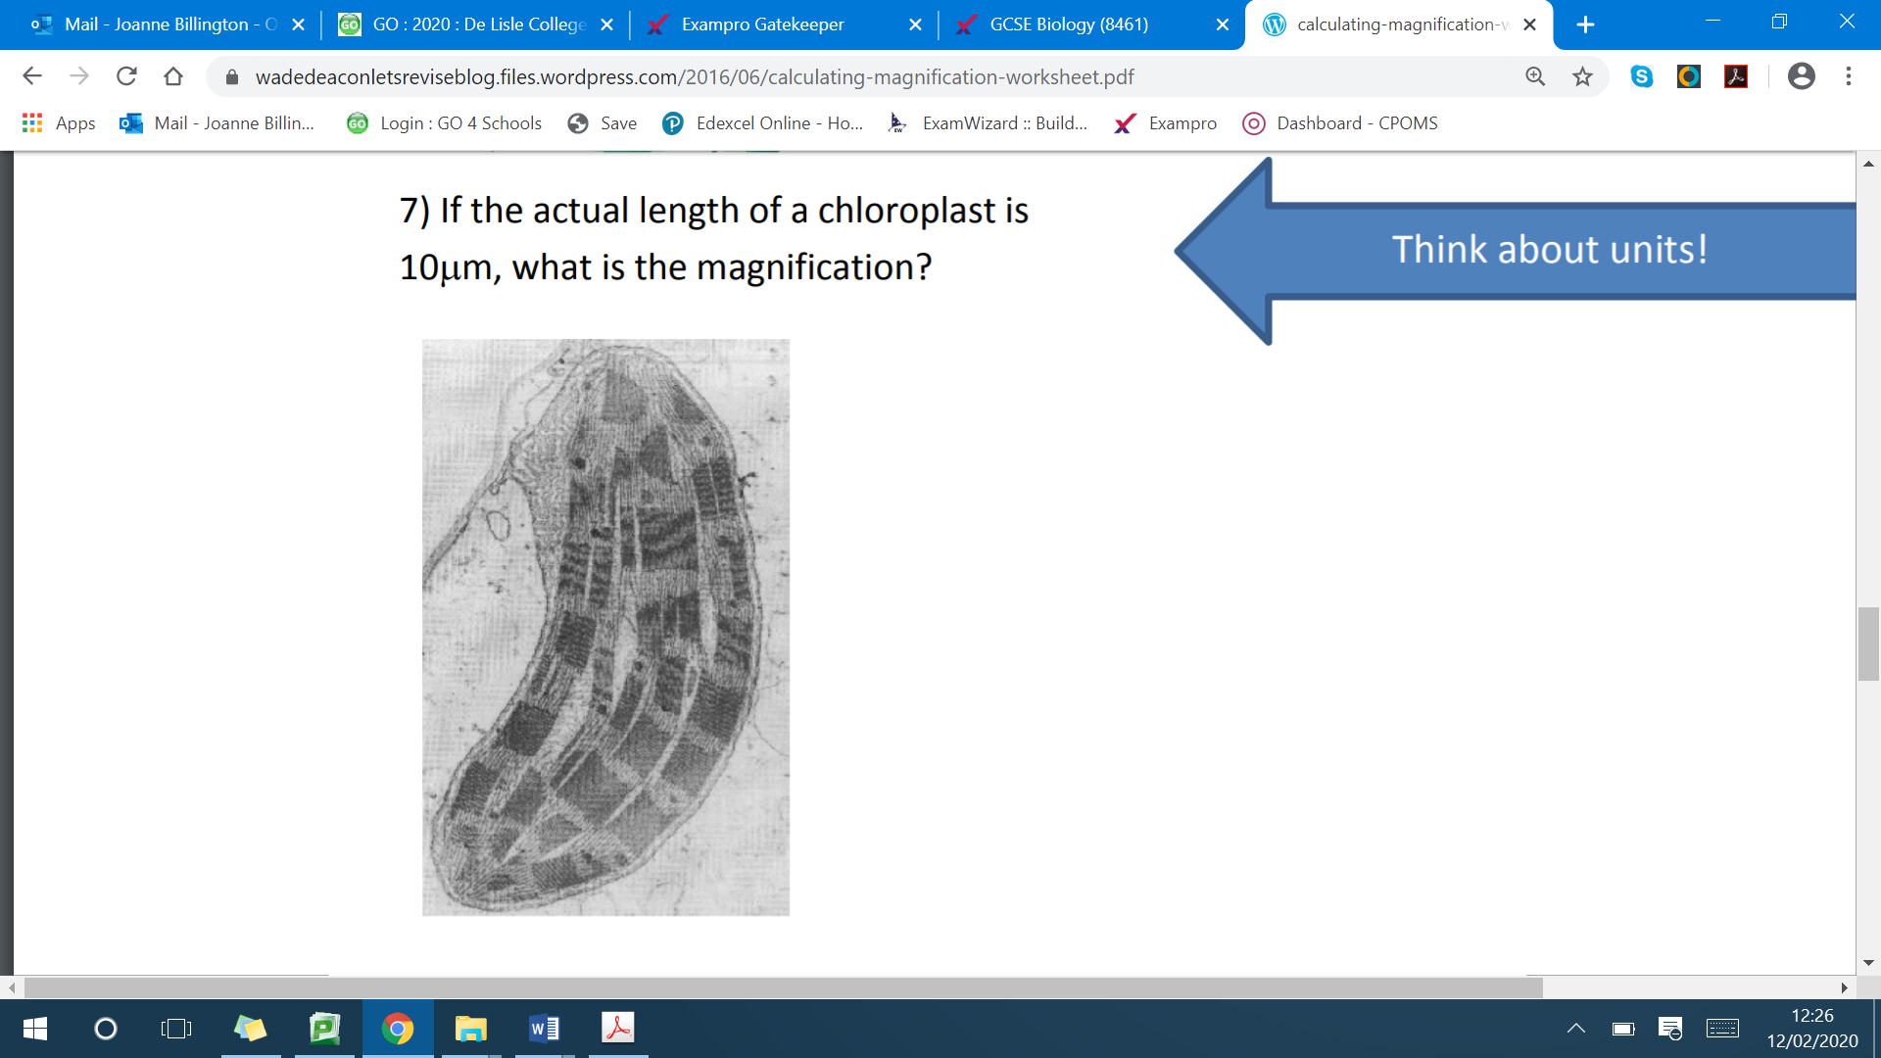6) Look at the picture below and work out the actual size of a chloroplast. The magnification used was x40.

7) If the actual length of a chloroplast is 10µm, what is the magnification?

4. Enzymes

|  |  |
| --- | --- |
| **Topic 2 – Genes and health** | **9 - 1 GCSE** |
| * 1. i) Understand the mechanism of action and the specificity of enzymes in terms of their three-dimensional structure.      1. Understand that enzymes are biological catalysts that reduce activation energy.      2. ow that there are intracellular enzymes catalysing reactions inside cells and extracellular enzymes produced by cells catalysing reactions outside of cells. | * 1. Explain the mechanism of enzyme action including the active site and enzyme specificity   2. Explain how enzymes can be denatured due to changes in the shape of the active site   3. Explain the effects of temperature, substrate concentration and pH on enzyme activity   1.11 Demonstrate an understanding of rate calculations for enzyme activity |
| CORE PRACTICAL 4: Investigate the effect of enzyme and substrate concentrations on the initial rates of reactions. | 1.10 *Core practical: Investigate the effect of pH on enzyme activity* |

## Summary sheet 4: Enzymes activity

Enzymes are biological catalysts that speed up chemical reactions. Enzymes work by reducing the amount of activation energy needed for the reaction to occur.

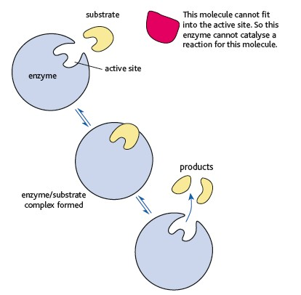

The active site of the enzyme is where the substrate binds. It has a specific shape which means enzymes can only bind to a specific substrate.

The substrate binds to the active site forming an enzyme-substrate complex. The reaction is catalysed and the products released.

Different factors can affect how quickly the enzymes work. These include temperature, pH, enzyme concentration and substrate concentration.

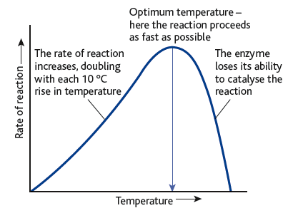As temperature increases there is more chance of a collision between the enzyme and substrates, as they have more kinetic energy. This continues until the optimum temperature where the rate of reaction is highest. As the temperature continues to rise the enzyme denatures, as the active site changes shape, when bonds holding the protein together break.

Enzymes also have an optimum pH, above and below the optimum pH the enzyme denatures.

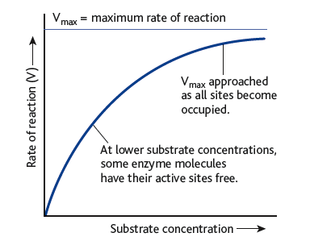

As the substrate concentration increases there is more chance of a collision between the substrate and the enzyme. The rate of reaction increases until all the actives sites are occupied.

The rate of reaction increases as enzyme concentration increases until all the substrate is bound to an enzyme.

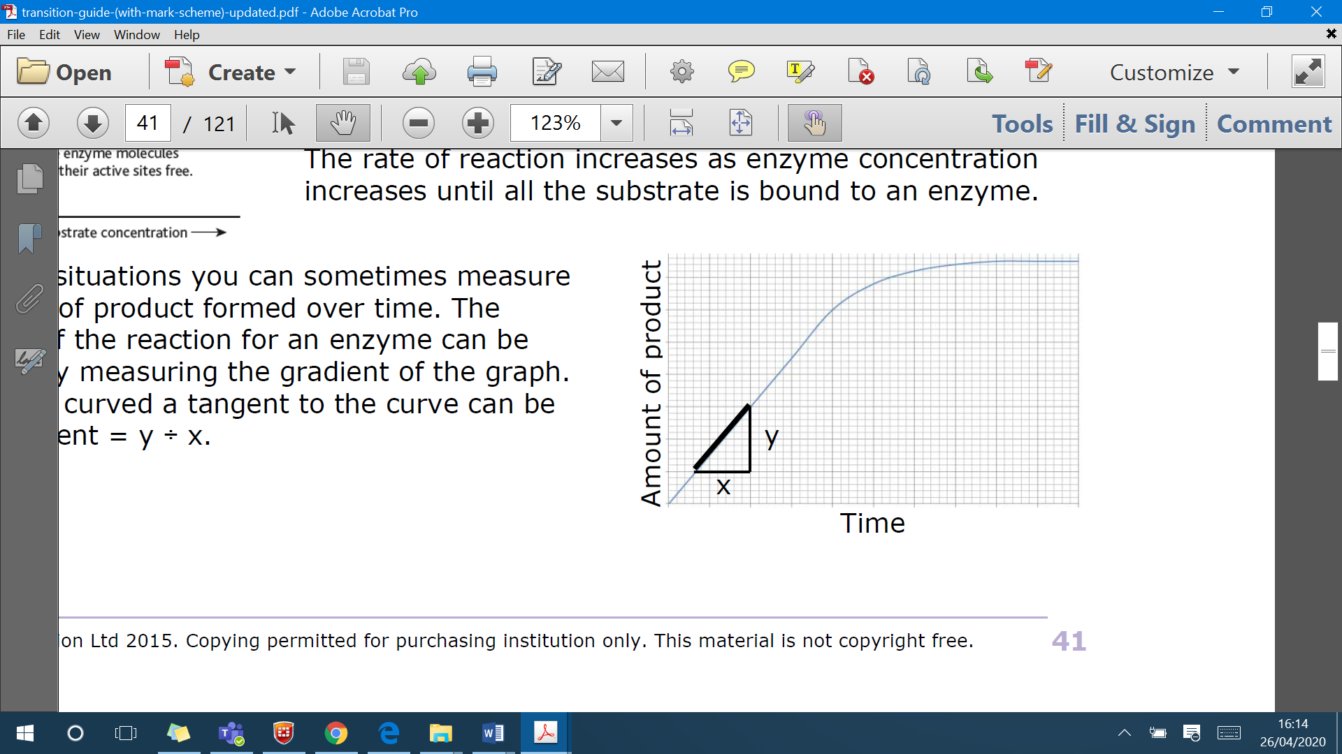In practical situations you can sometimes measure the amount of product formed over time. The initial rate of the reaction for an enzyme can be calculated by measuring the gradient of the graph. If the line is curved a tangent to the curve can be used : gradient = y ÷ x.

## Practice questions

1. Enzyme A catalyses the breakdown of molecule X into Y and Z.

Enzyme A

X Y + Z

Molecule X and enzyme A were mixed together at 30˚C at pH 6.8.

This graph shows the mass of molecule Z formed over a 10 minute time period.

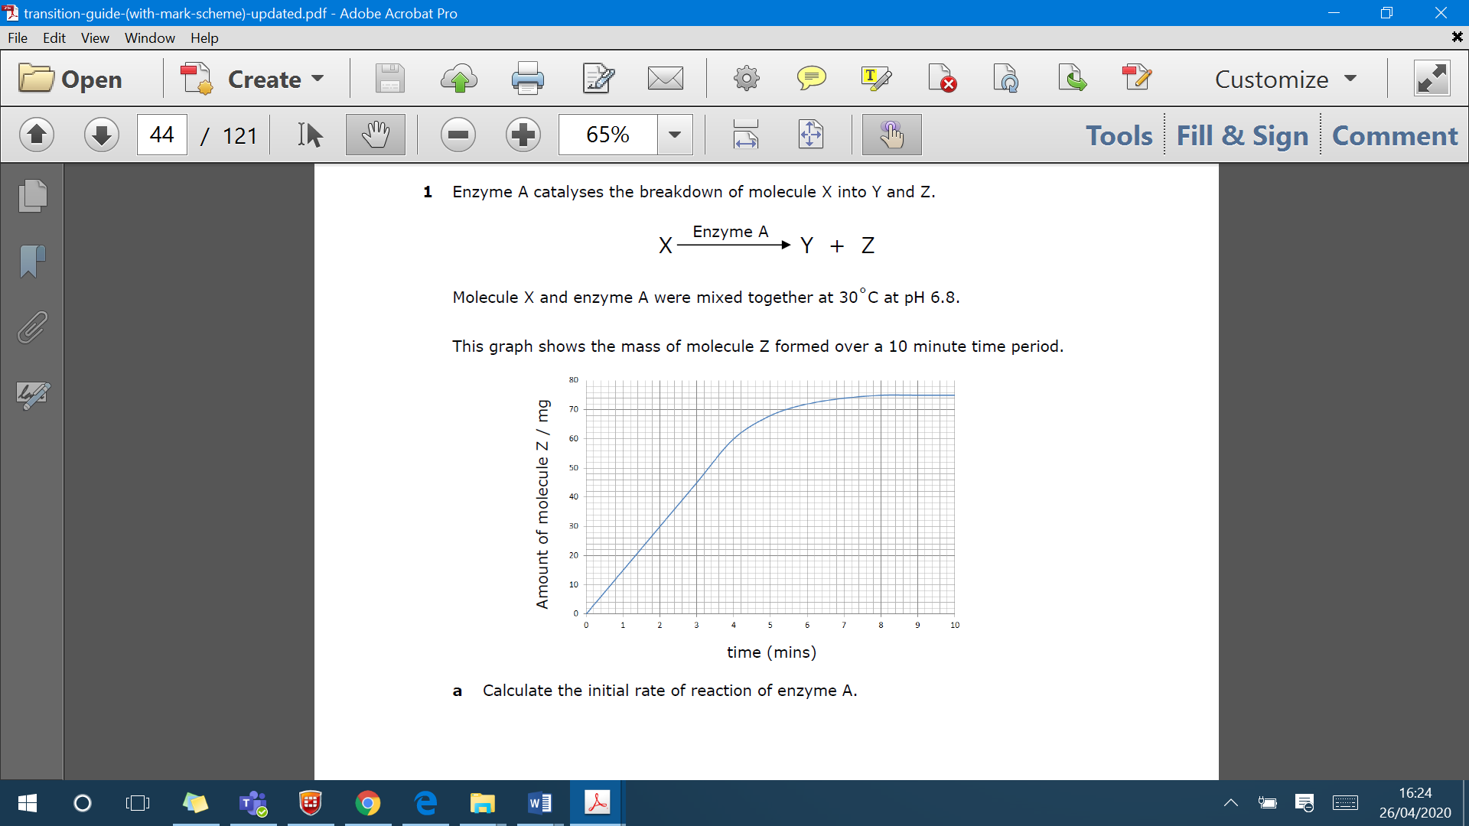

* 1. Calculate the initial rate of reaction of enzyme A.
  2. What is the rate of reaction of enzyme A after 8 minutes?

1. Enzyme B catalyses the breakdown of molecule X into Y and Z.

Enzyme B

X Y + Z

Molecule X and enzyme B were mixed together at different temperatures.

This table shows the initial rate of reaction of enzyme B at 15˚C, 25˚C, 30˚C, 35˚C, 40˚C and 50˚C.

|  |  |
| --- | --- |
| **Temperature** | **Initial rate of reaction of enzyme B (mmol.min-1)** |
| 15 | 8 |
| 25 | 14 |
| 30 | 18 |
| 35 | 20 |
| 40 | 18 |
| 50 | 12 |

1. The table has some missing information. Add the missing information to the table.
2. Plot the data from the table on graph to show the initial rate of reaction of enzyme B at different temperatures.

You should consider:

* + the variable which should be on the x-axis
  + the labels for the axis
  + the title of the graph.

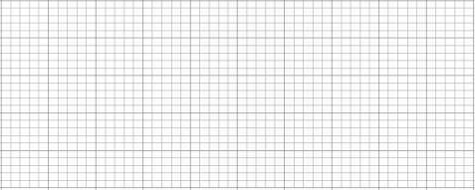

1. Compare different rates of reaction of enzyme B at 20˚C, 37˚C and 45˚C.

**For questions which involve the use of data from a graph you must use scientific knowledge to explain the data you have extract from the graph.**

5. Genetics

|  |  |
| --- | --- |
| **Topic 2 – Genes and health** | **9 - 1 GCSE** |
| 2.13 i) Know the meaning of the terms: gene, allele, genotype, phenotype, recessive, dominant, incomplete dominance, homozygote and heterozygote.  ii) Understand patterns of inheritance, including the interpretation of genetic pedigree diagrams, in the context of monohybrid inheritance. | * 1. Explain why there are differences in the inherited characteristics as a result of alleles   2. Explain the terms: chromosome, gene, allele, dominant, recessive, homozygous, heterozygous, genotype, phenotype, gamete and zygote   3. Explain monohybrid inheritance using genetic diagrams, Punnett squares and family pedigrees   3.16 Calculate and analyse outcomes (using probabilities, ratios and percentages) from monohybrid crosses and pedigree analysis for dominant and recessive traits |

**Summary sheet 5: Genetic inheritance**

A gene is the unit of heredity, and may be copied and passed on to the next generation. **Genes** are the sequence of bases in **DNA** that code for a particular sequence of amino acids, to make a specific protein. Each **gene** can have different forms or versions, and these are called **alleles**. Some characteristics are controlled by a single gene, such as fur in animals and red-green colour blindness in humans, but many characteristics are polygenic (meaning controlled by multiple genes).

Genes are located on chromosomes (a section of a chromosome is a genes). Chromposomes are found in pairs in the nucleus of a body cell. These chromosomes are inherited (passed on) from your parents, one chromosome is inherited from your mother and one is inherited from your father. The chromosomes in each pair carries the same genes in the same location. These genes could be exactly the same, or they can be different versions (alleles). As we have already defined alleles are different versions of the same gene. For example, the gene for eye colour has an allele for blue eye colour and an allele for brown eye colour. For any gene, a person may have the same two alleles, known as **homozygous** or two different ones, known as **heterozygous**. The **genotype** of a person is the collection of alleles that they have. These determine their physical characteristics and can be expressed as a **phenotype**. The alleles we inherit can be either dominant or recessive:

* A **dominant** allele is always expressed, even if only one copy is present. Dominant alleles are always represented by a capital letter, for example, A. The allele for brown eyes is dominant. You only need one copy of this allele to have brown eyes. Two copies will still give you brown eyes.
* A **recessive** allele is only expressed if the individual has two copies and does not have the dominant allele of that gene. Recessive alleles are always represented by a lower case letter, for example, a. The allele for blue eyes is recessive. You need two copies of this allele to have blue eyes.

**Showing genetic inheritance:**

Characteristics that are determined by a single gene (2 alleles) can be studied using a monohybrid cross. This is where you cross 2 parents to look at just one characteristic. We call the diagram we draw a Punnett square and we can use these to work out the probability of different combinations of alleles appearing in the offspring.

|  |  |  |
| --- | --- | --- |
|  | **T** | **T** |
| **t** | **Tt** | **Tt** |
| **t** | **Tt** | **Tt** |

**Worked example 1:**

The height of pea plants is controlled by a single gene which has two alleles: tall and short. The tall allele is dominant and is shown as T. The small allele is recessive and is shown as t. The Punnett square shows the possible allele combinations of the offspring produced when one short pea plants and one tall pea plant are bred.

## Genetics keywords:

Write a definition for each key word.

**Gene**

**Allele**

**Genotype**

**Phenotype**

**Recessive**

**Dominant**

**Incomplete dominance**

**Homozygote**

**Heterozygote**

## Constructing Punnett squares:

Answer the following questions, draw Punnett squares to help you:

1. Explain how two black mice could have brown offspring. The dominant allele is black (B) and the recessive allele is brown (b). Draw a simple genetic cross to show the possible genotypes and phenotypes of offspring from two heterozygous mice (Bb).
2. The ability to tongue roll is controlled by a dominant allele T. Complete a genetic cross of 2 parents who are heterozygous for tongue rolling. State the probability of their offspring having the ability to tongue roll.
3. In watermelons, solid green rind colour (G) is dominant to stripes (g). A farmer crosses two watermelon plants that are heterozygous for rind colour. What are the odds that the offspring will have solid green rinds?
4. Many farmers prefer cattle without horns because it is safer for their herds. The allele for no horns (N) is dominant to the allele for the presence of horns (n). A farmer mates a male with horns to a heterozygous female without horns. What is the chance that the offspring will have horns?
5. In horses, the allele for straight hair (H) is dominant, and the allele for curly hair (h) is recessive. A horse breeder mates a homozygous dominant mother with a heterozygous male. What is the chance that the offspring will have straight hair?
6. A mother who is heterozygous for cystic fibrosis wants to have children, her partner is a homozygous dominant. What is the probability of them having a child who is a carrier of the disease?

6. DNA & protein synthesis

|  |  |
| --- | --- |
| **Topic 2 – Genes and health** | **9 - 1 GCSE** |
| 2.5  i) Know the basic structure of mononucleotides (deoxyribose or ribose linked to a phosphate and a base, including thymine, uracil, cytosine, adenine or guanine) and the structures of DNA and RNA (polynucleotides composed of mononucleotides linked through condensation reactions).  ii) Know how complementary base pairing and the hydrogen bonding between two complementary strands are involved in the formation of the DNA double helix. | Describe DNA as a polymer made up of:   * + 1. two strands coiled to form a double helix     2. strands linked by a series of complementary base pairs joined together by weak hydrogen bonds     3. nucleotides that consist of a sugar and phosphate group with one of the four different bases attached to the sugar |
| 2.6  i) Understand the process of protein synthesis (transcription) including the role of RNA polymerase, translation, messenger RNA, transfer RNA, ribosomes and the role of start and stop codons.  ii) Understand the roles of the DNA template (antisense) strand in transcription, codons on messenger RNA and anticodons on transfer RNA. | * 1. B Explain how the order of bases in a section of DNA decides the order of amino acids in the protein and that these fold to produce specifically shaped proteins such as enzymes   2. B Describe the stages of protein synthesis, including transcription and translation:      1. RNA polymerase binds to non-coding DNA located in front of a gene      2. RNA polymerase produces a complementary mRNA strand from the coding DNA of the gene      3. the attachment of the mRNA to the ribosome      4. the coding by triplets of bases (codons) in the mRNA for specific amino acids      5. the transfer of amino acids to the ribosome by tRNA      6. the linking of amino acids to form polypeptides |

**Summary sheet 6: DNA structure**

**DNA structure:**

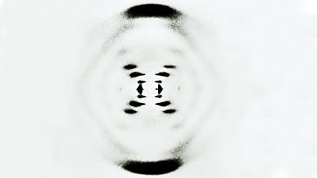James Watson and Francis Crick worked out the structure of DNA in 1953. They used data from other scientists (Rosalind Franklin and Maurice Wilkins) and were able to build a model of DNA. The X-ray crystallography data they used showed that DNA consists of two strands coiled into a double helix (photograph 51). Watson and Crick published their findings in a one-page paper, with the understated title "A Structure for Deoxyribose Nucleic Acid," in the British scientific weekly Nature on April 25, 1953. Take a look at the DVD clip about the discovery of the structure of DNA. <https://www.youtube.com/watch?v=3-mmjwXT5Dg>

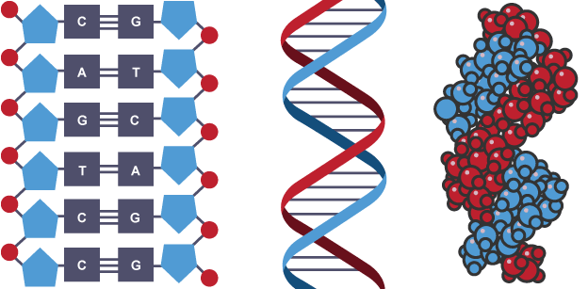DNA is a polymer made from four different **nucleotides**. Each nucleotide consists of a common **sugar** (deoxyribose) and a **phosphate** group with one of four different **nitrogenous bases** attached to the sugar. DNA contains four bases, **Adenine**, **Cytosine**, **Guanine** and **Thymine**. The nucleotides of DNA are arranged in a repeating fashion. Each nucleotide consists of alternating sugar and phosphate sections with one of the four different bases attached to the sugar. The nucleotides of DNA are **held together by weak hydrogen bonds**. The diagram shows the double helix of DNA and the nucleotide structure. <https://www.youtube.com/watch?v=GIzNlISbCxI>

**Base pairs**

Each strand of DNA is made of chemicals called bases. Note that these are different to bases in relation to acids and alkalis in chemistry. There are chemical cross-links between the two strands in DNA, formed by pairs of bases (held together by hydrogen bonds). They always pair up in a particular way, called **complementary base pairing**:

• thymine pairs with adenine (T-A)

• guanine pairs with cytosine (G-C)

## Summary sheet 1: Protein synthesis

A gene is a sequence of DNA which codes for a protein. Proteins are synthesised in a two-step process – **transcription** and **translation**.

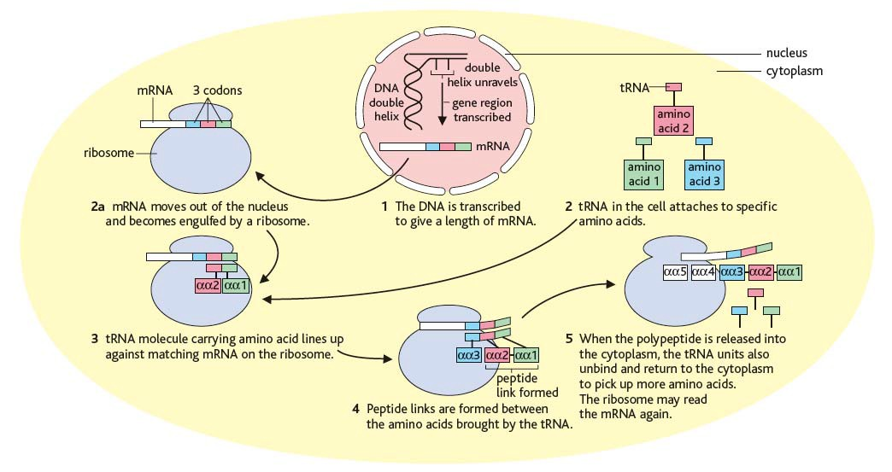**Transcription takes place in the nucleus** and **translation takes place at the ribosome**. A complementary mRNA strand is made using the DNA as a template. The **mRNA** leaves the nucleus and attaches to the ribosome in the cytoplasm. A **triplet** of bases on the mRNA (**a codon**) code for specific amino acids. The amino acids are delivered to the ribosome **by tRNA**. **Peptide bonds** are formed between the amino acids to make the polypeptide.

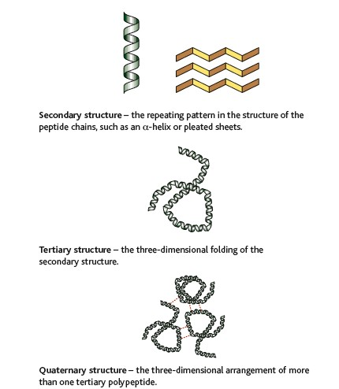

The DNA gene sequence is ACA CGG AAACCT GAC. The mRNA sequence is UGU GCC UUU GGA CUG. This codes for the amino acid sequence is:

Cys-Ala-Lys-Gly-Leu

The **protein folds** into a specific structure.

For enzymes this means that the active site

forms a specific shape that binds specific substrates.

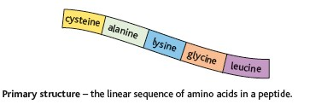

Practice questions:

1. Mutations in DNA can impact on the activity of enzymes.

This DNA sequence is from the region of the gene which codes for the active site of an enzyme.

GAA GAG AGT GGA CTC ACA GCT CGG

The table shows the amino acid coded for by some codons.

|  |  |  |  |  |
| --- | --- | --- | --- | --- |
| **Amino acid/stop signal** | **DNA triplet codons** | | | |
| Proline | GGT | GGG | GGA | |
| Alanine | CGG | CGA | CGT | CGC |
| Cysteine | ACA | ACG | | |
| Serine | AGG | AGA | AGT | AGC |
| Leucine | GAA | GAG | GAT | GAC |
| Arginine | GCA | GCG | GCT | GCC |
| Glutamine | CTT | CTC | | |
| Gkycine | CCT | CCG | CCA | CCC |
| Threonine | TGC | TGA | TGT | TGG |
| Stop signal | ATT | ATC | ACT | |

1. State the amino acid sequence coded for by the sequence above.
2. Using the information above explain the effect on the protein produced for the following mutations.

GAA GAT AGT GGA CTC ACA GCT CGG

GAA GAG AGT GGA CTC CCA GCT CGG