**Preparing for A Level Study: English Literature**

|  |  |  |
| --- | --- | --- |
| Threshold Concept | Description | Task title |
| 1 | AO1 - Articulate informed, personal and creative responses to literary texts, using associated concepts and terminology, and coherent, accurate written expression. | Read through the extract of a student’s response to a GCSE Macbeth extract question. Rewrite the response, improving the accuracy of the written expression including spelling, punctuation and grammar. |
| 2 | AO2 - Analyse ways in which meanings are shaped in literary texts. | Choose one of the 19th Century poems and complete the task. |
| 3 | AO3 - Demonstrate understanding of the significance and influence of the contexts in which literary texts are written and received. | Create a timeline that places the twelve texts in their chronological order. Choose one text and produce a context research poster. |
| 4 | AO5 - Explore literary texts informed by different interpretations. | Read one of the Shakespeare plays listed and consider the text in relation to the critical viewpoint given. Write down ten bullet points sharing your thoughts. |

**Summer Wider Reading**

Please read at least one text from the list below:

*Hag Seed* or *The Blind Assassin* – Margaret Atwood

*The Axeman's Jazz* – Ray Celestin

*Atonement* – Ian McEwan

*The Impressionist* – Hari Kunzru

*NW* – Zadie Smith

*Freshwater* – Akwaeke Emezi

*The Corrections* – Jonathan Franzen

*The Road* – Cormac McCarthy

*Cloud Atlas –* David Mitchell

*American Gods* – Neil Gaiman

*The Kite Runner ­–* Khaled Hosseini

Further wider reading materials and activities to help you prepare for making the transition from GCSE to A Level study can be found at <https://www.delisle.org.uk/1759/english>

**Task 1**

**Threshold Concept 1**

*AO1 - Articulate informed, personal and creative responses to literary texts, using associated concepts and terminology, and coherent, accurate written expression.*

Read through the extract of a student’s response to a GCSE Macbeth extract question. Rewrite the response, improving the accuracy of the written expression including spelling, punctuation and grammar.

The response can be found on the following page. You do not need to improve the quality of the student’s analysis. Please focus on the accuracy of their written expression. You are allowed to change the vocabulary used if you wish.

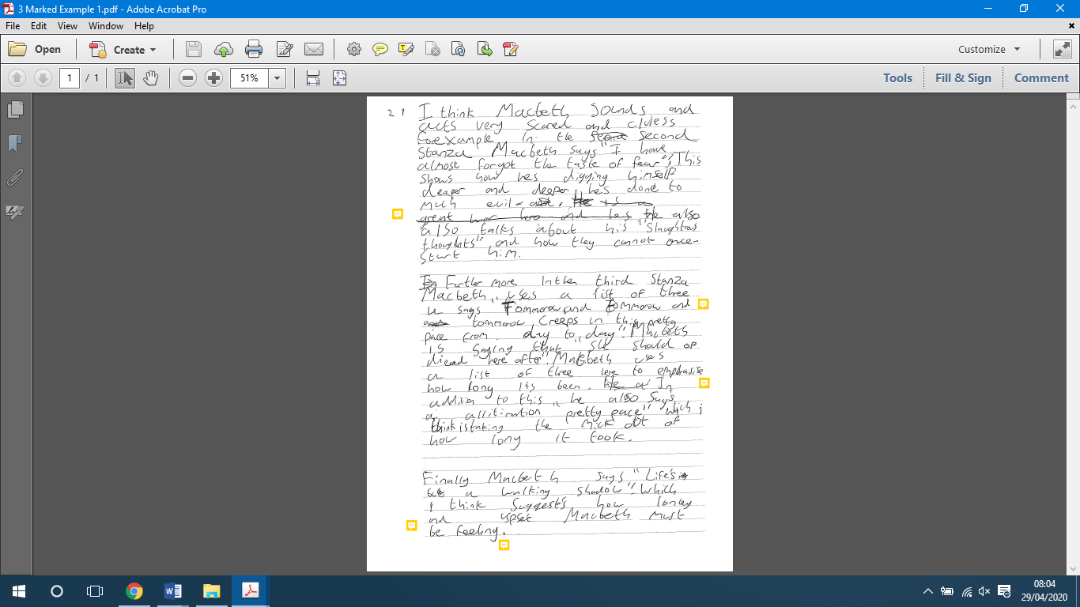

**Task 2**

**Threshold Concept 2**

*AO2 - Analyse ways in which meanings are shaped in literary texts.*

Choose one of the 19th century poems below and complete the following task:

Write about the poem and its effect on you.

*You may wish to consider:*

* *what the poem is about and how it is organised*
* *the ideas the poet may have wanted us to think about*
* *the poet’s choice of words, phrases and images and the effects they create*
* *how you respond to the poem*

**Poem 1**

**A Birthday**

BY [CHRISTINA ROSSETTI](https://www.poetryfoundation.org/poets/christina-rossetti)

My heart is like a singing bird

                  Whose nest is in a water'd shoot;

My heart is like an apple-tree

                  Whose boughs are bent with thickset fruit;

My heart is like a rainbow shell

                  That paddles in a halcyon sea;

My heart is gladder than all these

                  Because my love is come to me.

Raise me a dais of silk and down;

                  Hang it with vair and purple dyes;

Carve it in doves and pomegranates,

                  And peacocks with a hundred eyes;

Work it in gold and silver grapes,

                  In leaves and silver fleurs-de-lys;

Because the birthday of my life

                  Is come, my love is come to me.

**Poem 2**

**Remembrance**

BY [EMILY BRONTË](https://www.poetryfoundation.org/poets/emily-bronte)

Cold in the earth—and the deep snow piled above thee,

Far, far removed, cold in the dreary grave!

Have I forgot, my only Love, to love thee,

Severed at last by Time's all-severing wave?

Now, when alone, do my thoughts no longer hover

Over the mountains, on that northern shore,

Resting their wings where heath and fern-leaves cover

Thy noble heart forever, ever more?

Cold in the earth—and fifteen wild Decembers,

From those brown hills, have melted into spring:

Faithful, indeed, is the spirit that remembers

After such years of change and suffering!

Sweet Love of youth, forgive, if I forget thee,

While the world's tide is bearing me along;

Other desires and other hopes beset me,

Hopes which obscure, but cannot do thee wrong!

No later light has lightened up my heaven,

No second morn has ever shone for me;

All my life's bliss from thy dear life was given,

All my life's bliss is in the grave with thee.

But, when the days of golden dreams had perished,

And even Despair was powerless to destroy,

Then did I learn how existence could be cherished,

Strengthened, and fed without the aid of joy.

Then did I check the tears of useless passion—

Weaned my young soul from yearning after thine;

Sternly denied its burning wish to hasten

Down to that tomb already more than mine.

And, even yet, I dare not let it languish,

Dare not indulge in memory's rapturous pain;

Once drinking deep of that divinest anguish,

How could I seek the empty world again?

**Poem 3**

# The Kraken

BY ALFRED LORD TENNYSON

Below the thunders of the upper deep,  
Far, far beneath in the abysmal sea,  
His ancient, dreamless, uninvaded sleep  
The Kraken sleepeth: faintest sunlights flee  
About his shadowy sides; above him swell  
Huge sponges of millennial growth and height;  
And far away into the sickly light,  
From many a wondrous grot and secret cell  
Unnumbered and enormous polypi  
Winnow with giant arms the slumbering green.  
There hath he lain for ages, and will lie  
Battening upon huge sea worms in his sleep,  
Until the latter fire shall heat the deep;  
Then once by man and angels to be seen,  
In roaring he shall rise and on the surface die.

**Task 3**

**Threshold Concept 3**

*AO3 - Demonstrate understanding of the significance and influence of the contexts in which literary texts are written and received.*

1. Research the author and the date that the following texts were written/published and put them in chronological order in a timeline.

1984

Pride and Prejudice

Ulysses

The Canterbury Tales

Atonement

Wuthering Heights

The Handmaid’s Tale

Hamlet

The Bell Jar

Robinson Crusoe

Never Let Me Go

Beowulf

1. Choose one of the texts and produce a research poster/mind-map exploring the context in which they were produced. You could explore:

* the values and beliefs of the society in which they were written
* the role of women at the time it was written (if applicable)
* the reception to the text when it was first published
* relevant features of the writer’s biography

**Task 4**

**Threshold Concept 4**

*AO5 - Explore literary texts informed by different interpretations.*

1. Read and watch (if possible) one of the following Shakespeare plays:

*A Midsummer Night’s Dream*

*The Taming of the Shrew*

*Othello*

*Romeo and Juliet*

1. Think about the play in relation to the following critical viewpoint:

*‘Women in Shakespeare’s plays have no independence of their own, they are simply possessions, and their fate is always decided by their relationships with men.’*

1. Write down ten bullet points sharing your thoughts on the different ways that this viewpoint is evident (or not) in the play that you chose to read.