**Preparing for A-level PE 2022**

**Threshold concepts**

**­­**

**If you require any support with this work you must contact Mr Powell**

**Email:** [craig.powell@delisle.leics.sch.uk](mailto:craig.powell@delisle.leics.sch.uk)

**The following tasks have been divided to replicate the way that the AQA A-Level PE course (course code: 7582) is assessed and delivered.**

The PE department have created a list of what you can read or watch prior to undertaking A-Level PE. There is no expectation to read/watch them all but they will help you to gain a better understanding about some of the content covered on this course at De Lisle.



**There are 3 sections taught in Year 12**

* Section A – Applied Anatomy and Physiology
* Section B – Skill acquisition
* Section C – Sport and Society

The below tasks will help best prepare you for the start of this course at De Lisle College.

|  |  |  |  |  |
| --- | --- | --- | --- | --- |
| Threshold Concept | Description | Task title | Completed? | Date |
| 1 | Label the diagram of the heart and answer the questions | Section A – Applied Anatomy and Physiology  Topic area 1: The Cardiovascular System |  |  |
| 2 | Familiarise yourself with the definitions of skill classification and place sporting actions in the correct place on the continuums | Section B – Skill acquisition  Topic area 1: Skill characteristics and their impact on transfer and practice |  |  |
| 3 | Gain a better understanding about pre-industrial Britain, the class system and how sport was played in the 1850s | Section C – Sport and Society  Pre-Industrial Britain – what do you know? |  |  |

**Threshold concept 1**

Section A – Applied Anatomy and Physiology

Topic area 1: The Cardiovascular System

Task – Label the heart below using the correct terms

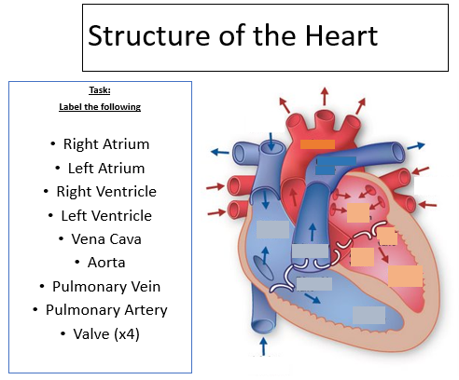

**Can you answer the following questions?**

1. What are the 4 chambers of the heart?
2. Which chambers are larger? Why?
3. Which side of the heart **myocardium** is larger? Why?
4. What are the 4 main blood vessels that enter and leave the heart, and where is blood being carried?
5. What are valves and what is their role in the movement of blood in the heart?

**Cardiac conduction system**

This is a group of specialised cells located in the wall of the heart which send electrical impulses to the cardiac muscle, causing it to contract.

Rearrange the following words to show the correct order that the impulse travels in:

AV node Ventricular systole SAN (Sinoatrial node) Atrial Systole

Bundle of his Purkinje Fibres

**The correct order**

**1.**

**2.**

**3.**

**4.**

**5.**

**6.**

**Label the conduction system – use the above 6 terms**

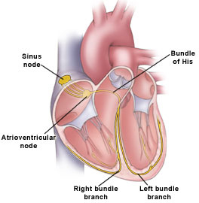

**Threshold concept 2**

Section B – Skill acquisition

Topic area 1: Skill characteristics and their impact on transfer and practice

Task: Definition of skill (define skill based on what you have read/know)

____________________________________________________________________________________________________________________________________________________________________________________________________________________________________________________________________________________________________________

Skill Continuums

View the continuums below and consider where you would place the following sport actions on to the continuums.

FINE SKILLS

* SMALL DELICATE MUSCLE MOVEMENTS OFTEN USING HANDS AND FINGERS
* OFTEN PART OF A GROSS SKILL

GROSS SKILLS

* USES LARGE MUSCLE GROUPS FOR MOVEMENT
* MOST MOVEMENTS USE GROSS SKILLS

Gross

Fine

MUSCULAR INVOLVEMENT CONTINUUM

Where would you place the following on this continuum?

1. A hurdler going over a hurdle at speed
2. A spin bowler upon moment of releasing the ball
3. A performer releasing an arrow in archery

OPEN SKILLS

* AFFECTED BY ENVIRONMENT
* MAINLY PERCEPTUAL
* MOVEMENTS NEED ADAPTING
* EXTERNALLY PACED
* NO CLEAR END OR START

CLOSED SKILLS

* NOT AFFECTED BY ENVIRONMENT
* PREDOMINANTLY HABITUAL
* SET MOVEMENTS

Open

Closed

ENVIRONMENTAL INFLUENCES CONTINUUM

Where would you place the following on this continuum?

1. Penalty kick in football
2. Shot putter performing in the shot put
3. Rugby tackle being completed

CONTINOUS

NO OBVIOUS BEGINNING OR END

CONTINUES FOR AS LONG AS PERFORMER WISHES

THE END OF ONE CYCLE IS THE BEGINNING OF THE NEXT

NO CLEAR SUB ROUTINES

DISCRETE

CLEAR BEGINNING AND END

SKILLS CAN BE REPEATED BUT PERFORMER MUST START AGAIN

SINGLE SPECIFIC SKILL

SERIAL

SEVERAL DISCRETE ELEMENTS

PUT TOGETHER INTO A SEQUENCE

THE ORDER OF THE ELEMENTS ARE IMPORTANT

Continuous

Serial

Discrete

CONTINUITY CONTINUUM

Where would you place the following on this continuum?

1. A tennis player completing a serve
2. A trampolinist performing a routine
3. A cross country running competing in a race

SELF PACED SKILLS

* THE PERFORMER CONTROLS THE SPEED AT WHICH THE SKILL IS CARRIES OUT
* THE PERFORMER DECIDES HOW THE SKILL WILL BE CARRIED OUT (PRO ACTION)

EXTERNALLY PACED SKILLS

* PERFORMER HAS NO CONTROL OVER RATE AT WHICH SKILL IS CARRIED OUT
* REQUIRES REACTION BY THE PERFORMER.

Self - paced

Externally paced

PACING CONTINUUM

Where would you place the following on this continuum?

1. A conversion in rugby
2. A sailor competing in the World Sailing Championship event
3. Basketball shooting a 3 point shot in a game of basketball

COMPLEX SKILLS

* LOTS OF INFORMATION TO BE PROCESSED
* CONCENTRATION NEEDED
* NUMEROUS VARIABLES
* LARGE COGNITIVE ELEMENT

SIMPLE SKILLS

* LIMITED AMOUNT OF INFORMATION TO PROCESS
* SMALL COGNITIVE ELEMENT
* EASIER TO FOCUS ON THE TASK UNTIL IT IS COMPLETED

SIMPLE

COMPLEX

COMPLEXITY CONTINUUM

Where would you place the following on this continuum?

1. A forward roll in gymnastics
2. Receiving a pass under pressure in netball
3. Tennis backhand whilst on the move

HIGHLY ORGANISED SKILLS

* HARD TO BREAK DOWN AS IT IS FAST AND BALLISTIC IN ITS ACTION
* THE PARTS THAT MAKE UP THE TASK ARE INTEGRATED CLOSELY IN THE ACTION

LOW ORGANISED SKILLS

* CAN BE BROKEN DOWN INTO PARTS OR SUBROUTINES
* THESE PARTS CAN BE IDENTIFIED AS INDEPENDENT ACTIONS
* EACH PART CAN BE TAUGHT SEPERATELY

HIGHLY ORGANISED

LOW ORGANISED

ORGANISATIONAL CONTINUUM

Where would you place the following on this continuum?

1. Swimming front crawl

2. Hitting a driver of a tee in golf 3. Shooting a basketball free throw

**Task - Can you classify the following skills using the classification system?**

Circle the most likely answer for each of the classifications

**3) Completing a chest pass in netball**

Organisational: Low organised/Highly organised

Complexity: Simple/Complex

Continuity: Discrete/Serial/Continuous

Environmental: Open/Closed

Muscular involvement: Gross/Fine

**3) Dribbling past an opponent in hockey**

Organisational: Low organised/Highly organised

Complexity: Simple/Complex

Continuity: Discrete/Serial/Continuous

Environmental: Open/Closed

Muscular involvement: Gross/Fine

**2) Waiting on the starting blocks for a 50m backstroke race**

Organisational: Low organised/Highly organised

Complexity: Simple/Complex

Continuity: Discrete/Serial/Continuous

Environmental: Open/Closed

Muscular involvement: Gross/Fine

1. **Taking a penalty in football**

Organisational: Low organised/Highly organised

Complexity: Simple/Complex

Continuity: Discrete/Serial/Continuous

Environmental: Open/Closed

Muscular involvement: Gross/Fine

**Threshold concept 3**

Section C – Sport and Society

Topic area 1: Emergence of the globilisation of sport in the twenty-first century

Task: Look at the images below and write down what each image represents in relation to pre-industrial life (pre 1780) – the first one has been done for you.

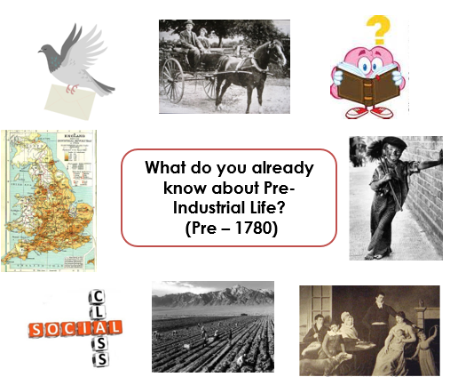

Communication was limited – no email or phone lines available

Transport was limited Widespread illiteracy – lower class Lived in countryside

Class division limited free time: long working hours Upper class lived in luxury

Lower class had cruel or violent existence

**Popular Recreation**

Popular recreation is described as the sport and pastimes of people in pre-industrial Britain.

Mob football was deemed popular recreation; can you list some characteristics of this?

1. 2) 3)

4) 5) 6)

7) 8) 9)

Watch this video to help you to understand more about pre-industrial Britain.

<https://www.youtube.com/watch?v=hIVqhj9d4Os> – video length 15 mins.

Video notes – Sport, Society and Culture pre-1850/pre-industrial Britain

Answer the following questions on pre-industrial Britain

1. Name the 2 classes of people ……………………………………………………………………………………
2. Who were deemed working class people? ………………………………………………………………..
3. Who were deemed upper/class? ………………………………………………………………………………
4. Who would normally participate in mob games? ……………………………………………………..
5. Who would normally participate in real tennis? ……………………………………………………….
6. List some characteristics of mob games …………………………………………………………………...

………………………………………………………………………………………………………………………………….

1. List some characteristics of games played by the upper class …………………………………..

…………………………………………………………………………………………………………………………………..