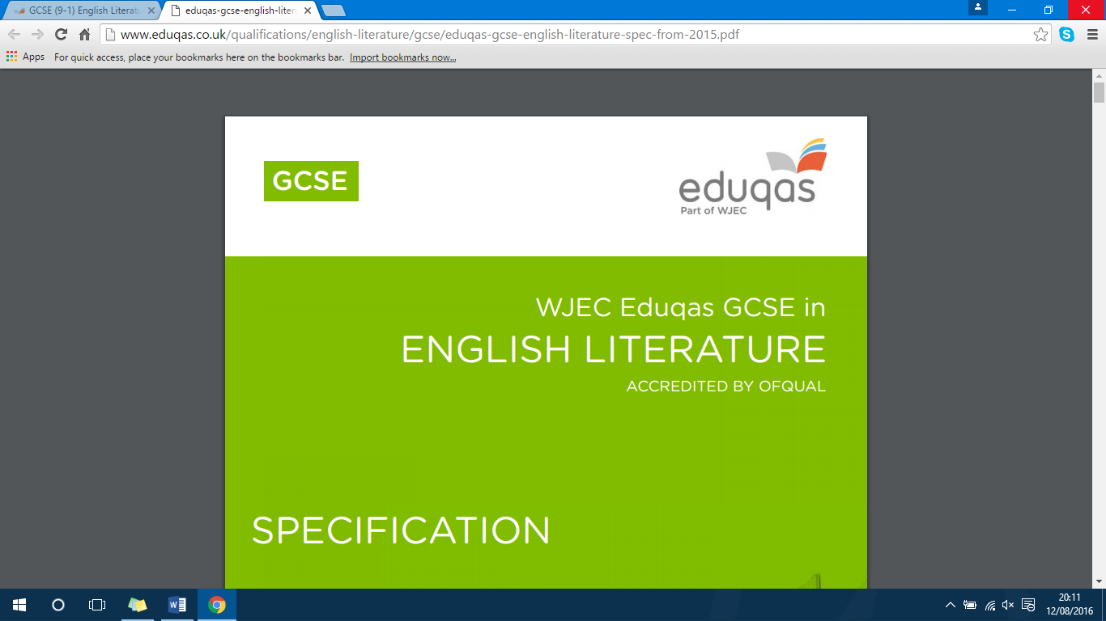

ENGLISH LITERATURE

COMPONENT 1: Section B (Poetry from 1789 to the present day)

Two questions based on poems from the WJEC Eduqas Poetry Anthology, one of which involves comparison. (20% - 40 marks – 1 hour)

THE POEMS:

***The Manhunt*** Simon Armitage

***Sonnet 43*** Elizabeth Barrett Browning

***London*** William Blake

***The Soldier*** Rupert Brooke

***She Walks in Beauty*** Lord Byron

***Living Space*** Imtiaz Dharker

***As Imperceptibly as Grief*** Emily Dickinson

***Cozy Apologia*** Rita Dove

***Valentine*** Carol Ann Duffy

***A Wife in London*** Thomas Hardy

***Death of a Naturalist*** Seamus Heaney

***Hawk Roosting*** Ted Hughes

***To Autumn*** John Keats

***Afternoons*** Philip Larkin

***Dulce et Decorum Est*** Wilfred Owen

***Ozymandias*** Percy Bysshe Shelley

***Mametz Wood*** Owen Sheers

Excerpt from ***The Prelude*** William Wordsworth

This assessment will test knowledge and understanding of poetry from 1789 to the present day. Learners will be assessed on two poems from the WJEC Eduqas Poetry Anthology.

In the first question, learners will be asked to write about a specified poem.

In the second question, learners will be asked to write about a second poem chosen from the WJEC Eduqas Poetry Anthology, and compare it to the first.

Learners will be expected to consider the context of each poem, its content and key ideas, and the poets’ use of language, structure and form.

Learners must study all of the poems in the WJEC Eduqas Poetry Anthology in preparation for this assessment.

The anthology covers a range of poetry and is designed to introduce learners to the rich heritage of poetry across centuries as well as illustrating how poets explore similar themes in different ways.

Section B assesses **AO1**, **AO2** and **AO3**.

Learners must demonstrate their ability to:

**AO1** Read, understand and respond to texts. Students should be able to:

• maintain a critical style and develop an informed personal response

• use textual references, including quotations, to support and illustrate interpretations.

**AO2** Analyse the language, form and structure used by a writer to create meanings and effects, using relevant subject terminology where appropriate.

**AO3** Show understanding of the relationships between texts and the contexts in which they were written.

Question a) Mark Scheme:

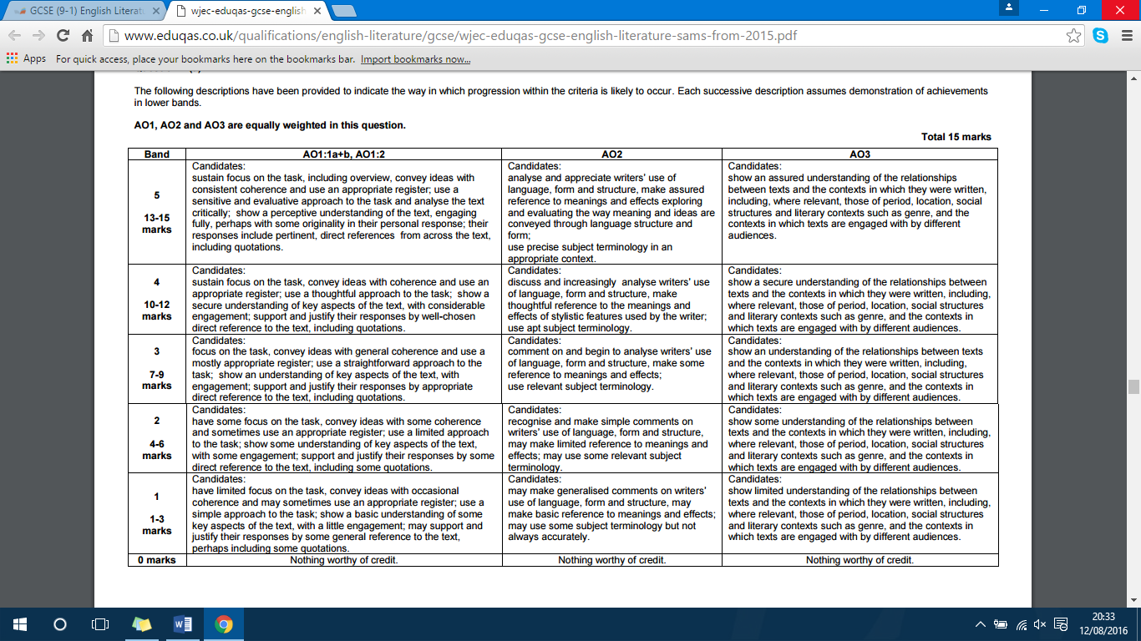

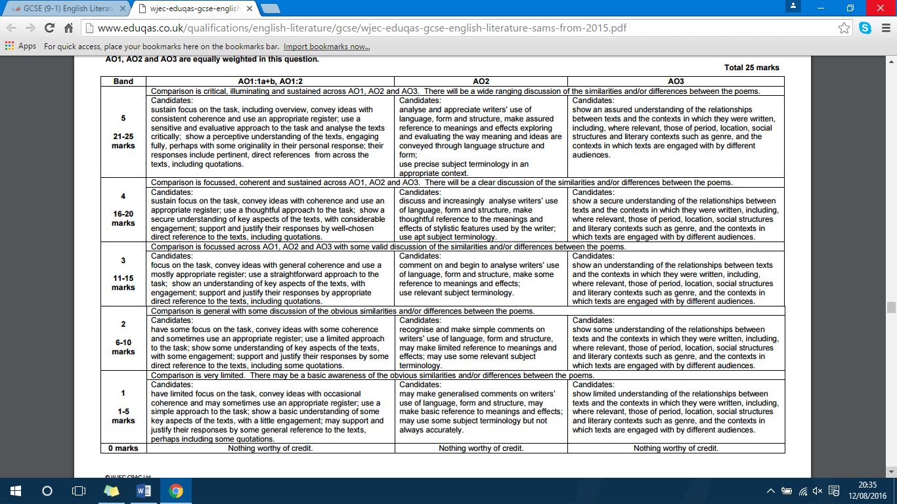Question b) Mark Scheme:

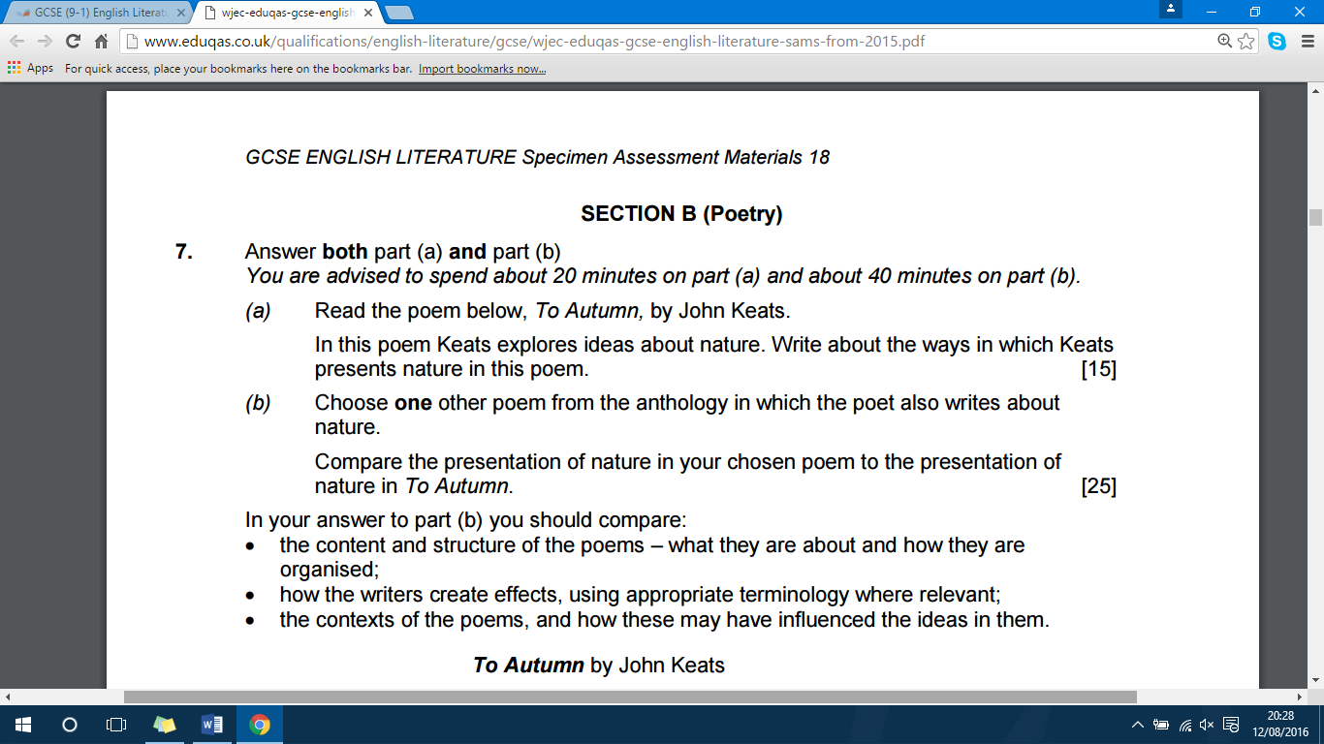

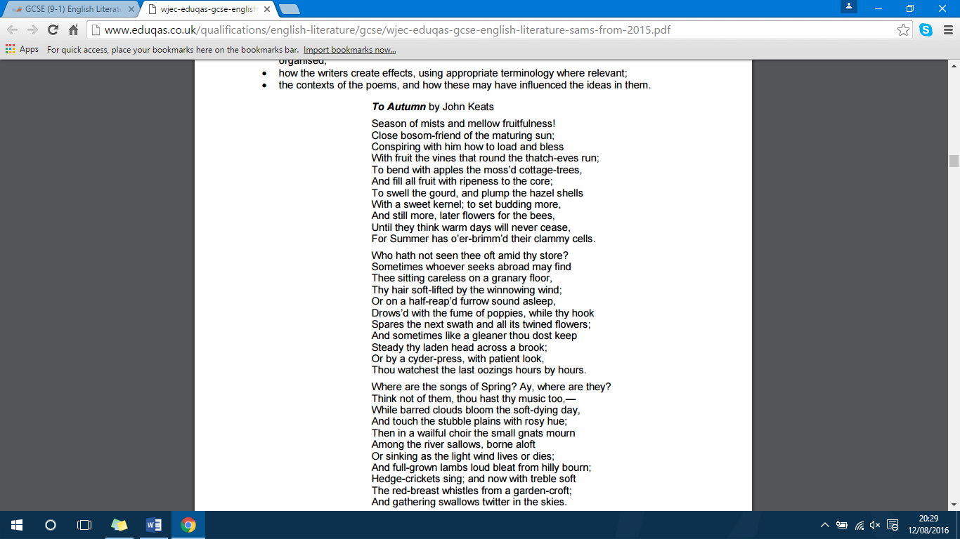

|  |  |  |
| --- | --- | --- |
| **POEM:** | **‘The Manhunt’** | **By Simon Armitage** |
| OVERVIEW OF CONTENT |  | |
| MAIN THEMES |  | |
| GENRE / STYLE / FORM OF THE POEM |  | |
| PUBLICATION DATE: |  | TIME PERIOD: |
| THE POET: | Born: | Died: |
| BIOGRAPHICAL INFORMATION RELATED TO THE POEM |  | |
| IMPORTANT HISTORICAL EVENTS WHICH MAY LINK TO THE IDEAS IN THE POEM |  | |
| LITERARY STYLE AND HOW THE POET WAS INFLUENCED |  | |
| ANY OTHER RELEVANT CONTEXT  (remember that doing your own research and adding your own thoughts will bring originality to your response) |  | |

|  |  |  |
| --- | --- | --- |
| **POEM:** | **‘Sonnet 43’** | **By Elizabeth Barrett Browning** |
| OVERVIEW OF CONTENT |  | |
| MAIN THEMES |  | |
| GENRE / STYLE / FORM OF THE POEM |  | |
| PUBLICATION DATE: |  | TIME PERIOD: |
| THE POET: | Born: | Died: |
| BIOGRAPHICAL INFORMATION RELATED TO THE POEM |  | |
| IMPORTANT HISTORICAL EVENTS WHICH MAY LINK TO THE IDEAS IN THE POEM |  | |
| LITERARY STYLE AND HOW THE POET WAS INFLUENCED |  | |
| ANY OTHER RELEVANT CONTEXT  (remember that doing your own research and adding your own thoughts will bring originality to your response) |  | |

|  |  |  |
| --- | --- | --- |
| **POEM:** | **‘London’** | **By William Blake** |
| OVERVIEW OF CONTENT |  | |
| MAIN THEMES |  | |
| GENRE / STYLE / FORM OF THE POEM |  | |
| PUBLICATION DATE: |  | TIME PERIOD: |
| THE POET: | Born: | Died: |
| BIOGRAPHICAL INFORMATION RELATED TO THE POEM |  | |
| IMPORTANT HISTORICAL EVENTS WHICH MAY LINK TO THE IDEAS IN THE POEM |  | |
| LITERARY STYLE AND HOW THE POET WAS INFLUENCED |  | |
| ANY OTHER RELEVANT CONTEXT  (remember that doing your own research and adding your own thoughts will bring originality to your response) |  | |

|  |  |  |
| --- | --- | --- |
| **POEM:** | **‘Soldier’** | **By Rupert Brooke** |
| OVERVIEW OF CONTENT |  | |
| MAIN THEMES |  | |
| GENRE / STYLE / FORM OF THE POEM |  | |
| PUBLICATION DATE: |  | TIME PERIOD: |
| THE POET: | Born: | Died: |
| BIOGRAPHICAL INFORMATION RELATED TO THE POEM |  | |
| IMPORTANT HISTORICAL EVENTS WHICH MAY LINK TO THE IDEAS IN THE POEM |  | |
| LITERARY STYLE AND HOW THE POET WAS INFLUENCED |  | |
| ANY OTHER RELEVANT CONTEXT  (remember that doing your own research and adding your own thoughts will bring originality to your response) |  | |

|  |  |  |
| --- | --- | --- |
| **POEM:** | **‘She Walks in Beauty’** | **By Lord Byron** |
| OVERVIEW OF CONTENT |  | |
| MAIN THEMES |  | |
| GENRE / STYLE / FORM OF THE POEM |  | |
| PUBLICATION DATE: |  | TIME PERIOD: |
| THE POET: | Born: | Died: |
| BIOGRAPHICAL INFORMATION RELATED TO THE POEM |  | |
| IMPORTANT HISTORICAL EVENTS WHICH MAY LINK TO THE IDEAS IN THE POEM |  | |
| LITERARY STYLE AND HOW THE POET WAS INFLUENCED |  | |
| ANY OTHER RELEVANT CONTEXT  (remember that doing your own research and adding your own thoughts will bring originality to your response) |  | |

|  |  |  |
| --- | --- | --- |
| **POEM:** | **‘Living Space’** | **By Imtiaz Dharker** |
| OVERVIEW OF CONTENT |  | |
| MAIN THEMES |  | |
| GENRE / STYLE / FORM OF THE POEM |  | |
| PUBLICATION DATE: |  | TIME PERIOD: |
| THE POET: | Born: | Died: |
| BIOGRAPHICAL INFORMATION RELATED TO THE POEM |  | |
| IMPORTANT HISTORICAL EVENTS WHICH MAY LINK TO THE IDEAS IN THE POEM |  | |
| LITERARY STYLE AND HOW THE POET WAS INFLUENCED |  | |
| ANY OTHER RELEVANT CONTEXT  (remember that doing your own research and adding your own thoughts will bring originality to your response) |  | |

|  |  |  |
| --- | --- | --- |
| **POEM:** | **‘As Imperceptibly As Grief’** | **By Emily Dickinson** |
| OVERVIEW OF CONTENT |  | |
| MAIN THEMES |  | |
| GENRE / STYLE / FORM OF THE POEM |  | |
| PUBLICATION DATE: |  | TIME PERIOD: |
| THE POET: | Born: | Died: |
| BIOGRAPHICAL INFORMATION RELATED TO THE POEM |  | |
| IMPORTANT HISTORICAL EVENTS WHICH MAY LINK TO THE IDEAS IN THE POEM |  | |
| LITERARY STYLE AND HOW THE POET WAS INFLUENCED |  | |
| ANY OTHER RELEVANT CONTEXT  (remember that doing your own research and adding your own thoughts will bring originality to your response) |  | |

|  |  |  |
| --- | --- | --- |
| **POEM:** | **‘Cozy Apologia’** | **By Rita Dove** |
| OVERVIEW OF CONTENT |  | |
| MAIN THEMES |  | |
| GENRE / STYLE / FORM OF THE POEM |  | |
| PUBLICATION DATE: |  | TIME PERIOD: |
| THE POET: | Born: | Died: |
| BIOGRAPHICAL INFORMATION RELATED TO THE POEM |  | |
| IMPORTANT HISTORICAL EVENTS WHICH MAY LINK TO THE IDEAS IN THE POEM |  | |
| LITERARY STYLE AND HOW THE POET WAS INFLUENCED |  | |
| ANY OTHER RELEVANT CONTEXT  (remember that doing your own research and adding your own thoughts will bring originality to your response) |  | |

|  |  |  |
| --- | --- | --- |
| **POEM:** | **‘Valentine’** | **By Carol Ann Duffy** |
| OVERVIEW OF CONTENT |  | |
| MAIN THEMES |  | |
| GENRE / STYLE / FORM OF THE POEM |  | |
| PUBLICATION DATE: |  | TIME PERIOD: |
| THE POET: | Born: | Died: |
| BIOGRAPHICAL INFORMATION RELATED TO THE POEM |  | |
| IMPORTANT HISTORICAL EVENTS WHICH MAY LINK TO THE IDEAS IN THE POEM |  | |
| LITERARY STYLE AND HOW THE POET WAS INFLUENCED |  | |
| ANY OTHER RELEVANT CONTEXT  (remember that doing your own research and adding your own thoughts will bring originality to your response) |  | |

|  |  |  |
| --- | --- | --- |
| **POEM:** | **‘A Wife in London’** | **By Thomas Hardy** |
| OVERVIEW OF CONTENT |  | |
| MAIN THEMES |  | |
| GENRE / STYLE / FORM OF THE POEM |  | |
| PUBLICATION DATE: |  | TIME PERIOD: |
| THE POET: | Born: | Died: |
| BIOGRAPHICAL INFORMATION RELATED TO THE POEM |  | |
| IMPORTANT HISTORICAL EVENTS WHICH MAY LINK TO THE IDEAS IN THE POEM |  | |
| LITERARY STYLE AND HOW THE POET WAS INFLUENCED |  | |
| ANY OTHER RELEVANT CONTEXT  (remember that doing your own research and adding your own thoughts will bring originality to your response) |  | |

|  |  |  |
| --- | --- | --- |
| **POEM:** | **‘Death Of A Naturalist’** | **By Seamus Heaney** |
| OVERVIEW OF CONTENT |  | |
| MAIN THEMES |  | |
| GENRE / STYLE / FORM OF THE POEM |  | |
| PUBLICATION DATE: |  | TIME PERIOD: |
| THE POET: | Born: | Died: |
| BIOGRAPHICAL INFORMATION RELATED TO THE POEM |  | |
| IMPORTANT HISTORICAL EVENTS WHICH MAY LINK TO THE IDEAS IN THE POEM |  | |
| LITERARY STYLE AND HOW THE POET WAS INFLUENCED |  | |
| ANY OTHER RELEVANT CONTEXT  (remember that doing your own research and adding your own thoughts will bring originality to your response) |  | |

|  |  |  |
| --- | --- | --- |
| **POEM:** | **‘Hawk Roosting’** | **By Ted Hughes** |
| OVERVIEW OF CONTENT |  | |
| MAIN THEMES |  | |
| GENRE / STYLE / FORM OF THE POEM |  | |
| PUBLICATION DATE: |  | TIME PERIOD: |
| THE POET: | Born: | Died: |
| BIOGRAPHICAL INFORMATION RELATED TO THE POEM |  | |
| IMPORTANT HISTORICAL EVENTS WHICH MAY LINK TO THE IDEAS IN THE POEM |  | |
| LITERARY STYLE AND HOW THE POET WAS INFLUENCED |  | |
| ANY OTHER RELEVANT CONTEXT  (remember that doing your own research and adding your own thoughts will bring originality to your response) |  | |

|  |  |  |
| --- | --- | --- |
| **POEM:** | **‘To Autumn’** | **By John Keats** |
| OVERVIEW OF CONTENT |  | |
| MAIN THEMES |  | |
| GENRE / STYLE / FORM OF THE POEM |  | |
| PUBLICATION DATE: |  | TIME PERIOD: |
| THE POET: | Born: | Died: |
| BIOGRAPHICAL INFORMATION RELATED TO THE POEM |  | |
| IMPORTANT HISTORICAL EVENTS WHICH MAY LINK TO THE IDEAS IN THE POEM |  | |
| LITERARY STYLE AND HOW THE POET WAS INFLUENCED |  | |
| ANY OTHER RELEVANT CONTEXT  (remember that doing your own research and adding your own thoughts will bring originality to your response) |  | |

|  |  |  |
| --- | --- | --- |
| **POEM:** | **‘Afternoons’** | **By Philip Larkin** |
| OVERVIEW OF CONTENT |  | |
| MAIN THEMES |  | |
| GENRE / STYLE / FORM OF THE POEM |  | |
| PUBLICATION DATE: |  | TIME PERIOD: |
| THE POET: | Born: | Died: |
| BIOGRAPHICAL INFORMATION RELATED TO THE POEM |  | |
| IMPORTANT HISTORICAL EVENTS WHICH MAY LINK TO THE IDEAS IN THE POEM |  | |
| LITERARY STYLE AND HOW THE POET WAS INFLUENCED |  | |
| ANY OTHER RELEVANT CONTEXT  (remember that doing your own research and adding your own thoughts will bring originality to your response) |  | |

|  |  |  |
| --- | --- | --- |
| **POEM:** | **‘Dulce et Decorum Est’** | **By Wilfred Owen** |
| OVERVIEW OF CONTENT |  | |
| MAIN THEMES |  | |
| GENRE / STYLE / FORM OF THE POEM |  | |
| PUBLICATION DATE: |  | TIME PERIOD: |
| THE POET: | Born: | Died: |
| BIOGRAPHICAL INFORMATION RELATED TO THE POEM |  | |
| IMPORTANT HISTORICAL EVENTS WHICH MAY LINK TO THE IDEAS IN THE POEM |  | |
| LITERARY STYLE AND HOW THE POET WAS INFLUENCED |  | |
| ANY OTHER RELEVANT CONTEXT  (remember that doing your own research and adding your own thoughts will bring originality to your response) |  | |

|  |  |  |
| --- | --- | --- |
| **POEM:** | **‘Ozymandias’** | **By Percy Bysshe Shelley** |
| OVERVIEW OF CONTENT |  | |
| MAIN THEMES |  | |
| GENRE / STYLE / FORM OF THE POEM |  | |
| PUBLICATION DATE: |  | TIME PERIOD: |
| THE POET: | Born: | Died: |
| BIOGRAPHICAL INFORMATION RELATED TO THE POEM |  | |
| IMPORTANT HISTORICAL EVENTS WHICH MAY LINK TO THE IDEAS IN THE POEM |  | |
| LITERARY STYLE AND HOW THE POET WAS INFLUENCED |  | |
| ANY OTHER RELEVANT CONTEXT  (remember that doing your own research and adding your own thoughts will bring originality to your response) |  | |

|  |  |  |
| --- | --- | --- |
| **POEM:** | **‘Mametz Wood’** | **By Owen Sheers** |
| OVERVIEW OF CONTENT |  | |
| MAIN THEMES |  | |
| GENRE / STYLE / FORM OF THE POEM |  | |
| PUBLICATION DATE: |  | TIME PERIOD: |
| THE POET: | Born: | Died: |
| BIOGRAPHICAL INFORMATION RELATED TO THE POEM |  | |
| IMPORTANT HISTORICAL EVENTS WHICH MAY LINK TO THE IDEAS IN THE POEM |  | |
| LITERARY STYLE AND HOW THE POET WAS INFLUENCED |  | |
| ANY OTHER RELEVANT CONTEXT  (remember that doing your own research and adding your own thoughts will bring originality to your response) |  | |

|  |  |  |
| --- | --- | --- |
| **POEM:** | Excerpt from **‘The Prelude’** | **By William Wordsworth** |
| OVERVIEW OF CONTENT |  | |
| MAIN THEMES |  | |
| GENRE / STYLE / FORM OF THE POEM |  | |
| PUBLICATION DATE: |  | TIME PERIOD: |
| THE POET: | Born: | Died: |
| BIOGRAPHICAL INFORMATION RELATED TO THE POEM |  | |
| IMPORTANT HISTORICAL EVENTS WHICH MAY LINK TO THE IDEAS IN THE POEM |  | |
| LITERARY STYLE AND HOW THE POET WAS INFLUENCED |  | |
| ANY OTHER RELEVANT CONTEXT  (remember that doing your own research and adding your own thoughts will bring originality to your response) |  | |

|  |  |
| --- | --- |
| POEM | POEMS IT CAN BE CONNECTED WITH |
|  |  |
|  |  |
|  |  |
|  |  |
|  |  |
|  |  |
|  |  |
|  |  |
|  |  |

The second part of the poetry question requires you to make connections between two poems. You need to know which poems go with which, linking them by content, themes, structure and context.

|  |  |
| --- | --- |
| POEM | POEMS IT CAN BE CONNECTED WITH |
| **‘The Manhunt’** Simon Armitage |  |
| **‘Sonnet 43’** Elizabeth Barrett Browning |  |
| **‘London’** William Blake |  |
| **‘The Soldier’** Rupert Brooke |  |
| **‘She Walks in Beauty’** Lord Byron |  |
| **‘Living Space’** Imtiaz Dharker |  |
| **‘As Imperceptibly As Grief’** Emily Dickinson |  |
| **‘Cozy Apologia’** Rita Dove |  |
| **‘Valentine’** Carol Ann Duffy |  |
| POEM | POEMS IT CAN BE CONNECTED WITH |
| **‘A Wife in London’** Thomas Hardy |  |
| **‘Death of a Naturalist’** Seamus Heaney |  |
| **‘Hawk Roosting’** Ted Hughes |  |
| **‘To Autumn’** John Keats |  |
| **‘Afternoons’** Philip Larkin |  |
| **‘Dulce et Decorum Est’** Wilfred Owen |  |
| **‘Ozymandias’** Percy Bysshe Shelley |  |
| **‘Mametz Wood’** Owen Sheers |  |
| Excerpt from **‘The Prelude’** William Wordsworth |  |