De Lisle College

**ENGLISH**

**HOMEWORK BOOKLET**

**YEAR 7**

# SECTION 1: PUNCTUATION AND GRAMMAR REVISION

The next ten pages each contain a separate homework exercise that will help you to improve the accuracy of your writing, as well as your handwriting skills.

For each exercise:

1. Read the information

1. Copy and correct the sentences.

These tasks are worth attempting several times – each time you do them, you should find your knowledge of how to do things correctly increases. Unfortunately, our memories are such that we tend to forget much of what we learn, so we need to repeat exercises like these, in order to reinforce the learning.

## FULL STOPS

*Each sentence needs to be followed by a full stop. Yes, you’ve known that for a while now, but you need to know exactly where to place your full stops. So, here’s a chance to practise.*

•

A full stop comes at the end of a sentence.

•

A sentence makes sense by itself

–

it is a

**complete statement**

.

•

If there is no connective, then there must be a full stop before you go on to make another

statement.

### TASK

Add full stops to these sentences where they belong.

1. Wolfgang Amadeus Mozart was a great composer he composed some of the most beautiful music ever written
2. Mozart was famous as a child he could play and compose music from a very early age
3. Mozart composed over forty symphonies a symphony uses a large orchestra
4. Mozart’s operas were also famous he wrote many a lot of them are still performed
5. Mozart also wrote chamber music chamber music is music written for a small number of players for example, Mozart wrote a number of string quartets these are pieces written for two violins, a viola and a cello
6. You probably would recognise some of Mozart’s music it has been used on adverts and in films
7. Mozart died when he was only thirty five years old he was working on a requiem when he died a requiem is piece of music that is played at a funeral
8. Some people have suggested that Mozart was murdered he certainly made enemies in his lifetime he was seen by some people as rude and arrogant others were jealous of his amazing talent
9. It has been suggested that listening to Mozart’s music is good for the brain it seems that it makes you think better this might be because the music is so detailed and intricate
10. Why are all these sentences about Mozart well, you might as well find out about something whilst you’re copying why not listen to some of Mozart’s music you might like it it’s good to be open-minded and try new things.

|  |
| --- |
| **EXTENSION**  Design and write a leaflet for Infant school children explaining how to use full stops. |

## CAPITAL LETTERS

*Even easier than full stops, and yet, people still make mistakes. So, here’s a chance to make sure that you never forget your capitals.*

* A capital letter comes at the start of every sentence.
* A capital letter is used for proper names – people, places, titles of books and films, etc.
* The word “I” is always a capital letter.

### TASK

Copy the following sentences, placing capital letters where they belong.

1. “well,” said tommy zoom, “i don’t mind doing this, so long as it’s not all about mozart again.”
2. johann sebastian bach was born in a place called eisenach.
3. bach was a famous composer. he worked in weimar, kothen and leipzig.
4. bach’s goldberg variations are a set of beautiful keyboard pieces. glenn gould, a canadian pianist, was famous for playing them.
5. bach’s first wife was called maria barbara. his second wife was called anna magdelena.
6. i like bach’s church music. he composed a piece called the st matthew passion, which is often performed at easter.
7. bach was from germany. his music has been played all over the world – including america and japan.
8. bach’s cello suites are very popular. the american cellist yo yo ma made a famous recording of them.
9. when someone mentions bach, it is correct to stare off into space meaningfully and sigh, “ah, bach!” i guarantee that this will impress anyone you meet.
10. bach had many children. several of them became composers also. these include: wilhelm friedemann bach, johann christian bach and carl philipp emanual bach.

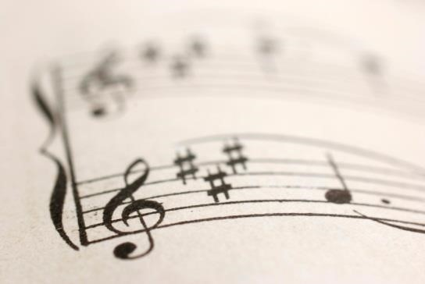

### EXTENSION

1. Find examples of ten different types of word that need capital letters.
2. Explain your choice of categories.

**IS IT A SENTENCE?**

*A key issue in knowing where to put full stops and capital letters is being able to recognise what is and is not a sentence. Again, you have known this for a while now - but this remains an issue for many writers, even at GCSE Grade. So, let’s see if we can’t sort it out once and for all.*

* A sentence is a complete unit of meaning. It makes sense by itself.
* A sentence needs a **SUBJECT** – a person, place or thing that the sentence is about.
* A sentence needs a **VERB** – an action or state of being (as in “was happy”).
* In a complete sentence, you can tell when the action took place: in the past (it happen**ed**); in the present (it happen**s**); in the future (it **will** happen).

### TASK

Decide whether each example is a proper sentence or an incorrect one by putting a tick or a cross next to them.

1. Ludwig Van Beethoven was a German composer.
2. He composed nine famous symphonies.
3. He’s great.
4. The symphony that most people most admire.
5. He also composed many string quartets, taking the form to a peak of expressivity and flexibility.
6. Having composed many piano sonatas.
7. Less well known for his operas than Mozart, he, nonetheless, composed one – Fidelio – which is still performed today.
8. Wrote the famous ninth symphony, with its ‘Ode to Joy’.
9. Beethoven – a man with extraordinary talent.
10. His deafness, which he hated.

### EXTENSION

1. For each incorrect example you found, state WHY it is incorrect.
2. Rewrite the incorrect examples so that they are proper sentences.

## NOUNS

*In order to work out what is and is not a sentence, some knowledge of the different types of word can be helpful. So, what are nouns, anyway?*

* A noun is often called a **naming word**.
* Nouns are the words that name **people, places and things**.
* The subject of a sentence may well be a noun.
* **Proper nouns** are the names of particular people and places: Eleanor, Richard, Alison, Plymouth, Hull, Oxford, Stokesley. They have a capital letter at the start.
* **Common nouns** name things and general places: chair, table, cat, garden, house, road.

### TASK

Underline the noun(s) in each sentence.

1. 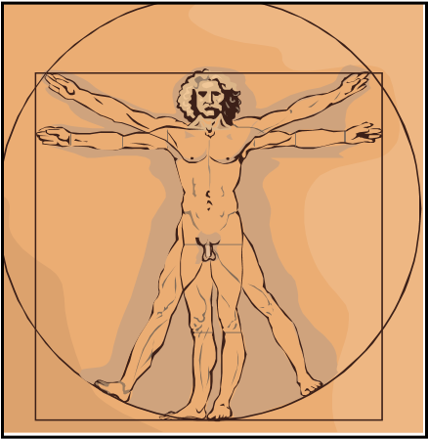Leonardo da Vinci is the greatest genius in world history.
2. He painted pictures of angels and strange women.
3. He lived in Florence for many years.
4. He did experiments.
5. He drew pictures of moving water.
6. He designed a giant bronze statue of a horse.
7. He invented a helicopter.
8. He studied plants and animals very carefully.
9. He worked in Milan.
10. He painted The Mona Lisa.
11. He studied the human body, making diagrams of the heart and the eye.
12. When he was a baby, a bird of prey landed on his cradle and brushed its feathers against his face.
13. As a young boy, he once got lost in a cave and feared that there might be a monster inside.
14. He painted The Last Supper, which showed Jesus and his disciples.
15. He inspired the book *The Da Vinci Code*.

### EXTENSION

1. List which are proper nouns and which are common nouns.
2. Do some research and find out what other categories of nouns there are (for example, abstract and concrete) and list examples of these categories.

## VERBS

*OK, nouns are easy. But what are verbs? Being able to spot verbs is vital in understanding what is and what is not a sentence, as every sentence needs a verb.*

* A verb is often called a **doing word**.
* It is the word that tells you what the main action of the sentence is: ate, ran, jumps, likes, will take, etc.
* The verb “to be” is a key verb. “Is” and “was” are part of this verb. These words are often the main verb in a sentence. They tell us about *states of being*.

### TASK A

Underline the verbs in each sentence.

1. Socrates was a famous philosopher.
2. He lived in ancient Greece.
3. He argued with people about the meaning of life.
4. He questioned people about their beliefs.
5. He often proved that they were confused.
6. His behaviour annoyed lots of people.
7. In the end, they arrested him.
8. They did not like being made fools of.
9. Socrates said that he only knew one thing, and that was that he knew nothing.
10. He drank hemlock and died.

### TASK B

Copy the following sentences into your English book, correcting the verbs as you do so.

1. Cricket be the most elevating of pastimes.
2. It are a game that required concentration.
3. It were most sophisticated and subtle.
4. Cricket cans still be exciting.
5. It involving many ups and downs.
6. Spin bowling are an art form.

### EXTENSION

1. Do some research. Find out about some different types and parts of verbs.
2. Design and write a leaflet to explain all about how verbs work.

## ADJECTIVES & ADVERBS

*Now you have the basic building blocks of a sentence, you can start to add the descriptive details. Adjectives and adverbs are the two main descriptive words.*

### TASK A

**Adjectives**

•

Adjectives

**describe nouns**

. They describe the colours and sizes of things and much more

besides.

*Example*

*s*

:

red, green, tall, big, angry

Complete these sentences by adding a suitable adjective in the space provided. Underline the adjectives in each sentence.

1. Shakespeare was a brilliant writer, who wrote _____________ plays.
2. He used detailed language in a very ______________ way.
3. *Macbeth* is a spooky play, with some _____________ witches.
4. *Hamlet* is magnificent, being his ____________ play.
5. *King Lear* is about a mad king and his ___________ daughters.
6. Romeo is a young lover, who is ____________.
7. Juliet is charming and ___________.
8. Foolish Bottom, turns into a ______________ donkey.
9. Richard III is an evil tyrant, who tricks his __________ brother.
10. *The Tempest* features the lively Ariel, who is a _____________ spirit.

**TASK B**

### Adverbs

* Adverbs **describe verbs**. They describe the way that something is done.

*Examples*: carelessly, foolishly, slowly, rapidly

* Many adverbs end in ‘–ly’, but not all of them. Not all words that end in ‘–ly’ are adverbs.

Complete these adverbs by adding a suitable adverb in the space provided. Underline the adverbs in each sentence.

1. Someone loudly blew a trumpet, and everyone ___________ made for the Globe Theatre.
2. The groundlings noisily entered, whilst the actors __________ waited.
3. The sophisticated members of the audience sat quietly in the covered seats, but the groundlings ___________ interrupted the play.
4. If it suddenly rained, the groundlings would __________ complain, because there was no cover over where they stood.
5. Shakespeare cleverly wrote his plays to appeal to both audiences, so he ____________ included both action and philosophy.
6. The actor loudly spoke, but the thunder __________ rumbled.
7. The rain came down heavily, and the audience _________ ran.
8. Falstaff behaved badly, which the groundlings _________ cheered.

## APOSTROPHES

*Apostrophes are simple really. There are only two ways they should be used. Don’t overuse them!*

### TASK A

**Apostrophe of Omission**

•

Use an apostrophe where you have

**missed**

**letter**

**(**

**s)**

out of a word. The apostrophe goes

where the missing letter(s) should have been.

*Example:*

Do not

→

don’t.

Add apostrophes to the following sentences where they belong.

1. 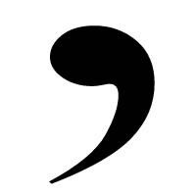I dont know what the meaning of life is.
2. I cant tell you what the meaning of life is.
3. I couldnt attend your philosophy class.
4. I wouldnt worry about it.
5. I shouldnt have missed it.
6. I shant tell on you.
7. It isnt good to miss important lessons.
8. Youre a good student, so you mustnt worry.
9. Weve got a very old car that often breaks down.
10. Ive got some notes that you can copy up.

**TASK B**

### Apostrophe of Possession

* Use an apostrophe before an ‘s’ to show that something **belongs** to someone or something. *Example:* Paul’s bike
* If the word already ends in ‘s’, you can just add an apostrophe at the end. *Example:* James’ bike.
* **REMEMBER:** Most words that end in ‘s’ do not have an apostrophe! Only use one to show that something belongs to someone.

Add apostrophes to the following sentences where they belong.

1. That is Pauls bike.
2. Socrates pupil was Plato.
3. Platos pupil was Aristotle.
4. Aristotles pupil was Alexander the Great.
5. Alexanders aim was to conquer the world.
6. His soldiers skills were famous throughout the world.
7. Persias army could not defeat Alexander.
8. Alexanders troops wanted to go home.
9. The elephants were surprised to see Alexander.
10. The chariots wheel fell off.

## SPEECH

*Setting out speech accurately in stories is important. You need to follow the rules here, in order to make sure that your writing is clear.*

* Each new speech should begin on a new line.

* There should be speech marks **before and after** the words actually spoken.
* The speech should end with a punctuation mark – a full stop if you do not go on to say who is speaking; a comma if you do go on to say who is speaking. The punctuation mark should come **before** the final speech marks.

*Example:* “Hello,” said Don.

“How are you?” asked Frank.

Don thought for a minute then said, “Fine, I guess.”

“Really?”

“Yeah,” Don began, “but I am a bit tired.”

### TASK

Copy the following sentences. Set them out and punctuate them correctly.

1. Where does the Minotaur live, asked Theseus. Under the palace said Ariadne in a weird labyrinth. Is it hard to find your way out? Theseus wondered. Nearly impossible said Ariadne.
2. What exactly is the Minotaur? asked Theseus. Ariadne began to explain it’s a terrible secret. My mother fell in love with a bull. Theseus was amazed. A bull? That sounds weird. It was, said Ariadne, especially when she had a child by the bull.
3. Why did she fall in love with a bull? Theseus asked. It was a curse put upon her, explained Ariadne, by a god. You see my father should have sacrificed his best bull to the gods, but he was so proud of the bull that he couldn’t bring himself to kill it. So the gods punished him, Theseus interrupted, by making your mother fall in love with the bull. How terrible!
4. And, Ariadne continued, when the child was born, it was half man, half bull. Like a monster!

cried Theseus. Yes, replied Ariadne, and my parents were so ashamed of it that they hid it in the labyrinth.

1. But why do we have to send people to your kingdom every few years, asked Theseus. I think you know, replied Ariadne. To feed the Minotaur? Yes.
2. I am going to put a stop to this, vowed Theseus. Ariadne looked worried. But how? she asked. I am going to kill the Minotaur. You’ll never succeed. Why not? wondered Theseus. Because, Ariadne replied, you’ll get lost in the labyrinth. No-one can find their way out. It was designed by Daedalus, a most cunning engineer. But wait, she added, I might be able to help you.

## COMMAS

**TASK A**

**Commas in a List**

•

You need to use commas in your writing. The simplest use of commas is to mark off items

in list.

*Example*

:

I like English,

maths

, science and French

.

Place commas in these sentences where they belong.

1. The Minotaur had a huge head horns fur and hooves.



1. His eyes were red yellow and sickly green.
2. His horns were huge sharp and covered in blood.
3. He had sharp teeth a fierce bellow and a terrible temper.
4. His hands were gnarled blood-stained and strong.
5. Angry terrified and confused he charged at Theseus.
6. Theseus was brave strong determined skilful clever.
7. Thesues’ sharp glinting threatening sword swung through the air.
8. The Minotaur pawed the earth snorted through his huge nostrils and began to charge towards Theseus.
9. Theseus shouted a loud curse raised his sword and smashed it down onto the Minotaur’s huge skull.

**1-5 correct: Copy the rules for using commas in your book.**

**6- 10 correct: Write a number of sentences about your school which include lists within them.**

**Make sure that you include the commas where they belong.**

**TASK B**

### Commas in Speech

* Commas are used at the end of speeches, within the speech marks; when you go on to say who is speaking.
* If you say who is speaking first, the comma comes before the first speech marks.

Place commas in these sentences where they belong.

1. “Use this thread” said Ariadne.
2. “I don’t understand” said Theseus.
3. “Unroll the thread as you walk through the labyrinth” explained Ariadne.
4. “I can do that easily” boasted Theseus.
5. Ariadne explained “You will be able to follow the thread.”
6. Theseus asked “How will that help?”
7. Ariadne sighed “Oh, Theseus, don’t you get it?”
8. “Oh, I see” said Theseus “I can follow the thread out.”

|  |
| --- |
| **EXTENSION**    Write a conversation between Ariadne and Theseus, in which Theseus explains how he killed the    Minotaur and escaped. Make sure you use commas correctly. |

## CORRECTING A PASSAGE

*Here’s a test for you! Try to put all the skills you have used in the previous exercises together here.*

### TASK

Copy the passage below, correcting all of the mistakes as you go along.

#### REMEMBER

* Full stops
* Capital letters
* Apostrophes
* Speech
* Commas

ariadne was in love with theseus she wanted to run away with him after he killed the minotaur i have helped you she said now you can do something for me what is it asked theseus take me away from this cold unhappy palace marry me and we can live together happily ever after theseus did not love ariadne but he didnt know how to tell her youve helped me a lot so i guess i cant say no well sail at midnight youll need to get ready quickly

ariadnes face lit up she hurried into her fathers palace and grabbed her bag her coat and her favourite book she rushed down to the harbour and onto theseus ship

through the dark silent night theseus ship sailed silently slowly secretly the sea was calm still and gentle a light easy breeze stirred the sails steadily i cant believe that were here together said ariadne excitedly theseus just stared moodily into the darkness he was distracted he forgot that he had promised his father that he would change the colour of the sails from black to white if he survived

they had sailed out of the harbour well rest on the nearest island until dawn said theseus everyone disembarked and set up camp on the cool soft spacious sands

the next morning ariadne woke up late she was expecting to see theseus men on the beach she was expecting to see theseus ship anchored nearby however what she did see was a wide empty expanse of nothing there was the silent sea the lonely sand and the fluffy clouds floating across the blue beautiful sky there were no sailors there was no ship there was no theseus ariadne cried out in horror where are you my husband how could you do this to me how could you abandon me

theseus was miles away he had sneaked away like a cunning untrustworthy selfish coward he was sailing towards home still showing the black sails that would say to his father that he had failed so the final tragedy was about to happen when theseus father saw the black sails and could not bear to live anymore

**SECTION 2: READING**

# What you need to do

* **SELECT** information to show that you **UNDERSTAND** a text.

* Read between the lines, picking up on **HINTS** in a text:

**INFER** and **DEDUCE.**

* Comment on the **STRUCTURE** of a text.

* Comment on the **LANGUAGE** of a text.

* Comment on the **OVERALL INTENTIONS** and **EFFECTS** of a text.



## READING 1: ‘La Belle Dame Sans Merci’

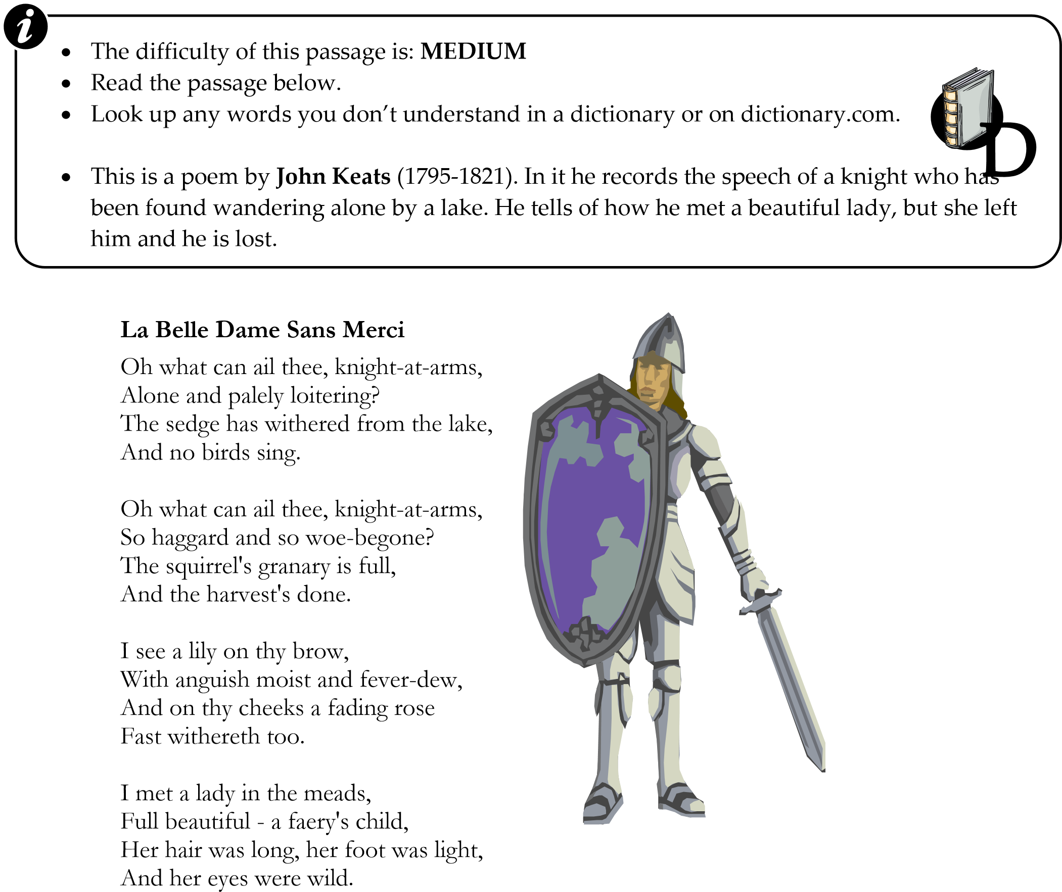

I made a garland for her head,

And bracelets too, and fragrant zone;

She looked at me as she did love, And made sweet moan.

I set her on my pacing steed,

And nothing else saw all day long, For sidelong would she bend, and sing A faery's song.

She found me roots of relish sweet,

And honey wild, and manna-dew, And sure in language strange she said – 'I love thee true'.

She took me to her elfin grot,

And there she wept and sighed full sore, And there I shut her wild, wild eyes, With kisses four.

And there she lulled me asleep

And there I dreamed - Ah! woe betide! - The latest dream I ever dreamt On the cold hill side.

I saw pale kings and princes too,

Pale warriors, death-pale were they all;

They cried - 'La Belle Dame sans Merci

Hath thee in thrall!'

I saw their starved lips in the gloam,

With horrid warning gaped wide, And I awoke and found me here, On the cold hill's side.

And this is why I sojourn here

Alone and palely loitering,

Though the sedge is withered from the lake, And no birds sing.

-John Keats-

### TASK

Answer **at least one** question in each section.

Answer questions at different Grades if you wish.

#### SELECT AND RETRIEVE

GRADE 4: What does the speaker call the Knight?

GRADE 5: What is the Knight doing in the first verse?

GRADE 6: Which plant is mentioned in the first verse?

GRADE 7: How many negative words can you find in the poem?

#### INFER AND DEDUCE

GRADE 4: How does the Knight feel at the start?

GRADE 5: Why did the Knight go with the lady? GRADE 6: How did the lady trick the Knight?

GRADE 7: What exactly happened to the Knight?

#### STRUCTURE

GRADE 4: How does the poem start and end?

GRADE 5: Why does the poem start and end as it does?

GRADE 6: How does the poem contrast different moods?

GRADE 7: Why does Keats structure his poem as he does?

#### LANGUAGE

GRADE 4: Which words create a mood at the start of the poem?

GRADE 5: What does this phrase make you feel/think: “with horrid warning gaped wide?” GRADE 6: How does Keats use language to create a mood?

GRADE 7: How does Keats use language to depict the Knight’s state of mind?

#### OVERALL EFFECT

GRADE 4: What is your response to the poem?

GRADE 5: What is Keats’ message in the poem?

GRADE 6: Why did Keats set his poem in olden times?

GRADE 7: What does the poem tell us about love and relationships?

## READING 2: ‘Araby’

* The difficulty of this passage is: **MEDIUM** • Read the passage below.
* Look up any words you don’t understand in a dictionary or on dictionary.com.

* This is the end of a story by **James Joyce** (1882-1941). In the story a boy is keen to go to a special market (or bazaar) to buy a present for a girl whom he likes. He gets delayed and very frustrated. By the time he gets to the bazaar it is closing down, and he realises that he was foolish to get so excited about going.



*Dubliners* by James Joyce; Penguin Classics (1996); ISBN-10: 0140622179

I could not find any sixpenny entrance and, fearing that the bazaar would be closed, I passed in quickly through a turnstile, handing a shilling to a weary-looking man. I found myself in a big hall girded at half its height by a gallery. Nearly all the stalls were closed and the greater part of the hall was in darkness. I recognized a silence like that which pervades a church after a service. I walked into the centre of the bazaar timidly. A few people were gathered about the stalls which were still open. Before a curtain, over which the words *Café Chantant* were written in coloured lamps, two men were counting money on a salver. I listened to the fall of the coins.

Remembering with difficulty why I had come, I went over to one of the stalls and examined porcelain vases and flowered tea-sets. At the door of the stall a young lady was talking and laughing with two young gentlemen. I remarked their English accents and listened vaguely to their conversation.

'O, I never said such a thing!'

'O, but you did!'

'O, but I didn't!'

'Didn't she say that?'

'Yes. I heard her.'

'O, there's a... fib!'

Observing me, the young lady came over and asked me did I wish to buy anything. The tone of her voice was not encouraging; she seemed to have spoken to me out of a sense of duty. I looked humbly at the great jars that stood like eastern guards at either side of the dark entrance to the stall and murmured:

'No, thank you.'

The young lady changed the position of one of the vases and went back to the two young men. They began to talk of the same subject. Once or twice the young lady glanced at me over her shoulder.

I lingered before her stall, though I knew my stay was useless, to make my interest in her wares seem the more real. Then I turned away slowly and walked down the middle of the bazaar. I allowed the two pennies to fall against the sixpence in my pocket. I heard a voice call from one end of the gallery that the light was out. The upper part of the hall was now completely dark.

Gazing up into the darkness I saw myself as a creature driven and derided by vanity; and my eyes burned with anguish and anger.

### TASK

Answer **at least one** question in each section.

Answer questions at different Grades if you wish.

#### SELECT AND RETRIEVE

GRADE 4: Which entrance can the boy not find?

GRADE 5: What is the name of the café in the bazaar?

GRADE 6: How much money does the boy have with him?

GRADE 7: Select one detail that tells you that the bazaar is nearly closed.

#### INFER AND DEDUCE

GRADE 4: Why does the boy go in at an expensive entrance?

GRADE 5: What is the mood of the young lady at the stall?

GRADE 6: Why does the boy linger at the stall?

GRADE 7: Why does the boy feel so angry at the end?

#### STRUCTURE

GRADE 4: Why does Joyce describe the bazaar in the first paragraph of this section?

GRADE 5: Why does Joyce include the conversation in the middle of the section?

GRADE 6: How does Joyce create contrasts in this section? GRADE 7: How does Joyce build up to the final sentence?

#### LANGUAGE

GRADE 4: Which words in the last sentence tell us how the boy feels? GRADE 5: Which words in the first paragraph create an atmosphere?

GRADE 6: How does Joyce’s language create a sense of hopelessness? GRADE 7: How does Joyce’s language reflect the feelings of the boy?

#### OVERALL EFFECT

GRADE 4: What do you feel as you read this section?

GRADE 5: What does Joyce want you to feel about the boy?

GRADE 6: How does Joyce make us care about what happens? GRADE 7: What is Joyce’s message in this story?

### EXTENSION

1. Read some more of Joyce’s stories in his book *Dubliners*.
2. Write your own story about a child who is disappointed by how things turn out.
3. Try to write the first part of this story. What do you think happened before this concluding section? How can you make your writing fit with Joyce’s style here?

## READING 3: ‘The Badger’

* The difficulty of this passage is: **EASY** • Read the passage below.
* Look up any words you don’t understand in a dictionary or on dictionary.com.

* This poem is by **John Clare** (1793-1864). In it he describes how men hunt a badger with dogs.



### The Badger

When midnight comes a host of dogs and men

Go out and track the badger to his den, And put a sack within the hole, and lie Till the old grunting badger passes by.

He comes and hears - they let the strongest loose.

The old fox hears the noise and drops the goose. The poacher shoots and hurries from the cry, And the old hare half wounded buzzes by.

They get a forked stick to bear him down

And clap the dogs and take him to the town,

And bait him all the day with many dogs,

And laugh and shout and fright the scampering hogs.

He runs along and bites at all he meets:

They shout and hollo down the noisy streets.

He turns about to face the loud uproar And drives the rebels to their very door.

The frequent stone is hurled where'er they go; When badgers fight, then everyone's a foe.

The dogs are clapped and urged to join the fray.

The badger turns and drives them all away.

Though scarcely half as big, demure and small, He fights with dogs for hours and beats them all. The heavy mastiff, savage in the fray,

Lies down and licks his feet and turns away. The bulldog knows his match and waxes cold, The badger grins and never leaves his hold.

He drives the crowd and follows at their heels

And bites them through – the drunkard swears and reels.

The frighted women take the boys away.

The blackguard laughs and hurries on the fray. He tries to reach the woods, and awkward race, But sticks and cudgels quickly stop the chase. He turns again and drives the noisy crowd And beats the many dogs in noises loud.

He drives away and beats them every one, And then they loose them all and set them on.

He falls as dead and kicked by boys and men,

Then starts and grins and drives the crowd again;

Till kicked and torn and beaten out he lies

And leaves his hold and cackles, groans, and dies.

-John Clare-

What time does the hunt begin?

What do they put in the badger’s hole?

Who hears the noise of the hunt?

Who and what does the badger beat or scare in the poem?

#### INFER AND DEDUCE

GRADE 4: What does John Clare feel about the badger?

GRADE 5: Why does John Clare mention everyone and everything hearing the hunt?

GRADE 6: What impression do you get of the badger from the poem?

GRADE 7: What does John Clare think of the people? How can you tell?

#### STRUCTURE

GRADE 4: Why does the poem begin at the time it starts?

GRADE 5: How does the poem build up tension and drama?

GRADE 6: Why does the poem end as it does?

GRADE 7: Why does the poem repeat so much about the fighting badger?

#### LANGUAGE

GRADE 4: What are the key words used to describe the badger?

GRADE 5: How does Clare’s language create contrasts?

GRADE 6: How does Clare’s language manipulate your emotions?

GRADE 7: How does Clare’s language make the scene seem vivid and powerful?

#### OVERALL EFFECT

GRADE 4: What does Clare want us to think about the badger?

GRADE 5: How does Clare use the poem to make a protest?

GRADE 6: How does Clare make us share his opinions?

GRADE 7: What is Clare’s message in the poem? How can you tell?

#### EXTENSION

1. Write your own poem about hunting.
2. Write a response to the poem from a hunter – it could be a letter or a poem – saying what Clare got wrong. Write a letter to a newspaper protesting about people who take pleasure in harming animals.

## READING 4: ‘Infant Sorrow’ and ‘Infant Joy’

* The difficulty of this passage is: **EASY** • Read the passage below.
* Look up any words you don’t understand in a dictionary or on dictionary.com.

* These two poems were written by **William Blake** (1757-1827) for his book *Songs of Innocence* *and Experience.* In them he contrasts two types of child.



### Infant Sorrow

My mother groaned, my father wept,

Into the dangerous world I leapt; Helpless, naked, piping loud, Like a fiend hid in a cloud.

Struggling in my father's hands,

Striving against my swaddling bands, Bound and weary, I thought best To sulk upon my mother's breast.

-William Blake-

### Infant Joy

"I have no name: I am but two days old." What shall I call thee?

"I happy am,

Joy is my name." Sweet joy befall thee!

Pretty Joy!

Sweet Joy, but two days old.

Sweet Joy I call thee:

Thou dost smile,

I sing the while, Sweet joy befall thee!

-William Blake-

Pick out three negative words in ‘Infant Sorrow’.

Which is the most powerful line in ‘Infant Sorrow’?

Select a metaphor or simile from either poem.

Select the strongest words in each poem. Explain the effect they have.

#### INFER AND DEDUCE

GRADE 4: Why is the child in ‘Infant Sorrow’ unhappy?

GRADE 5: How can you tell that the parents in ‘Infant Joy’ love their child?

GRADE 6: Why does Blake show the babies talking?

GRADE 7: How does Blake suggest that what happens to you as a baby can affect your whole life?

#### STRUCTURE

GRADE 4: Why does Blake begin ‘Infant Sorrow’ as he does?

GRADE 5: Why does he use repetition in ‘Infant Joy’?

GRADE 6: How are the structures of the poems different? GRADE 7: Why are the structures of the poems different?

#### LANGUAGE

GRADE 4: What are the key words in ‘Infant Joy’?

GRADE 5: What are the key words in ‘Infant Sorrow’?

GRADE 6: How does Blake use language in ‘Infant Sorrow’ to affect our feelings? GRADE 7: How does Blake use language differently in the two poems?

#### OVERALL EFFECT

GRADE 4: What feelings do the two poems give you?

GRADE 5: How do the poems differ?

GRADE 6: What is Blake’s message in these two poems?

GRADE 7: One poem is a song of experience, the other a song of innocence. Which is which? How can you tell? What is the difference between experience and innocence?

#### EXTENSION

1. Read some more of Blake’s poems. Write about your responses to them.
2. Write your own pair of poems about childhood pleasures and pains.
3. Draw an image to illustrate each poem.
4. Find a copy of Blake’s own illustrations for these poems. What do you think of them?

**READING 5: *A Christmas Carol***



* + The difficulty of this passage is: **MEDIUM** • Read the passage below.
  + Look up any words you don’t understand in a dictionary or on dictionary.com.

* + This is a passage from *A Christmas Carol* by **Charles Dickens** (1812-1870). In this famous book, Dickens depicts the miserable Scrooge, who hates Christmas. He is visited by ghosts, who make him change his ways. Here, early in the book, Dickens describes Scrooge.

Oh! But he was a tight-fisted hand at the grind-stone, Scrooge! a squeezing, wrenching, grasping, scraping, clutching, covetous, old sinner! Hard and sharp as flint, from which no steel had ever struck out generous fire; secret, and self-contained, and solitary as an oyster. The cold within him froze his old features, nipped his pointed nose, shriveled his cheek, stiffened his gait; made his eyes red, his thin lips blue and spoke out shrewdly in his grating voice. A frosty rime was on his head, and on his eyebrows, and his wiry chin. He carried his own low temperature always about with him; he iced his office in the dogdays; and didn't thaw it one degree at Christmas.

External heat and cold had little influence on Scrooge. No warmth could warm, no wintry weather chill him. No wind that blew was bitterer than he, no falling snow was more intent upon its purpose, no pelting rain less open to entreaty. Foul weather didn't know where to have him. The heaviest rain, and snow, and hail, and sleet, could boast of the advantage over him in only one respect. They often "came down" handsomely, and Scrooge never did.

Nobody ever stopped him in the street to say, with gladsome looks, "My dear Scrooge, how are you? When will you come to see me?" No beggars implored him to bestow a trifle, no children asked him what it was o'clock, no man or woman ever once in all his life inquired the way to such and such a place, of Scrooge. Even the blind men's dogs appeared to know him; and when they saw him coming on, would tug their owners into doorways and up courts; and then would wag their tails as though they said, "No eye at all is better than an evil eye, dark master!"

But what did Scrooge care? It was the very thing he liked. To edge his way along the crowded paths of life, warning all human sympathy to keep its distance, was what the knowing ones call "nuts" to Scrooge.

Pick out one detail that shows how unappealing Scrooge is.

Pick out one metaphor or simile that Dickens uses to describe Scrooge.

List as many negative words as you can find in the passage.

Select the strongest phrase in the passage. Why did you choose it?

##### INFER AND DEDUCE

GRADE 4: What is Scrooge’s attitude to money?

GRADE 5: Why do the blind men’s dogs avoid Scrooge?

GRADE 6: Why does Dickens refer so much to the weather here?

GRADE 7: Why does Dickens spend so long telling us about Scrooge?

##### STRUCTURE

GRADE 4: Why does Dickens begin the section as he does?

GRADE 5: Why does Dickens end the section as he does?

GRADE 6: How does Dickens build up to a climax here?

GRADE 7: What are the reasons for the different paragraph breaks here?

##### LANGUAGE

GRADE 4: What does “hand at the grindstone” suggest?

GRADE 5: List some of examples of Dickens’ descriptive language.

GRADE 6: Explain the effects of some of Dickens’ negative language. GRADE 7: How does Dickens manipulate his readers here?

##### OVERALL EFFECT

GRADE 4: What is Dickens telling us about Scrooge?

GRADE 5: What is Dickens’ overall message in the story?

GRADE 6: Why does Dickens put Scrooge in a Christmas story?

GRADE 7: How does Dickens make us think about our own attitudes here?

#### EXTENSION

1. Read the rest of *A Christmas Carol*.
2. Write your own Christmas story.
3. Watch some different films based on the book. Write about which is best.
4. Write a character description of a person who is the total opposite to Scrooge.
5. Try to write some other parts of Scrooge’s story yourself. Try copying Dickens’ style.

## READING 6: ‘Ozymandias’



* The difficulty of this passage is: **MEDIUM** • Read the passage below.
* Look up any words you don’t understand in a dictionary or on dictionary.com.

* This poem was written by **Percy Bysshe Shelley** (1792-1822). In it he describes a ruined statue that was found in the desert. It is all that remains of a once huge city. The inscription on the base of the statue tells us that it was a statue of a great and proud ruler. Now his boast about how great his city is sounds like a warning to other rulers that the same thing might happen to their kingdoms.

### ‘Ozymandias’

I met a traveller from an antique land

Who said: Two vast and trunkless legs of stone

Stand in the desert. Near them, on the sand,

Half sunk, a shattered visage lies, whose frown,

And wrinkled lip, and sneer of cold command,

Tell that its sculptor well those passions read,

Which yet survive, stamped on these lifeless things, The hand that mocked them, and the heart that fed, And on the pedestal these words appear:

"My name is Ozymandias, King of Kings:

Look upon my works, ye Mighty, and despair!"

Nothing beside remains. Round the decay Of that colossal wreck, boundless and bare

The lone and Grade sands stretch far away.

-Percy Bysshe Shelley-

Pick out one detail that describes the statue.

Pick out one detail that describes the king.

Pick out one detail that suggests that the king was proud.

Pick out any details that tell you what Shelley’s message might be.

#### INFER AND DEDUCE

GRADE 4: What does the word “sneer” suggest about the king?

GRADE 5: Why did Ozymandias call himself “king of kings”?

GRADE 6: Why did Ozymandias say “Look on my works, ye Mighty, and despair”?

GRADE 7: What do the words “Look on my works, ye Mighty, and despair” mean now?

#### STRUCTURE

GRADE 4: Why does the poem end as it does?

GRADE 5: Why does the poem begin as it does?

GRADE 6: How does the poem create contrasts?

GRADE 7: The poem is a sonnet. What is a sonnet? How and why does Shelley use that structure here?

#### LANGUAGE

GRADE 4: What are the negative words in the poem?

GRADE 5: How does Shelley’s language convey his feelings about proud kings?

GRADE 6: How does Shelley’s language create a sense of emptiness? GRADE 7: What poetic devices does Shelley use? To what effect?

#### OVERALL EFFECT

GRADE 4: What is your response to the poem?

GRADE 5: What is Shelley’s message?

GRADE 6: What kind of man do you think Shelley was?

GRADE 7: How does Shelley manipulate our feelings and thoughts?

#### EXTENSION

1. Write an archaeologist’s report about the finds in the desert.
2. Write a description of Ozymandias’ city when it was new.
3. Write your own story or poem about a cruel leader.
4. Write your description of an ideal leader.

## READING 7: ‘The Sack of Troy’

* The difficulty of this passage is: **MEDIUM** • Read the passage below.
* Look up any words you don’t understand in a dictionary or on dictionary.com.

* This is a modern version of the story of how Troy was destroyed. After a long siege, the Greeks tricked the Trojans with a wooden horse. The Trojans thought it was a peace offering, and they took it into the city to be burned for the gods. The Greeks who hid in the horse let the rest of the army into the city, and so it was destroyed. Cassandra had warned the Trojans not to take the horse in, but she was cursed to see the future but to never be believed.



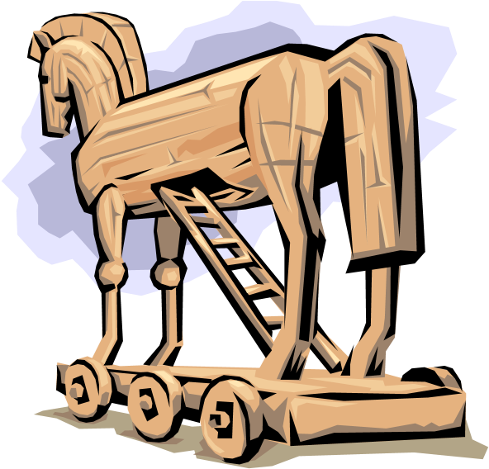Through the dark and silent streets, four Greek warriors secretly hurried. Each sped swiftly to one of the four massive gates that had barred the way for so long. At the same time, the Greek ships were stealthily returning to the Trojan shoreline, and the masses of armed soldiers were disembarking. The battalions huddled together in the darkness, awaiting the signal from within the city, feeling tense but exhilarated, scarcely daring to believe that Odysseus’s audacious plan could work. What would the night have in store for them? Would the Trojans put up a fight or would they just tamely surrender, once they knew that their defences had been breached? Certainly, after all the celebrating that had taken place in Troy that evening, few of the Trojan warriors would be ready for a fight – to a man they lay in drunken sleep, little imagining that the hour of their defeat was at hand.

Suddenly, a torch was hurled high above the main gate. The Greeks recognised the sign and scurried rapidly towards the town. There it was – the main gate to the city: wide open. Other regiments found the other gateways similarly gaping. Troy was at their mercy. Once the bands of men had assembled at each corner of the city, as confirmed by the owl hoots that each team leader made in turn, Odysseus himself let out a wild whoop of joy and release, which was echoed by the thousand cries of the Greek soldiers, as they charged headlong into the city, waving swords and torches about their heads. Soon buildings were ablaze; sleepy grooms lay dead, their throats cut with a single swipe of a blade; the Trojans, first singly and confused, then in groups and in increasing panic, were emerging from their homes to see what was causing the commotion. Greeks were everywhere, flying through the streets and alleys in murderous fury. It seemed, suddenly, that the whole city was on fire. The blackness of the starless night had given way to a wayward orange glow – as the flames leaped higher, ripping through the timber houses and flaring wildly when they reached the straw roofs.

Panic spread through Troy faster than the flames. At once, the city was a mad rush of people, fleeing they knew not where. Women, men and children were all made victims of the Greeks’ swords. Years of frustration and pent up rage were released in a single hour of merciless violence. No one was to be spared. An old man, staggering across the market place, in search of his family, was run through by a well-aimed spear. Three teenage fighters, struggling to buckle on their armour, as they stumbled from their barracks, were downed in a hail of spiteful arrows. The gutters ran red with blood. The screams of horrified innocents curdled the air. The Trojans had no chance.

From a balcony at the front of the palace, Cassandra watched in helpless misery, as the conflagration and the bloodshed spread relentlessly towards her. It was little comfort to her now, to know that she had been right all along. She held tightly to the balcony rail, the whites of her knuckles bulging, as her desperate grip strengthened. Her head was bowed; tears streamed down her cheeks; her teeth were gritted; her face was a frozen mask of pain.

Below her she saw, in the courtyard before the palace, the huge wooden horse, its belly gaping wide open, its massive shape silhouetted by the angry glow of the fires that were bursting from the adjacent buildings. Cassandra looked up to the blank night sky and let out a mad, horrified scream of pain: everything she knew, all that she had ever cared about, was coming to an end before her eyes.

### TASK

Answer **at least one** question in each section.

Answer questions at different Grades if you wish.

#### SELECT AND RETRIEVE

GRADE 4: Who gives the signal for the Greeks to enter the city?

GRADE 5: Who predicted that this would happen?

GRADE 6: Whose plan was it?

GRADE 7: Write out one effective sentence. Why did you choose this example?

#### INFER AND DEDUCE

GRADE 4: How can you tell that the Trojans were unprepared?

GRADE 5: How does Cassandra feel about what she sees?

GRADE 6: Why did the Greeks destroy Troy?

GRADE 7: Why might you feel sorry for the Trojans?

#### STRUCTURE

GRADE 4: Why does the writer end by mentioning the horse?

GRADE 5: Why does the writer mention Cassandra near the end of the passage?

GRADE 6: How is the passage structured to create tension and drama? GRADE 7: How does the passage rise to a climax?

#### LANGUAGE

GRADE 4: How does the writer create a sense of panic in his language?

GRADE 5: How does the writer’s language convey strong emotion in the last paragraph?

GRADE 6: How does the writer’s language make you sympathise with the Trojans? GRADE 7: What techniques does the writer use? To what effect?

#### OVERALL EFFECT

GRADE 4: What does the writer expect you to feel about the events in the passage?

GRADE 5: How does the writer suggest that this event was a tragedy?

GRADE 6: What did the writer want the readers to feel and think about violence when they read this piece?

GRADE 7: What is the writer’s message?

**EXTENSION**

Write a description of the morning after the destruction.

## READING 8: ‘Pay the Penalty’



* The difficulty of this passage is: **EASY** • Read the passage below.
* Look up any words you don’t understand in a dictionary or on dictionary.com.

* This is a section from a story about a boy called Charlie and his problems and triumphs on the football pitch. This comes early in the story and sets up Charlie’s main worries for the rest of the story.

Charlie picked himself up and wiped the mud from his face. Jonesy handed him the ball: “Here,” he said, “you won us the penalty; you’d better take it.” Charlie couldn’t believe it: he’d never taken a pen before; it was the last minute of normal time; this was United’s only chance to equalise and stay in the Under 15’s cup.

“No,” said Charlie, weakly, but no-one seemed to hear him.

Charlie carefully placed the ball on the spot, noticing as he did just how muddy and cut up the ground was in the penalty area. Looking up, into the keeper’s face, he saw his hard, mean, piggy little eyes staring back at him. Suddenly, this ordinary boy seemed to take on giant proportions: his hands seemed like dinner plates; his thick-set body blotted out most of the goal mouth. Waves of anxiety crashed over Charlie. “If I look to the left,” he thought, “the keeper will think that I’m going to place it that way, and he’ll dive to that side; then I can trick him and slam it into the empty right hand side. But, hang on,” Charlie reasoned, “surely the goalie will guess that I’m tricking him, so he’ll cover the right hand side, knowing that’s where I’m going to place it. So, I’d be better to go left after all. But what if he just does the obvious and falls for the trick …”

Sweat was dripping down Charlie’s forehead. He could hear the brothers and sisters of the team members chanting his name. “Go on Charlie!” muttered some of his team mates. The ref blew his whistle. This was it. Heart pounding, breath panting, legs a little wobbly, he started his run up: his moment of truth!

Just as he was about to strike the ball, Charlie felt the ground slip beneath his standing foot. With his whole body tilting awkwardly, he kicked the ball high into the air and way over the bar.

From his undignified position on his back in the mud, he could hear the groans, the jeers and the cheers of the opposition. The referee was blowing his whistle for full time. It was all over. United had lost, and it was all Charlie’s fault.

Smudge’s voice was the first he heard distinctly: “You idiot!” he bellowed. “Why did you take that pen? Anyone else would have scored, anyone!” Then all the others joined in, blaming him, questioning why he had taken the penalty at all. Hopelessly, he tried to explain that it wasn’t his idea, but no-one was listening. Even Jonesy, whose idea it had actually been, now turned on him: “Have you ever even taken a pen before?” he asked fiercely. Charlie knew now that he would never live this moment down.

How many times has Charlie taken a penalty before?

Select two details that tell you that the pitch is muddy.

Select one sentence that shows you that Charlie is nervous.

Select one sentence that builds up the tension of the story.

### INFER AND DEDUCE

GRADE 4: Why does the writer mention how many penalties Charlie had taken before?

GRADE 5: How does Charlie feel before he takes the penalty?

GRADE 6: Why does Jonesy join in the complaints at the end?

GRADE 7: What different emotions does Charlie feel in this section of the story?

### STRUCTURE

GRADE 4: Why does the writer describe Charlie’s thoughts before he takes the penalty?

GRADE 5: How does the writer build up tension in this section?

GRADE 6: Compare the first and last paragraphs of this section. GRADE 7: How does this section set up the rest of the story?

### LANGUAGE

GRADE 4: Which words tell us how Charlie feels?

GRADE 5: How does the writer describe the goalkeeper?

GRADE 6: Which words help to build up the tension?

GRADE 7: Which techniques does the writer use? To what effect?

### OVERALL EFFECT

GRADE 4: What is your response to this passage?

GRADE 5: How does the writer make you sympathise with Charlie?

GRADE 6: How does the writer help you get inside Charlie’s thoughts? GRADE 7: What are the writer’s key aims in this section?

### EXTENSION

1. Continue the story from here. Say what will happen next.
2. Write your own story about a sporting event.
3. Write an imagined radio commentary for United’s match, covering the awarding and taking of the penalty.

## READING 9: ‘Pyramus and Thisbe’



* The difficulty of this passage is: **MEDIUM** • Read the passage below.
* Look up any words you don’t understand in a dictionary or on dictionary.com.

* This is a modern version of a famous Greek story. In it, Pyramus and Thisbe fall in love, but their parents try to keep them apart. So they agree to meet secretly in the woods. Thisbe is frightened away by a lion, which chews on a scarf that she dropped. When Pyramus arrives, he sees the lion chewing the scarf, covering it with blood from an animal it killed earlier. Pyramus recognises the scarf and assumes that Thisbe has been eaten.

Suddenly, Pyramus’ feelings changed from fear to despair. He forgot his worries about whether the lion might attack him, as he was overcome with feelings of horror and wretched misery. The more he looked, the more he was certain: the turquoise scarf that the lion was contentedly munching on was the very one that Pyramus had given to his beloved Thisbe as a token of his undying love. Oblivious to Pyramus’s presence, the king of the beasts concentrated on trying to get the fabric of the scarf out of his huge teeth. What was clear to Pyramus was that the beautiful green-blue silk was heavily stained with gobbets and splashes of crimson. How could Pyramus know that the blood really belonged to the unlucky deer that the lion had felled after Thisbe had made her safe retreat? For Pyramus, only one explanation seemed possible: the blood was Thisbe’s; the lion had killed and eaten her.

Feeling that he was about to faint, Pyramus stumbled, then collapsed onto the stony ground. Flashing through his brain like lightning were dozens of remembered images: he saw Thisbe’s sweet, shy smile; he saw the wall through which they had secretly exchanged their vows of love; he saw his parents sternly warning him to stay away from the daughter of their loathed enemy. All this had happened so quickly, so helplessly. And now this: was this the end?

“Oh, why, why did I delay?” howled the hopeless Pyramus. “Why couldn’t I have arrived first? You lion, you wretched, thoughtless, brute beast: how I would have dealt with you!” Pyramus threatened, reaching for the sword that hung by his side. “But no, you had to take your chance, didn’t you? To pick on a defenceless girl! Coward! Miserable, cruel, evil creature!” But the lion seemed not to hear Pyramus’ wild cries.

“Come on!” shouted Pyramus, “Kill me now, lion. Let me join my one true love. Without her, my life seems pointless, empty, barren.” Boldly, carelessly, Pyramus approached the gnawing animal, but the lion was no longer hungry. It glanced up at Pyramus and snorted. As Pyramus didn’t take the hint, the lion slowly heaved itself onto its four legs and slunk away into the forest, leaving the raving mad man behind him.

Dejected, exhausted, desperate, Pyramus slumped against a tree. Tossing his sword to the ground, he wept for his lost love. “Ah, Thisbe, Thisbe, how can I go on without you?” he cried. Blinking through his tears, he saw the sun glinting from his sword by his feet. Suddenly, a terrible, inevitable thought struck him.

question in each section.

Grades if you wish.

Whose scarf is the lion chewing?

Who gave the scarf as a present?

What does Pyramus remember about his relationship with Thisbe?

Which details describe Pyramus’ emotions?

### INFER AND DEDUCE

GRADE 4: Why does Pyramus hate the lion?

GRADE 5: Why is the lion not interested in Pyramus?

GRADE 6: How can you tell that Pyramus really loves Thisbe? GRADE 7: What will happen next?

### STRUCTURE

GRADE 4: How can you tell that this is from the middle of a story?

GRADE 5: What is the topic for each of the paragraphs?

GRADE 6: Why does the writer spend so long describing Pyramus’ feelings? GRADE 7: Why does the writer end this section as he does?

### LANGUAGE

GRADE 4: Which words convey Pyramus’ feelings?

GRADE 5: How does the writer’s language make us sympathise with Pyramus?

GRADE 6: How does the writer’s language create tension?

GRADE 7: What techniques does the writer use? To what effect?

### OVERALL EFFECT

GRADE 4: What is your response to this section?

GRADE 5: What message is the writer trying to convey?

GRADE 6: What does this passage tell you about love?

GRADE 7: How does the writer make the passage interesting?

### EXTENSION

1. Write the next section of the story.
2. Write your own love story.
3. Read some more Greek myths and legends. Write about your responses.

## READING 10: ‘Life is a Rollercoaster!’

•

The difficulty of this passage is:

**EASY**

•

Read the passage below.

•

Look up any words you don’t understand in a dictionary or on dictionary.com.

•

This is an extract from an article

, in which

she describes her fears and excitem

ent about

going on a theme park ride.



Queuing for hours, stepping in vomit, having your ears burst by the cries and wails of ungrateful children: sound like fun? Welcome to the world of the theme park! And yes, people – me included – travel for miles and pay good money to subject themselves to this sort of torture. Why do I put myself through it? Why must I?

The air rushes through my flowing hair; my stomach is doing back flips; my blood is pumping through my veins; my adrenaline is surging through my every fibre: I’m up at the top, teetering on the edge, then woooosh! Down I go, plunging into an abyss of nothingness, only to suddenly hit a pool of water and feel the fresh shower of water slap me in the face and leave me soaked to the bone. Oh, boy, you just have to love this trip: every nerve, every sinew, every part of my little frame is tense, shaken, thrilled. I love a rollercoaster; I adore a theme park ride. Nothing matches the excitement of this amazing turbulence. I’m an addict and I don’t care who knows it!

Why do we love a fright? What makes us seek out terror? It’s the same instinct that makes us read a horror story or peak from behind the cushions at Doctor Who or fall in love with the very worst possible person in the world. We just have to take a risk; it’s the only way to feel alive!

What is bad about being at a theme park?

What will the writer do to go on a rollercoaster?

What does the writer compare the ride to?

Which details convey the writer’s enthusiasm?

### INFER AND DEDUCE

GRADE 4: Why does the writer go to theme parks?

GRADE 5: Is the writer serious about theme parks? How can you tell?

GRADE 6: Who is the author writing this piece for?

GRADE 7: What does the writer expect us to think of her?

### STRUCTURE

GRADE 4: What contrasts does the piece contain?

GRADE 5: Why does the piece begin as it does?

GRADE 6: What is the main topic in each paragraph?

GRADE 7: How does the piece’s structure affect the reader?

### LANGUAGE

GRADE 4: What strong language does the writer use?

GRADE 5: How does the writer express her emotions?

GRADE 6: How does the writer create a sense of excitement?

GRADE 7: What techniques does the writer use? To what effect?

### OVERALL EFFECT

GRADE 4: What is the writer’s main message?

GRADE 5: How does the writer portray herself in the passage?

GRADE 6: How does the writer manipulate the reader in the passage?

GRADE 7: What kind of person is the writer? What is appealing about her?

### EXTENSION

1. Write your own piece about being at a theme park.
2. Write about one of your own interests in a similar way.

**SECTION 3: WRITING**

# What you need to do

* Be **IMAGINATIVE**

* Write for particular **AUDIENCES** and **PURPOSES.**

* **ORGANISE** the whole text: beginning, middle, end, etc.

* Use and links **PARAGRAPHS.**

* Vary **SENTENCE** lengths and structures.

* **PUNCTUATE** accurately.

* Use a wide **VOCABULARY.**

* **SPELL** accurately.

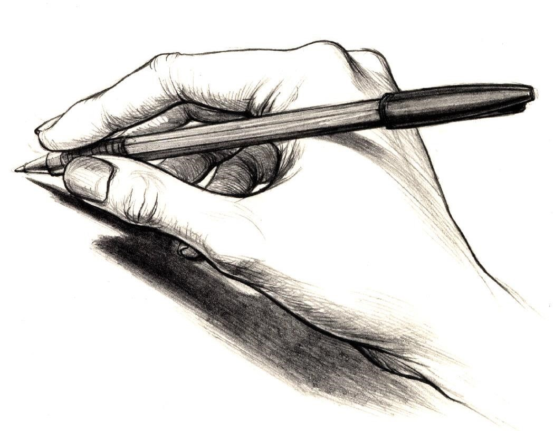

**WRITING TASKS**

## WRITING TASK 1



**TASK:**

Write a review of your favourite television programme for

a

magazine aimed at

12

-

14

year

olds.

**AUDIENCE:**

1

2

-

14

year olds

–

so make it lively, relevant, funny, etc.

**FORM:**

Magazine

–

so include headings, boxes, pictures, captions, a clear opening.

**PURPOSE:**

To review/inform/persuade

–

persuade them that you’re right!

**ASSESSMENT CRITERIA:**

### GRADE THREE

* Simple sentences will be correct.
* Some full stops will be used.
* There may be some blocks of text separated from other parts.
* There will be basic content words to describe the programme.

### GRADE FOUR

* Some long sentences will be used.
* A few commas will be included.
* There may be an opening paragraph and some other sections.
* The vocabulary will be more persuasive and refer to details.

### GRADE FIVE

* A variety of sentences will be used: long and short.
* Commas will be used to divide different clauses.
* There will be subheadings, separate sections and paragraphs.
* A variety of words to describe the style and content will be used.

### GRADE SIX

* Longer sentence structures will be used accurately.
* Commas will be used effectively.
* Paragraphs will start with link words.
* The vocabulary will be strong and persuasive and funny.

### GRADE SEVEN

A full range of sentence types and structures will be included.

Commas will be used to create interesting effects.

There will be lots of variety in paragraphs, boxes, subsections, etc. Vocabulary will include sophisticated terminology

## WRITING TASK 2

**TASK:**

Write a short story about your first day at secondary school.

**AUDIENCE:**

Pupils in Year 6

–

so don’t patronise or scare them.

**FORM:**

Story

–

so describe places, people,

feelings, etc.

**PURPOSE:**

To entertain and inform

–

include details, but make it lively.

**ASSESSMENT CRITERIA:**

### GRADE THREE

* Simple sentences will be correct.
* Some full stops will be used.
* There may be a sense of an opening and conclusion.
* The vocabulary will include obvious objects from school.

### GRADE FOUR

* Some long sentences will be used.
* A few commas will be included.
* There may be an opening paragraph that sets out key points.
* The vocabulary may include references to feelings.

### GRADE FIVE

* A variety of sentences will be used: long and short.
* Commas will be used to divide different clauses.
* Paragraphs will be used to show changes in time and place.
* Interesting vocabulary about personal perceptions will be included.

### GRADE SIX

* Longer sentence structures will be used accurately.
* Commas will be used effectively.
* Paragraphs will focus on opinions and emotions.
* Vocabulary will be clever and personal.

### GRADE SEVEN

A full range of sentence types and structures will be included.

Commas will be used to create interesting effects.

Paragraphs will be used to create drama and suspense.

Impressive vocabulary about people, places and ideas will be used.

## WRITING TASK 3

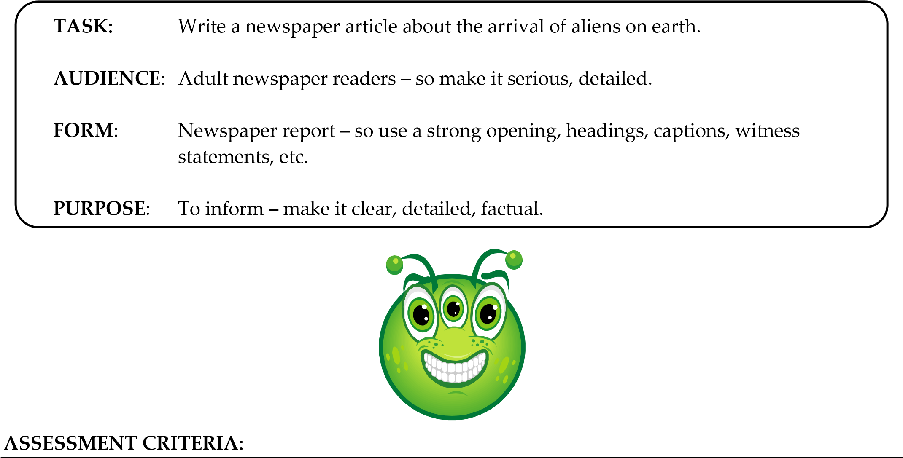

### GRADE THREE

* Simple sentences will be correct.
* Some full stops will be used.
* There may be a clear opening section.
* The vocabulary may include basic references to what has happened.

### GRADE FOUR

* Some long sentences will be used.
* A few commas will be included.
* There will be some paragraph breaks.
* The vocabulary will be more mature and serious.

### GRADE FIVE

* A variety of sentences will be used: long and short.
* Commas will be used to divide different clauses.
* Paragraphs will be used to structure the story and round it off.
* A variety of vocabulary will reflect different responses to the event.

### GRADE SIX

* Longer sentence structures will be used accurately.
* Commas will be used effectively.
* The opening will include all key points; witness statements come later.
* The vocabulary will be appropriately sensational.

### GRADE SEVEN

A full range of sentence types and structures will be included.

Commas will be used to create interesting effects.

Paragraphs will be of varied lengths and clear topics.

Vocabulary will be varied in conveying the drama of events.

## WRITING TASK 4

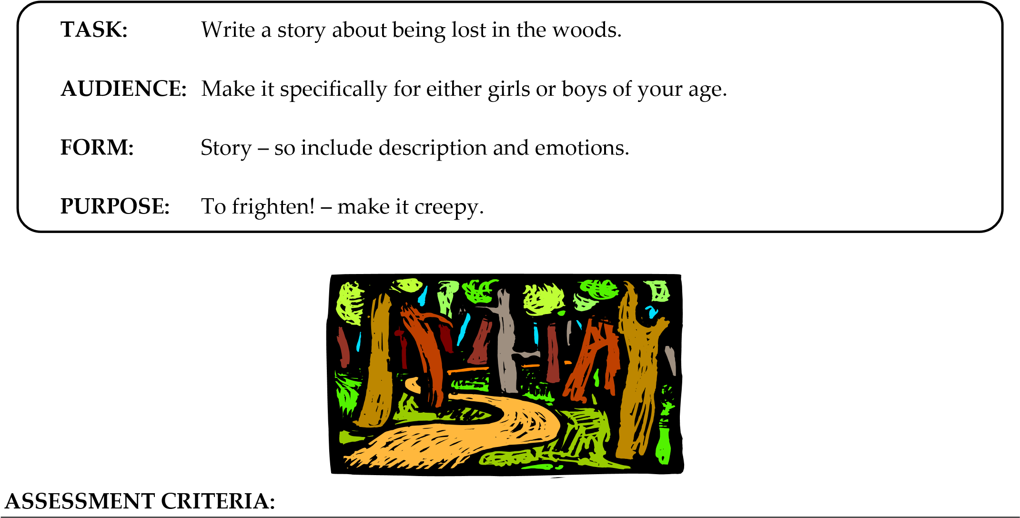

### GRADE THREE

* Simple sentences will be correct.
* Some full stops will be used.
* There may be a sense of a beginning and conclusion.
* The vocabulary will give the basic facts.

### GRADE FOUR

* Some long sentences will be used.
* A few commas will be included.
* Paragraphs will be used to show different parts of the story.
* The vocabulary will include some emotive language.

### GRADE FIVE

* A variety of sentences will be used: long and short.
* Commas will be used to divide different clauses. • Paragraphs will be used when the topic changes.
* Vocabulary will be used to create a sinister effect.

### GRADE SIX

* Longer sentence structures will be used accurately.
* Commas will be used effectively.
* Paragraphs will be linked to show the progress of events.
* Vocabulary will reflect feelings and create atmosphere.

### GRADE SEVEN

A full range of sentence types and structures will be included.

Commas will be used to create interesting effects.

Paragraphs will be used to add to the sense of drama.

Vocabulary will hook the readers and control their reactions.

## 

## WRITING TASK 5



**TASK:**

Write a letter to local residents protesting that your school is going to be

knocked down to build a motorway.

**AUDIENCE:**

Adult homeowners (especially parents)

–

make them care about the iss

ue; they

need to see that it will be bad for them.

**FORM:**

Formal letter

–

so

set it out correctly, start directly

**,**

etc.

**PURPOSE:**

To i

nform, argue and persuade

–

use strong, powerful language and lots of

examples; you want them to join your campaign to sav

e the school.

**ASSESSMENT CRITERIA:**

### GRADE THREE

* Simple sentences will be correct.
* Some full stops will be used.
* There may be an introduction and conclusion.
* The vocabulary will feature simple facts about the case.

### GRADE FOUR

* Some long sentences will be used.
* A few commas will be included.
* There will be some paragraphing, marking off different points.
* The vocabulary will be more persuasive and memorable.

### GRADE FIVE

* A variety of sentences will be used: long and short.
* Commas will be used to divide different clauses.
* Paragraphs will mark changes in topic and inclusion of anecdotes.
* Vocabulary will be strong and specific.

### GRADE SIX

* Longer sentence structures will be used accurately.
* Commas will be used effectively.
* Paragraphs will be linked to show how the argument progresses.
* Vocabulary will make the audience react emotionally to the situation.

### GRADE SEVEN

A full range of sentence types and structures will be included.

Commas will be used to create interesting effects.

Paragraphs will be varied in length and will be used to create drama.

Vocabulary will be powerful and addressed directly to the homeowners’ concerns.

## WRITING TASK 6

**TASK:**

Write an advice leaflet telling a 7 year old

about

how to look after a pet

–

choose

a specific pet, if you like.

**AUDIENCE:**

7

year olds

–

so keep fairly simple

–

but not too basic.

**FORM:**

Leaflet

–

so use headings, bullet points, images, etc.

**PURPOSE:**

To advise

–

make it clear, specific, step

-

by

-

step.

**ASSESSMENT CRITERIA:**

### GRADE THREE

* Simple sentences will be correct.
* Some full stops will be used.
* There may be some separate sections.
* The vocabulary may simply record basic information.

### GRADE FOUR

* Some long sentences will be used.
* A few commas will be included.
* There will be some paragraphs for different sections.
* The vocabulary will be more descriptive and detailed.

### GRADE FIVE

* A variety of sentences will be used: long and short.
* Commas will be used to divide different clauses.
* Paragraphs will be used to mark off different ideas.
* Vocabulary will be friendly and supportive.

### GRADE SIX

* Longer sentence structures will be used accurately.
* Commas will be used effectively.
* Paragraphs will be linked as they describe different steps for success.
* The vocabulary will suit the young children, being fun and humorous.

### GRADE SEVEN

A full range of sentence types and structures will be included.

Commas will be used to create interesting effects.

Paragraphs will vary according to purpose – with boxes and lists, etc.

Vocabulary will be specific and detailed, with difficult words explained.

## WRITING TASK 7

**TASK:**

Write a letter to your headteacher asking for more school trips.

**AUDIENCE:**

The headteacher

–

so keep it respectful and formal.

**FORM:**

Formal letter

–

so

set it out correctly, start directly.

**PURPOSE:**

To p

ersuade and argue

–

use strong language, give examples.

**ASSESSMENT CRITERIA:**

### GRADE THREE

* Simple sentences will be correct.
* Some full stops will be used.
* There may some sense of an opening and conclusion.
* The vocabulary may be too basic for the task.

### GRADE FOUR

* Some long sentences will be used.
* A few commas will be included.
* There will be some paragraph breaks.
* The vocabulary will be more suitable for the formal purpose.

### GRADE FIVE

* A variety of sentences will be used: long and short.
* Commas will be used to divide different clauses.
* Paragraphs will mark changes in topic and focus.
* Interesting vocabulary will catch the head’s attention.

### GRADE SIX

* Longer sentence structures will be used accurately.
* Commas will be used effectively.
* Paragraphs will be linked into a coherent argument.
* More varied and mature vocabulary will be used to impress the head.

### GRADE SEVEN

A full range of sentence types and structures will be included.

Commas will be used to create interesting effects.

Paragraphs will be used in creative ways to create surprises and emphasis.

Very impressive vocabulary will be included to persuade the head.

## WRITING TASK 8

**TASK:**

Describe a place where you have been on

holiday.

**AUDIENCE:**

Holidaymakers, travellers

–

so make it refer to what will be interesting to

people who are interested in travel.

**FORM:**

A travel magazine

–

so

describe the place so that people feel

as if

they are there.

**PURPOSE:**

To inform and explain

–

make it detailed.

**ASSESSMENT CRITERIA:**

### GRADE THREE

* Simple sentences will be correct.
* Some full stops will be used.
* There may some sense of different sections.
* The vocabulary will give simple facts about the place.

### GRADE FOUR

* Some long sentences will be used.
* A few commas will be included.
* There will be some signs of paragraphing to show different topics.
* The vocabulary will be more specific.

### GRADE FIVE

* A variety of sentences will be used: long and short.
* Commas will be used to divide different clauses.
* Paragraphs will show changes in focus and topic.
* Vocabulary will be descriptive.

### GRADE SIX

* Longer sentence structures will be used accurately.
* Commas will be used effectively.
* Paragraphs will be linked by an overall feeling or idea.
* Vocabulary will vary as different parts of the place are described.

### GRADE SEVEN

A full range of sentence types and structures will be included.

Commas will be used to create interesting effects.

Paragraphs will create interesting contrasts and twists.

Vocabulary will be vigorous, exciting, varied.

## WRITING TASK 9

**TASK**

:

Write a leaflet telling people how they can help save the natural environment.

**AUDIENCE**

:

Aim it at car

-

owners and homeowners

–

so refer to what they can do about their

cars and

homes.

**FORM:**

Leaflet

–

so use bullet points, pictures, lists, etc.

**PURPOSE:**

To p

ersuade and advise

–

make it strong but supportive.

**ASSESSMENT CRITERIA:**



### GRADE THREE

* Simple sentences will be correct.
* Some full stops will be used.
* There may some sense of different sections.
* The vocabulary may be factual.

### GRADE FOUR

* Some long sentences will be used.
* A few commas will be included.
* There will be some paragraph breaks.
* The vocabulary will be more persuasive.

### GRADE FIVE

* A variety of sentences will be used: long and short. • Commas will be used to divide different clauses.
* Paragraphs will be clearly used to shape the leaflet.
* Vocabulary will attract attention and shape responses.

### GRADE SIX

* Longer sentence structures will be used accurately.
* Commas will be used effectively.
* Paragraphs will be varied – with boxes and lists, etc.
* More detailed and persuasive language will be used.

### GRADE SEVEN

A full range of sentence types and structures will be included.

Commas will be used to create interesting effects.

Paragraphs will be used to create memorable, surprising effects. Vocabulary will appeal to the audience’s interests and concerns.

## WRITING TASK 10

**TASK:**

Write a first chapter of a story about an animal.

**AUDIENCE:**

Aim it at 13 year old girls or boys

–

so make it fit the gender you choose.

**FORM:**

Make it the first c

hapter of a novel

–

so set things up but don’t conclude

anything; focus on characters and settings.

**PURPOSE:**

To entertain

–

make it emotional, descriptive, action

-

packed.

**ASSESSME**

**NT CRITERIA:**

### GRADE THREE

* Simple sentences will be correct.
* Some full stops will be used.
* There may some sense of structure – a beginning, for example.
* The vocabulary may be mostly basic and factual.

### GRADE FOUR

* Some long sentences will be used.
* A few commas will be included.
* There will be some use of paragraphs to show topic changes.
* The vocabulary will be more descriptive.

### GRADE FIVE

* A variety of sentences will be used: long and short.
* Commas will be used to divide different clauses.
* Paragraphs will structure the story, dividing description from action.
* Interesting vocabulary will create emotional responses.

### GRADE SIX

* Longer sentence structures will be used accurately.
* Commas will be used effectively.
* Paragraphs will show how the story progresses, whilst being linked.
* Varied and mature vocabulary will excite and surprise the readers.

### GRADE SEVEN

A full range of sentence types and structures will be included.

Commas will be used to create interesting effects.

Paragraphs will be used to create suspense and surprises.

Very impressive vocabulary will engage and grip the readers.

## SECTION 4: SPELLING

*What can you do to improve your spelling? Here are some strategies for you to try and a task for you to complete, which will let you try the strategies out.*

### 1. Look/Say/Cover/Write/Check

This is the most efficient way to learn a spelling. Look at the correct spelling. Say it out loud – perhaps emphasising the letters used by pronouncing the word in an exaggerated way. Cover up the correct spelling. See if you can write out the correct spelling without looking. Check if you got it right. Repeat the process to make sure that it wasn’t a fluke! The more often you do this, the more likely it is that the word will stick.

### 2. Common Patterns

Look for common letter patterns in words and try to learn them. Look at ‘–tion’ endings; ‘–ed’ endings; double letters, etc. The exercises here will help with this.

### 3. Learn your Phonics

You need to know which letters make which sounds. Most letters can make a range of different sounds, especially the vowels – ‘a’, ‘e’, ‘i’, ‘o’, ‘u’. Think also about clusters of letters that make particular sounds – ‘sh’, ‘sn’, ‘ch’, ‘ght’, and many more!

### 4. Look for words within words

Sometimes long words can be broken down into sections of smaller words. If you know how to spell the short words, then you can piece together the long one. The famously long word “antidisestablishmentarianism” is basically the word “establish” with lots of prefixes and suffixes, for example.

### 5. Mnemonics

These are sentences that you use to help you remember something. For example, you might give a word to each letter in a difficult spelling: **B**ig **E**lephants **C**annot **A**lways **U**se **S**mall **E**ntrances – **BECAUSE!** Try inventing some of your own for words that you have struggled with.

### 6. Play word games

Crosswords, word searches, anagrams, Scrabble, and any number of other word games can be a fun way to expand your vocabulary and get you thinking about spelling.

### TASK

Take the information here and turn it into a bright and interesting leaflet that could be given out to Year 7 students to help them with their spellings.

### 1 i before e

* Probably the most famous spelling rule in English is: ***i before e, except after c***. It means that in most words you will find ‘i’ is followed by ‘e’, not the other way round. However, in words that have the letter ‘c’ before the ‘ie’/’ei’ combination, the rule is reversed, so ‘e’ comes before ‘i’.

*Examples:* believe, achieve, relieve – all ‘i’ before ‘e’

*Examples*: receive, deceive, conceive – all ‘e’ before ‘i’, because of the ‘c’.

* **BUT**, there are exceptions. We will look at them on the next page!



#### TASK

Choose the correct spelling of each word below and write it . Check your answer in a dictionary or at dictionary.com.

1. a) achieve 5. a) niecce 9. a) conceeve

1. acheive b) neice b) concieve



1. acheeve c) neece c) conceive
2. acheve d) niece d) conceve

2.. a) frend 6. a) relieve 10. a) ceeling

1. freind b) releive b) ceiling
2. friend c) relleeeve c) cieling
3. frenid d) releve d) celing

1. a) feeld 7. a) peece 11. a) preceeve
   1. feild b) peice b) percieve
   2. field c) piece c) perceve
   3. feld d) pecie d) perceive

1. a) greef 8. a) receive 12. a) receipt
   1. greif b) receeve b) recipt
   2. grief c) recieve c) reciept
   3. grefi d) receve d) recept

### SPELLING 2: i before e – the exceptions

•

*i before e except after c*

is a helpful rule, because it will lead to you getting most words right

that fit that pattern.

•

However, there are exceptions. There are words that ought to be

‘

ie

’

but are

‘

ei

’

.

•

All the examples on this page are

**exceptions**

, so they

**disobey**

the rule.

**TASK**

Choose the correct spelling

of each word below and write it

.

Check your answer in a

dictionary or at dictionary.com.



1. a) weight 5. a) wierd 9. a) foraign
   1. wieght b) weerd b) foreiegn
   2. waight c) werde c) foreign
   3. weieght d) weird d) foriegn

1. a) heieght 6. a) freight 10. a) reign b) hight b) freieght b) riegn
   1. hieght c) frieght c) reiegn
   2. height d) fraight d) raign

1. a) seeze 7. a) ieght 11. a) lesure
   1. sieze b) aight b) liesure
   2. seize c) eieght c) leiesure
   3. seiese d) eight d) leisure

1. a) wier 8. a) eiether 12. a) viel b) weir b) either b) veil
   1. weer c) iether c) veiel
   2. wiere d) eether d) vail

#### EXTENSION

Design some posters to illustrate the exceptions to the rule. Think of some mnemonics to help students remember the correct spellings.

### 3 –ed endings

* As spellings go, these ought to be easy enough, but they seem to cause trouble, nonetheless.
* Many verbs take an ‘–ed’ ending when they are in the past tense – depicting events that have already happened.

*Examples:* happens → happened

chases → chased

* It’s simple enough to turn present tense verbs into past, but practice makes perfect, I guess. Plus there are some exceptions.

#### TASK

Write down the following verbs. Write the past tense of each verb next to it.

1. trembles → _________________________
2. fumbles → _________________________
3. escapes → _________________________
4. changes → _________________________
5. rearranges → _________________________
6. scrapes → _________________________
7. makes → _________________________
8. takes → _________________________
9. shakes → _________________________
10. wakes → _________________________
11. fakes → _________________________
12. loses → _________________________
13. fails → _________________________
14. sails → _________________________
15. cries → _________________________
16. walks → _________________________
17. talks → _________________________
18. runs → _________________________
19. speaks → _________________________
20. shivers → _________________________

#### EXTENSION

1. Make a list of all the exceptions from the list above.
2. Make a list of as many other exceptions as you can think of.
3. Make some posters to illustrate how the past tense is formed and how some words are irregular.

### 4 –tion/–sion/–cion

#### TASK

* ‘–tion’ endings are common in English.

* Young children tend to make wild guesses about how to make the ‘–tion’ sound.
* Here is a chance for you to practise that particular pattern.

*Example:* A description of the meaning of a word is called a definition.

Complete each sentence by adding the correct missing word. They all feature the ‘–tion’ ending.

1. A place where you catch a train is called a __________________.
2. A piece of writing that describes someone is called a __________________.
3. If you are naughty, you might get a __________________.
4. When you want someone to listen, you have to get their __________________.
5. Keeping your mind on your work means keeping your __________________.
6. In the mirror, you would see your __________________.
7. A detective needs to do some __________________.
8. The ball hit a defender and went into the net from the __________________.
9. Use sun-cream for __________________.
10. If you catch a disease, you have an __________________.
11. When you react, you show a __________________.
12. The inspector carried out an __________________.
13. When you make a mistake, you should do your __________________.
14. Love is a kind of __________________.
15. We get to vote in an __________________.

**TASK**

•

Not al

l words that include the sound ‘

–

tion

’

use the letter

‘

t

’

.

*Example*

*:*

If you extend something, you have an

exten

sion

.

Complete the following sentences by adding the correct missing word. They use a different letter combination to make the ‘–tion’ sound.

1. If you suspend something, you have a __________________.
2. You measure something to find its __________________.
3. If you suspect something, you have a __________________.
4. If you decide something, you make a __________________.
5. If you revise something, you do your __________________.
6. If you submit something, you make a __________________.
7. If you are a spy with a job to do, you’re on a __________________.
8. If you are precise, you show __________________.

**EXTENSION**

Try to write an explanation of why you might use ‘–tion’, ‘–sion’ or ‘–cion’ in the examples

### 5 –gh/–ght

• Another common pattern in many spellings is ‘–gh’ and ‘–ght’.

*Examples:* If you find something funny, you **laugh.**

If you think about something, you have a **thought.**

#### TASK A

Complete each sentence by adding the correct missing word. They all feature the ‘–ght’ ending.

1. If someone teaches you, you have been __________________.
2. If you get nothing, you get __________________.
3. One more than seven is __________________.
4. If you were seeking, you have __________________.
5. If you like boxing, you like a __________________.
6. After the evening, comes the __________________.
7. A medieval soldier could be a __________________.
8. Another word for power is __________________.
9. If you are clever, you are __________________.
10. The opposite of heavy is __________________.
11. An island off the south coast of England is the Isle of __________________.
12. If you are scared, you are __________________.
13. The opposite of loose is __________________.
14. If you make a catch, you have __________________.
15. If you bring something, you have __________________.
16. If you should do something, you __________________.
17. If you were in a battle, you have __________________.
18. If you can see, you have __________________.
19. If you measure how high something is, you find out its __________________.
20. If you find out how heavy something is, you discover its __________________.
21. If there is no rain, there may be a __________________.

#### TASK B

Complete each sentence by adding the correct missing word. They all feature the ‘–gh’ ending.

1. The opposite of smooth is __________________.
2. If you go from one end of a tunnel to the other, you go __________________.
3. If you do something really well, you do it __________________.
4. Animals eat from a __________________.
5. If a puzzle is hard, you call it __________________.

|  |
| --- |
| **EXTENSION**  Can you find any other examples of words that use ‘–gh’ or ‘–ght’? |

### 6 Sound-a-likes

* Homophones are words that sound alike but are spelt differently.
* They are a common source of mistakes when writers choose the wrong one.

*Example:* To decide who gets what is to allot**.** To have many is to have a lot.

#### TASK

Complete each set of sentences by adding the correct missing words.

1. To speak up is to speak __________________

To be permitted is to be __________________

1. If you say you did go somewhere, you say you have __________________

In tomato sauce, you might find a baked __________________

1. The name of a colour __________________

What the wind did __________________

1. A piece of wood is a __________________

When you are not having fun, you are __________________

1. If you smash something, you will see it __________________

If you slow a bike down, you use the __________________

1. You walk on __________________

At the shops, you __________________

You say, good __________________

1. An obstacle __________________

Something that is rough is __________________

1. You start a letter with __________________
   1. woodland animal is a __________________
2. A white powdery food stuff __________________

Something that grows in the garden __________________

1. Something you can do with cheese __________________

Something which is very good is __________________

1. On your head, you have __________________

An animal, a bit like a rabbit __________________

1. A group of animals is a __________________

If you listened, you would have __________________

1. The place we are in is __________________

When you listen, you __________________

1. Referring to a man, you would mention __________________
   1. song sung in church is a __________________
2. You might dig a __________________

If you have two halves, you have a __________________

1. A word that is short for an aeroplane __________________
   1. type of chocolate __________________
2. Seven days make a __________________

The opposite of strong is __________________

1. The second person is __________________ A type of tree is __________________
   1. female sheep __________________

### 7 Problem Words

*Some spellings cause special problems. Try to learn which spelling to use from the examples below.*

**TASK A**

There, their, they’re

* **There** is the most common spelling. It refers to places – over **there**. It also works in sentences like: **there** are four sides on a square.
* **Their** refers only to situations when something belongs to some people – the house belongs to them; it is **their** house.
* **They’re** is short for ‘they are' – **they’re** coming to see us today.

Add in the correct missing words.

1. The entrance is over __________.
2. It is __________ turn.
3. __________ very busy today.
4. I don’t like Macdonald’s; I dislike __________ burgers.
5. How many are __________?
6. __________ is no excuse.
7. __________ on __________ way.
8. What is __________ to do here?
9. Why are __________ no British teams in the finals?
10. I like the way they play __________ instruments.

**TASK**

**B**

**Your, you’re**

•

**Your**

means belongs to you

–

that’s

**your**

pencil.

•

**You’re**

is short for

‘

you are

’

–

**you’re**

coming to see us today.

Add in the correct missing words.

1. It was ______ fault.
2. ______ not playing very well today.
3. ______ very busy today.
4. I don’t like ______ hair cut.
5. Which is ______ painting?

**TASK**

**C**

**Its, it’s**

•

**It’s**

is short for

‘

it is

’

–

**it’s**

Tuesday.

•

**Its**

refers to something belonging to it

–

the dog likes

**its**

bone.

Add in the correct missing words.

1. ____ time to go home.
2. Look at the chair. You have bent ____ leg.
3. ____ always raining.
4. I don’t like the carpet. ____ pattern is too busy.
5. The sun has got ____ hat on.

### 8 Your Own List

*The best way to improve your spelling is to work on your own mistakes.*

**TASK**

**A**

Look back over

y

our writing from recent months

. Look in books for all subjects, not just

English.



* List a number of different spelling errors that you made.
* Use a dictionary or dictionary.com on the internet to check what the correct spelling is.
* Try to spot patterns in your mistakes. Do you have problems with particular patterns – like ‘–tion’? Do you get your double letters wrong? Do you mix up vowels or consonants?
* Use the **Look,** **Say, Cover, Write, Check** method to learn the correct spellings.
* Get someone to test you.
* Spend time learning any words that you still get wrong.
* Try to invent mnemonics to help you remember some of these words.

*Example:* ***R****hythm* ***H****elps* ***Y****our* ***T****wo* ***H****ips* ***M****ove –* **RHYTHM**!

**IMPORTANT:**

* Once you know the spelling, you need to make an effort to use it in some of your writing. Otherwise, you will probably forget the spelling again.
* Get someone to test you again after a week or so. You need to make sure that you haven’t forgotten any spellings.

|  |
| --- |
| Now you need to keep an eye on your spelling all the time. Every time you make a mistake in any  writing for any subject, you need to check what the correct spelling is and learn it.    Occasionally, get someone to test you on words that you have made mistakes on over the recent months.    If you do a little work on spelling each day – 5 minutes, for example – you will make a difference to your spelling. |

* Flick through the dictionary. Look for tricky words.



**TASK**

**B**

You don’t just have to wait until you make mistakes.



* , list difficult spellings that you come across in your reading.
* With the vocabulary exercises that follow, you will – of course – have to learn how to spell the words that you are learning to understand and use.

**The best thing that you can do to help your spelling is: take an interest in words; think about words; talk about words; play with words; ask about words; wonder about words.**

## SECTION 5: VOCABULARY



### Introduction

*Expanding your vocabulary is a key part of developing into a mature writer. You need to be able to say more and say things more precisely. Many people will judge your intelligence and maturity by the words you write and speak. You need to be able to impress! So what can you do?*

1. **Look it up!**

When you read a word that you do not recognise, get a dictionary and look it up.

1. **Not sure – look it up!**

Sometimes you will see a word that you recognise and sort of understand, but if pressed to define it, you’d struggle. These are words that you need to look up as well. You’re not likely to use the word yourself if you are not exactly sure what it means.

1. **Use it or lose it!**

Once you have worked out what a word means, you need to start using it, or you’ll be likely to forget what it means. So start amazing and amusing your friends and family, by slipping the odd new bit of vocabulary into your conversations. The same goes for writing: make a real effort to write words that you have just learnt – this will help you to fix the spelling in your mind.

#### 4. Read for vocabulary

Mostly, you want to read for enjoyment or to gain information. However, sometimes it is useful to read with the specific aim of developing your vocabulary. This means you’ll have to read something challenging, so that you are likely to find difficult words. Try reading news reports and feature articles from the so-called broadsheet newspapers – *The Guardian*, *The Independent*, *The Times*, *The Observer*. They all have websites, so you don’t have to spend any money to get their articles. Another website that might help would be Wikipedia, which is an online encyclopaedia – but be aware that Wikipedia is not checked to the same Grade as an ordinary encyclopaedia. Of course, you could look into a real encyclopaedia, which any library will have if you don't have one at home.

#### 5. Use a thesaurus

A thesaurus is a book that offers alternative words for a word that you might have used too much. They are a good way to expand your vocabulary. You’ll find a thesaurus function on your computer, too! You need to look up the meaning of a word before you try to use it, so you’ll need to use a dictionary or dictionary.com to make sure that you know exactly how to use the word.

#### 6. Listen to the radio and the television

Listening to the radio and watching television, you’ll hear words that you might not recognise. You need, sometimes, to look these words up and try to use them. The news, documentaries, and programmes featuring Stephen Fry are good sources for interesting words.

#### EXTENSION

Develop your own ideas to help you to widen your vocabulary. Let your teacher know what you are doing so that he/she can pass the idea on.

### 1 Word of the Week

*One way to expand your vocabulary is to choose a Word of the Week, each week. This means that you choose a word at the beginning of the week that you are going to try and use as often as possible during the week. Surprise your friends and family by using your chosen word in lots of surprising situations. Impress your teachers with what you say and write.*

Below is an example of a dictionary definition for the word “abate” as well as some useful information about its different features. Make sure that you know how to use a dictionary properly.

|  |
| --- |
| Next the definition tells you which part of speech this word fits. “Abate” is a verb – a word that conveys an action or a state of being. It is important that you know what part of speech the word fits, otherwise you won’t know how to use it in a sentence. |

|  |
| --- |
| This definition offers two types of verb – one that takes an object and one that does not take an object – which means that it can be used with a word following it or on its own. |

|  |
| --- |
| You get some useful examples of how the word is used. This will be helpful. |

Firstly, we have the headword: abate. That’s what we’re defining here. The next thing that you see is a guide to how to say the word: “uh-beyt”. Then there are some variations of the word with alternative endings – “abated”, “abating”.

a·bate

ə

ˈ

be

ɪ

t

-

[

uh

-

beyt

]

verb

, a·bat·ed,

a·bat·ing

.

–verb (used with object)

1. to reduce in amount, degree, intensity, etc.; lessen; diminish:

to abate a tax; to abate one’s enthusiasm.

1. Law.
   1. to put an end to or suppress ( a nuisance).
   2. to suspend or extinguish (an action).
   3. to annul (a writ).
2. to deduct or subtract: to abate part of the cost.
3. to omit: to abate all mention of names.
4. to remove, as in stone carving, or hammer down, as in metalwork, (a portion of a surface) in order to produce a figure or pattern in low relief.

–verb (used without object)

1. to diminish in intensity, violence, amount, etc.: The storm has abated. The pain in his shoulder finally abated.
2. Law. to end; become null and void.

[Origin: 1300–50; ME < MF abatre to beat down, equiv. to a- + batre < LL batere for L battuere to beat; a- perh.]

#### TASK

1. Use a dictionary or dictionary.com and a thesaurus to find a word that is new to you but one that will be useful and impressive.



1. Once you have chosen your word, write it down . Make sure that you know what the word means and how it is used.

### 2 Multiple Choice

Learn and use the words below.

1. For each word, chose the correct meaning and write it down . Check your answer in a dictionary or at dictionary.com.

1. For each word, write a sentence that uses it.

* 1. abate
     1. To hate someone
     2. To have eaten something
     3. Another word for a bear
     4. To reduce in amount or intensity

* 1. abhor
     1. To be bored
     2. To feel amazed
     3. To hate something very much.
     4. To make a hole in something

* 1. cacophony
     1. A fake
     2. A fizzy drink
     3. A loud, unpleasant noise
     4. A type of cake

* 1. defer
     1. To postpone
     2. To be different
     3. To not hear
     4. To cut fur off

* 1. ebullient
     1. A male cow
     2. A high energy drink
     3. Overflowing with enthusiasm
     4. A type of email

* 1. facsimile
     1. A copy of something
     2. A fact
     3. A mobile phone card
     4. A dream

* 1. grace
     1. A colour
     2. How sheep eat
     3. A small scratch
     4. Beauty of movement

### 3 Define and Use

Using a dictionary or dictionary.com, find the definitions for these words and write them down . Make sure that you understand how you use the word in a sentence. Try out the word with family and friends.

Next to each word is a clue about how you might use it, but you’ll still need to find out the precise definition.

habitat .................... this is a useful word for describing the places in which people or animals live.

ichneumon ............ what a great word! You pronounce it *ick-new-mon*. It’s an animal.

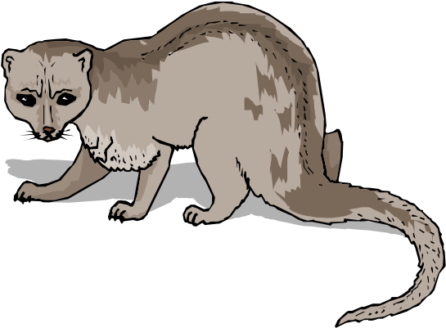

jubilant ................... a useful word for describing happy feelings.

kestrel ..................... a bird worth finding out about. Ever seen one?

laborious ................ a good word to describe certain kinds of work.

magnum opus ....... a Latin term that is used in English.

nefarious ................ this word describes a type of person or activity.

obliterate ............... a strong word, useful for powerful writing.

palatial .................... a good descriptive word that goes with a certain type of building.

quench ................... a useful verb to describe a common activity.

radiate .................... a verb that gives a strong, specific impression.

sacred ..................... a word that will be useful in R.E.

tenacious ................ a word that describes a certain type of attitude.

ultimate .................. a word for extremes.

valiant .................... a strong descriptive word.

yearn....................... a powerful verb that conveys a particular feeling.

zeal .......................... a strong quality.

**EXTENSION**

Write a story that uses all of the words in this list.

### 4 Alternatives for Common Words

*Below are some words that tend to be over-used. They are a little too general or vague.*

#### TASK

Find interesting alternatives for these words and write them down . Try to use these alternatives as much as possible.

1. said

*Try*: bellowed, whispered

What else?

1. big

*Try*: massive, huge

What else?

1. walked

*Try*: marched, ambled

What else?

1. ran

*Try*: rushed, hurtled

What else?

1. thought

*Try*: considered, wondered

What else?

1. sad

*Try*: melancholy, miserable

What else?

1. happy

*Try*: joyful, merry

What else?



1. wanted

*Try*: wished for, desired

What else?

1. ate

*Try*: consumed, devoured

What else?

1. bored

*Try* … not using this word! Take an interest in life; take pride in an ability to try hard even when the work gets difficult; be happy to labour away at something that you know will be useful. In short, be positive!

### 5 Colours

*Colour words can be a rich source of vocabulary, but they are often not used creatively.*

#### TASK

blue

, t

ry to write a description of a feeling using a colour: I was c

rimson with anger.

•

Thin

k of specific shades of each colour

–

not red, but crimson, etc.

•

Think of the emotions that each colour might go well with

.

1

.

red

Shades:

________________________________

___________

Emotions:

________________________________

___________

2

.

Shades: ___________________________________________

Emotions: ___________________________________________

1. yellow

Shades: ___________________________________________

Emotions: ___________________________________________

1. green

Shades: ___________________________________________

Emotions: ___________________________________________

1. purple

Shades: ___________________________________________

Emotions: ___________________________________________

1. orange

Shades: ___________________________________________

Emotions: ___________________________________________

1. black

Shades: ___________________________________________

Emotions: ___________________________________________

1. white

Shades: ___________________________________________

Emotions: ___________________________________________

1. brown

Shades: ___________________________________________

Emotions: ___________________________________________

1. pink

Shades: ___________________________________________

Emotions: ___________________________________________

### 6 Fill in the Missing Words

**TASK**

These sentences suggest the meaning for a useful, interesting word.

Try to think what the

missing word might be.

A thesaurus might h

elp.

•

Check your answer in a dictionary to make sure that it is right.

•

Ask for help from your family if you are stuck.



Complete the sentences by filling in the missing word. The first two letters of each word have been given for you.

1. To shorten a word is to ab_____________ it.
2. To put a complete stop to something is to ab_____________ it.
3. To avoid eating is to ab_____________.
4. To achieve something is to ac_____________ it.
5. To judge is to ad_____________.
6. To make a mistake is to make a bl_____________.
7. To be cruel and uncaring is to be ca_____________.
8. To give up completely is to ca_____________.
9. A formal presentation might be a ce_____________.
10. To be secretive is to behave in a cl_____________ way.
11. To be well-suited is to be co_____________.
12. The voice in your head that tells you what is right is your co_____________.
13. To confirm what someone else has said is to co_____________.
14. A moorland bird with a haunting cry is a cu_____________.
15. To be easily broken is to be de_____________.
16. A casual or disconnected speech is de_____________.
17. To persuade someone not to do something is to di_____________ them.
18. Lying or double dealing is du_____________.
19. A strong word for hatred is en_____________.
20. Special knowledge known only to a few is called es_____________.
21. A person who explains or expounds a topic is known as an ex_____________.
22. Faithfulness is known as fi_____________.
23. Something that is frantic or frenzied is called fr_____________.
24. Looking back on something that has already happened is called hi_____________.
25. To be poor is to be im_____________.

**EXTENSION**

Try to write a story that uses all of the words that you had to find.

### 7 Semantic Fields

•

A semantic field is an area of language

.

For example “farming” could be a semantic field

.

It

would include vocabulary such as: tractor, sheep, fence, plough, harvest, veterinary

surgeon, till, hoe, etc

.

**TASK**

a)

Look at the general topics below, and try to list as many words as you can that would go

with that topic.

Use a thesaurus to expand your list

.



* Check the meaning of the words in a dictionary.
* Follow up on chains of vocabulary, looking up more and more words in the thesaurus and so finding more words to look up.

b) Write a paragraph about each topic, using as many of your words as you can.

#### 1. School

Find words for: subjects; teachers; pupils; types of lesson; types of work; assessment; exams; displays; equipment; etc.

#### 2. Sport

Find words for: different sports; players; moves and types of action; equipment; things a commentator would say; etc.

#### 3. Health

Find words for: doctors, nurses, other professionals; illnesses; equipment; medicines; getting better; therapies; hospitals; surgeries; etc.

#### 4. The Theatre

Find words for: plays; actors; other performers; audience; programmes; refreshments; sections of plays; equipment and props; reviews, opinions, responses; etc.

#### 5. The countryside

Find words for: animals; plants; trees; hills; rivers; lakes; rocks; walking; birds and birdwatching; climbing; etc.

#### 6. The Media

Find words for: films; television; radio; the internet; advertising; pop music; magazines; performers; technicians; etc.

7. **What else?**

Think of some of your own semantic fields and make vocabulary lists to go with them.

#### EXTENSION

1. Divide your lists into two sections: those words that seem powerful, interesting and unusual; and those words that seem predictable and obvious.
2. Write several sentences using the powerful, interesting and unusual words.

### 8 English Subject Words

**TASK**

Below are some words that you might need to use in your English work.

•

Chose ten of the

word

s

in a dictionary

to

check

their

precise meaning.



Write a sentence that uses each of the words. Try to use each word at least once in discussion or in writing in English this year. Next to the words are some clues about how may use them.

advertisement ......... you might create or analyse one in English

alliteration .............. a poetic and rhetorical technique that makes writing powerful apostrophe .............. a helpful punctuation mark; the enemy of green-grocers

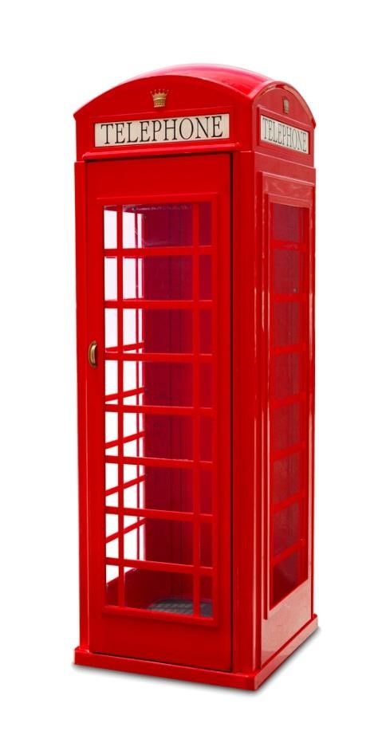

atmosphere ............. you might create this for a story

chorus ...................... a poem might have one; so might a Greek play clause ....................... a key part of a sentence cliché ....................... something to be avoided comma ..................... a key punctuation mark comparison.............. a key technique in reading conjunction ............. an important type of word consonant ................ you’ll need these to make words

dialogue ................... a way of adding life to a story; central to a play exclamation ............. a type of sentence

expression ............... you need to think about this in your writing figurative ................. a way of writing that adds interest

genre ....................... you need to be able to define different types of text grammar .................. you need to learn about this imagery ................... a way of making writing interesting metaphor ................. a poetic and rhetorical device to spot and use myth ........................ a key type of story

narrative .................. a useful word in responding to reading onomatopoeia ......... a poetic technique to use and spot pamphlet ................. a text type to write and read paragraph ................ a key part of structuring your writing personification ........ a type of metaphor playwright............... Shakespeare, for instance plural ....................... you need to get plurals right prefix ....................... a part of a word

preposition .............. a small but significant word resolution ................ a useful term for responding to reading rhyme ...................... you know what this is! scene ........................ how plays are made up simile ....................... a useful poetic technique soliloquy .................. Shakespeare uses them all the time

subordinate ............. a useful word for describing sentences suffix ........................ a part of a word

synonym ................. a key word when thinking about vocabulary

tabloid ..................... useful for media studies vocabulary .............. now that’s what I’m talking about! vowel ....................... a type of letter