

De Lisle College

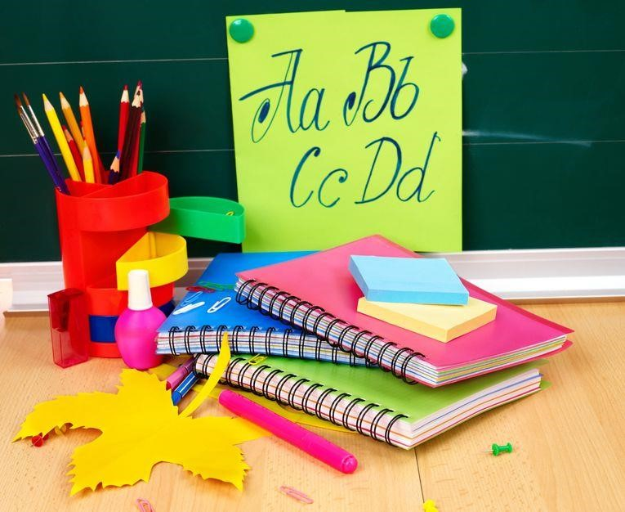

**ENGLISH**

**HOMEWORK**

**BOOKLET**

**YEAR 8**

# SECTION 1: PUNCTUATION AND GRAMMAR REVISION

In Year 8, you need to keep working on your writing skills. If you don’t think about grammar and punctuation, you’ll forget what you learnt in primary school. You might find that bad habits become entrenched.

The next ten pages each contain a separate homework exercise that will help you to improve the accuracy of your writing.

For each exercise:

1. Read the information.

2. Copy and correct the sentences.

These tasks are worth attempting several times – each time you do them, you should find your knowledge of what is correct increases. Unfortunately, our memories are such that we tend to forget much of what we learn, so we need to repeat exercises like these, in order to reinforce the learning.

THE CLAUSE

A **clause** is the main part of a sentence. It contains:

1. A verb (a doing word: *looks*, *runs*, *ate*, *fell*, *is*, *was*, etc.);
2. A subject (someone or thing that does the action: *I*, *she*, *Paul*, *Jenny*, *the* *cat*).

A clause must be followed by one of the following:

* A full stop: I ran away**.**

* A semi-colon: I ran away**;** the dog chased me.

* A comma *and* a joining word: I ran away**, but** the dog chased me.

Note: A comma on its own cannot separate two clauses. The comma must be followedby a **joining word** (*because*, *which*, *but*, *and*, etc.).



### TASK

Copy and add **full stops**, **semi-colons**, **commas**, and **capital letters** to the sentences below.

1. galileo galilei was born in italy in 1564 he became an important scientist

2. galileo observed the planets and he discovered jupiter’s moons

3. he improved the telescope but he did not invent it

4. he is called the father of modern astronomy because he discovered a lot

5. he said that the earth is not at the centre of the universe it goes round the sun

6. this was controversial at the time because the church did not teach this idea

7. galileo was summoned to rome where he had to answer questions

8. he was forced to say that the earth was the centre of the universe it is not

9. galileo made other scientific discoveries so he is called the father of science

10. he showed how maths and physics go together he was also a philosopher

11. he thought that the meaning of life is written in the universe

12. he proposed new ideas about motion which were important to scientists

13. he observed sunspots he was one of the first people to understand them

14. he described craters on the moon which he had seen through his telescope

15. he observed the milky way which is a star system not a chocolate bar

16. he was silenced by the church but he did not change his views

17. his views are now accepted most people know he was right

18. he was brave and curious many scientists revere him

19. he is important because he furthered our understanding

20. he shows us how to live he was true to his beliefs

### EXTENSION

1. Do some more research on Galileo. Write an encyclopaedia entry on him.
2. Write a leaflet for Year 6 students explaining the clause.

## COLONS

*A good punctuation mark to use is the colon. It impresses folk, even though it’s pretty easy to use. So, here’s a chance to make sure that you can use colons perfectly.*

A

colon points forward to more information. It

comes

before

**lists**

and

**bullet**

**points**

, saying:

“Here it is! Here’s the information I promised you!”

A

colon

can

also be used for dramatic emphasis, creating a pause and a brief sense of

anticipation.

*Example*

*s:*

•

The best school subjects are: English, maths, drama and science.

•

The

next

thing that happened: a bull crashed through the gate.

•

The

answer

was: Yes!

### TASK

Place the colons where they should go.

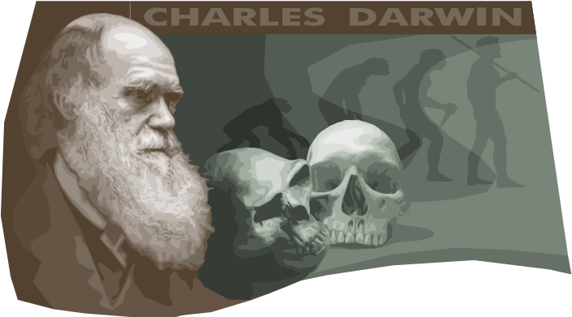1. Charles Darwin the most important scientist Britain ever produced.

2. He developed a theory the theory of evolution.

3. He added one key idea to the theory natural selection.

4. He wrote several books *On* *the Origin of Species, The Voyage of the Beagle, The Descent of Man.*

5. He was educated at Shrewsbury School, The University of Edinburgh and Christ’s College Cambridge.

6. On the voyage of The Beagle, he travelled to Argentina, Chile and Australia.

7. The most famous place he visited was the Galapagos Islands.

8. Darwin’s theory stated animals evolve when individuals that are well-adapted to the prevailing conditions out-breed less “fit” members of the species.

9. Darwin’s most controversial idea the notion that human beings might be descended from apes.

1. Darwin’s other works include *Insectivorous Plants; Climbing Plant; The Power of Movement in Plants; The Formation of Vegetable Mould through the action of Worms.*

|  |
| --- |
| **EXTENSION**  If that was too easy: write some of your own sentences that include colons. The topic should be: the life and works of Isambard Kingdom Brunel. You’ll need to do some research first! |

## SEMICOLONS

*Semicolons are not as difficult as some people seem to think. They can be used to separate parts of a sentence. They provide a stronger break than a comma, but one that is not as strong as a full stop. Elegant, sophisticated writers use semicolons.*



A semicolon can be placed between items in a list, where each item has several parts. If the list is a list of sentences, semicolons should be used to separate each item. If the items in the list have commas in them already, then semicolons should be used. More simply, they are used in long lists.

A semicolon can also be used to divide two closely related sentences. They are used to replace a full stop in these cases.

*Examples:*

* My favourite meals are: fish, chips and peas; pizza, beans and salad; curry, rice and garlic bread; choc ice, snails and raw onions.
* My brother likes jam; I like marmalade.

**TASK**

Add the semicolons where they belong.



1. The key facts about Rembrandt are: he was born in 1606 he lived in Amsterdam he was a famous painter he is most remembered for his selfportraits.

1. Some of his best self-portraits are: one in which he is young, dashing and handsome one in which he is holding his painting materials one in which he is old, troubled and rather bewildered.

1. Rembrandt’s painting of Abraham is powerful it shows Isaac’s terror and Abraham’s intensity.

1. Rembrandt’s painting of The Night Watch is well regarded it features vivid portraits of the men of Amsterdam.

1. Rembrandt’s paintings feature: dramatic, powerful effects of light realistic, detailed and thoughtful portrayals of people a forceful, expressive and free handling of paint.

1. Rembrandt expresses human experiences directly he captures what it is to be human on canvas.

|  |
| --- |
| **EXTENSION**  Write your own sentences that feature semicolons. Make the topic: the life and works of Pieter Brueghel the Elder. You’ll need to do some research. |

## NOUNS: Agreement

*We might not always agree, but noun endings should. Agreement in language is a matter of making sure that different parts of the sentence go together.*



As you know, a

noun is often called a naming word.

Nouns are the words that name

people, places and things.

Nouns are pretty simple

.

But they do change if the number changes. You need to make sure that

you get the ending right.

### TASK

Copy the sentences below, correcting the noun endings as you go along.

1. James Cook went to schools in a villages called Great Ayton.

2. He learnt about sailing in a towns called Whitby.

3. He sailed on a ships that went to Newfoundland.

4. In 1768 he commanded the ships The Endeavour.

5. The Endeavours sailed to New Zealands and Australias.

6. The purpose of the voyages was to observe the star in the skies.

7. Cook sailed round the many island in the Pacifics.

8. In three year of sailing there was only one deaths on his ship.

9. Cook is known as a skilful navigators.

10. His several voyage made many important discovery.

11. He helped further various science.

12. He was the first Europeans to see many of the Pacific island.

13. He landed in Australias when few peoples had been there.

14. His names is remembered in many Australian location.

15. There is a huge monuments to him on a hills near Great Ayton.

16. Cook was killed by a group of Pacific islander.

17. He returned to get a boats back.

18. A group of islander set upon him.

### EXTENSION

OK, that’s too easy! Try to write a simple guide for Year 5 students, explaining how to get the right endings for their nouns.

## VERBS: Agreement

*OK, nouns are easy. Agreed? Verbs have a bit more going on for them.*

As you know, a verb is often called a **doing word**. It is the word that tells you what the main action of the sentence is: *ate*, *ran*, *jumps*, *likes*, *will* *take*, etc.

Verbs need to change their endings in order to agree with the subject. They have different endings if the subject is “I” or “she”. The subject could be “we” or “they” or “it” or “you” – you

need to get the ending right for each.

There is a clear difference between the ending that goes with singular subjects and that which goes with plural subjects.

*Example*: Apples **are** great. An apple **is** great.

TASK

Copy the sentences below, correcting the verbs as you do so.

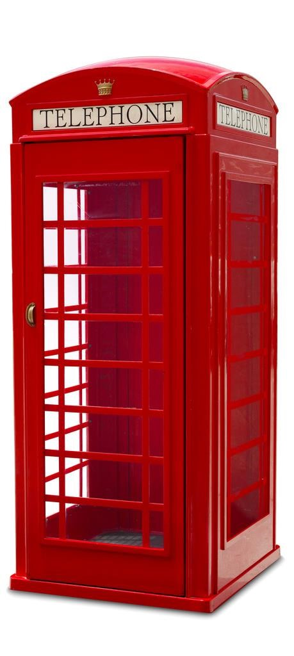

1. The London Underground Map are a design classic.

1. The red telephone box have been praised as an icon.

1. Mini cars is nippy and sporty.

1. The angle poise lamp have been described as an elegant solution to an everyday problem.

1. Concorde have the look of a futuristic plane.

1. The Bauhaus chair are ergonomically perfect.

1. Many people loves the Routemaster London bus.

1. The mini skirt were a popular sixties sign of women’s liberation.

1. The Sinclair C5 were a bizarre buggy that no-one bought.

1. An American Quilt are a sign of community effort.

1. Experts reveres Chippendale furniture designs.

1. The catseye are a smart invention that helps road safety.

1. The spitfire plane are a design that are fit for purpose.

1. The World Wide Web are a British invention.

1. The E-type Jaguar were another elegant British design.

1. Some people thinks that computer games like Tomb Raider is design classics as well.

### EXTENSION

Do some research. Find out all the different types and parts of verbs. Design and write a leaflet to explain all about how verbs work.

## COMBINE SENTENCES

*You need to start using commas as a matter of course. People often get them wrong, putting a comma where a full stop belongs. Here is an exercise to get you thinking about commas.*



Add some sort of connective and you can combine two short sentences into one long one. A

comma can divide the clauses if they are properly linked.

### TASK

Rewrite each set of sentences below, combining them as one or more sentences as you think appropriate. Add a connective word like: *but*, *because*, *if*, *when*, *so*, etc., along with a comma. Make whatever changes you need to reduce the number of sentences but keep the same meaning.

1. Gilgamesh is the first story known. It was written in Iraq.

1. The story was written in the year 2700 BC. It has survived over 4000 years.

1. Gilgamesh is an unpopular king. He fights Enkidu.

1. The fight goes on for a long time. They decide neither can win.

1. Gilgamesh and Enkidu become friends. They are equal in strength. They respect each other.

1. They set out on an adventure. They go to the forest. They aim to kill Humbaba.

1. Gilgamesh and Enkidu kill Humbaba. They use team work. They succeed. They feel guilty afterwards. They regret killing Humbaba.

1. Enkidu dies. It is a punishment. Gilgamesh is very sad.

1. Gilgamesh fears his own death. He goes in search of immortality. He knows of a place. In this place he can find eternal life.

1. He is on his way. He meets an old woman. The woman tells him something. She says he should give up his search. He ignores her.

1. He travels over the ocean. It is dangerous. It takes a long time.

1. He gets there. He finds a herb. It will keep him young and healthy all his life.

1. He returns to the old woman. He sleeps. A snake steals the herb.

1. The old woman tells him something. She tells him to return home. She tells him to return to his family. She tells him to value them.

1. There is a message to the story. The message is that family is important. The message is also that you should value what you have.

### EXTENSION

Find out more about the region where this story comes from. Write a guide to the history of the place for Year 8 students to read and enjoy. Try to use long sentences.

## PARAGRAPHS

*Paragraphs are essential for structuring texts. They need to be used if writing is to be clear.*



Start a new paragraph when you change topic.

Start a new paragraph when a story includes a change in place.

Start a new paragraph when a story moves forward or back in time.

Start a new paragraph when you want to include a section of description.

Put your paragraphs in an order that allows you to link them.

### TASK A

Here is a mixed up paragraph plan for the Gilgamesh story.

1. Decide which order the paragraphs should be in.
2. Write an explanation of why you made the choices that you did.

* 1. Gilgamesh and Enkidu become friends.

* 1. Gilgamesh decides to seek eternal life.

* 1. Gilgamesh and Enkidu kill Humbaba.

* 1. Gilgamesh is king of Uruk.

* 1. Enkidu dies.

* 1. Gilgamesh finds the secret of eternal life.

* 1. Gilgamesh decides to fight Enkidu.

* 1. Gilgamesh and Enkidu regret killing Humbaba.

* 1. Gilgamesh is warned not to seek eternal life.

* 1. Gilgamesh and Enkidu fight.

* 1. Gilgamesh loses the secret herb of youth.

* 1. Gilgamesh and Enkidu are equals.

* 1. Gilgamesh returns to his family.

* 1. Gilgamesh and Enkidu return to Uruk together.

* 1. Gilgamesh and Enkidu set out to kill Humbaba.

### TASK B

Now try to link the paragraphs.

1. Write an opening sentence for each paragraph in the story.
2. Make each sentence a topic sentence – one which clearly shows what the paragraph is about.
3. Make clear what the link between each paragraph will be. Use words like “however”, “later”, “surprisingly”, etc. You might want to write a final sentence for each paragraph, to help you see how the paragraph will link to the next.

By the time you have done this, you might want to write your own complete version of the story.

## DASHES

*A dash can be used to show that some information has been added to the end or into the middle of the sentence.*



When a fragment of extra information is tacked on to the end of the sentence, use a dash – it shows that the extra statement is indeed extra.

If you want to put a little aside – a short explanation for example – in the middle of a sentence, a

pair of dashes can be used. Start a new paragraph when you change topic.

### TASK

Copy the sentences below. Add the dashes where they belong.

1. Beowulf one of the oldest English poems tells an heroic story.

1. It is set in Denmark many settlers came from there to England.

1. Grendel a lonely, hairy monster terrorises the Danish court.

1. Grendel feasts on the Danish soldiers there is no escape.

1. Hrothgar is the Danish king he cannot rid his nation of Grendel.

1. Beowulf a soldier from over the seas comes to challenge Grendel.

1. No-one believes that Beowulf can kill Grendel a man called Unferth is especially negative about Beowulf’s chances.

1. Unferth asks Beowulf to tell a story he has heard it features Beowulf losing a swimming race.

1. Beowulf puts him right he lost the race because he stopped to fight a sea monster.

1. That night Grendel visits the feast hall he attacks the sleeping warriors.

1. Beowulf lying in wait just for this moment surprises Grendel.

1. Grendel fights with Beowulf he is shocked by Beowulf’s strength.

1. Beowulf holds onto Grendel’s shoulder his grip is like iron.

1. Grendel screams he doesn’t know what to do.

1. Beowulf wrenches Grendel’s arm off the original poem describes this very powerfully.

1. Grendel slinks off he is nearly dead.

1. Everyone in the Danish court celebrates they think their troubles are over.

1. Grendel is dead his mother is not pleased.

1. Beowulf’s work is just beginning he’ll soon have another fight to undertake.

1. Grendel’s mother is worse than her son she’ll be hard to kill.

### EXTENSION

1. Write your own description of the fight between Grendel and Beowulf.
2. Read the original poem – Seamus Heaney has written a modern English version of it.

## COMMAS

*You need to use commas in your writing. We’ve looked at them a few times in this booklet. Here, you can try to use them to mark off different clauses.*

### TASK

Add the commas where they belong.

1. When Beowulf reached the lake he knew he was at Grendel’s mother’s lair.

1. Having waited for hours he decided that he would have to dive into the murky water.

1. Swimming down through the waters Beowulf looked out for Grendel’s mother.

1. He was uneasy because the lake was littered with corpses.

1. Waiting at the edge of the lake Beowulf’s men began to fear that he would not return.

1. When Beowulf caught sight of the huge monster he swam towards it.

1. Beowulf struggled with the monster and soon he began to realise that he could not defeat it.

1. Beowulf began to feel terror because he was being crushed by the monster.

1. When he felt that the end was near he touched something with his hand.

1. He was lucky because he had found a sword on the bottom of the lake.

1. Having grabbed the sword he swung it towards Grendel’s mother.

1. The sword cut through the monster’s neck and so Grendel’s mother was defeated.

1. Exhausted but satisfied Beowulf swam for the surface.

1. When Beowulf returned everyone was amazed.

1. Their questions were answered straight away because Beowulf was holding Grendel’s mother’s head in one hand.

|  |
| --- |
| **FEEDBACK TASKS**    **Choose one:**     1. Write your own description of the fight between Beowulf and Grendel’s mother.      1. Write a description of the celebration feast that takes place after Beowulf defeats Grendel’s   mother.     1. Write a guide to using commas for Year 5 pupils. |

## CORRECTING A PASSAGE

*Here’s a test for you! Try to put all the skills you have used in the preceding exercises together here.*

### TASK

Copy the passage below. Correct all the mistakes:

|  |  |
| --- | --- |
| * Full stops * Capital letters * Apostrophes * Speech * Commas | * Colons * Semicolons * Agreement * Dashes * Paragraphs |

beowulf were a happy successful kings for many year and the people loved him he were his peoples protector they relied on him when the winters nights were cold he would recalls his adventure’s once he said i was a young warriors who could defeat anyone imagine me then a strong athletic arrogant heroes these was the stories he would tell the killing of the sea monster the battle with grendel the fight with grendels mother he loved to tell tales those were his glory day as he got older his people began to forgets his many youthful exploit they saw him as an old man few peoples could imagine that he were ever a mighty fighter he seemed so frail then one day a terrible events took place from nowhere a dragon appeared the dragons breath was fire and his bite was bitter he preyed on beowulfs lands the dreadful dragon layed waste to many villages how the people complained help us king beowulf they cried send for a warrior who can rid us of this terrible threats beowulf old as he was rose to answer his subject i will fights this terrible beast he promised wishing to be respectful the people did not laugh but they felt that beowulf was being ridiculous they could not believe whatever he said that beowulf could fight any kind of beast the next day beowulf set out to the dragons layer sure that he could kill it he was brave perhaps he was foolish his people followed him they hoped he would fulfil his promise but they feared that he would fail miserably how could such an old men fight such a grim monster

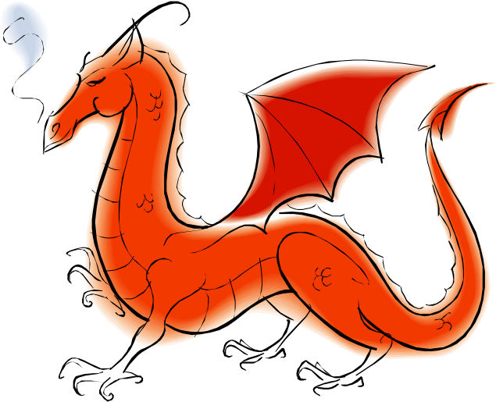

### EXTENSION

Write your own description of the fight between Beowulf and the dragon – he wins, but is wounded and dies afterwards.

# SECTION 2: READING

## *What you need to do*

* **SELECT** information to show that you **UNDERSTAND** a text.

* Read between the lines, picking up on **HINTS** in a text: **INFER** and **DEDUCE**.

* Comment on the **STRUCTURE** of a text.

* Comment on the **LANGUAGE** of a text.

* Comment on the **OVERALL INTENTIONS** and **EFFECTS** of a text.



**READING 1: *Bleak House***

*Read the passage below. Look up any words you don’t understand in a dictionary or on dictionary.com.*

*Complete the task that follows.*



This passage is the opening of **Charles Dickens**’ (1812-1870) novel *Bleak House*. Here he describes

a fog-bound London. The book is partly about a court case – “Chancery” was a court where

disputes about money were settled – which has dragged on for many years. So the fog might

stand for the confusion that the people involved in the case are feeling.

• The difficulty of this passage is: HARD

LONDON. Michaelmas Term lately over, and the Lord Chancellor sitting in Lincoln’s Inn Hall. Implacable November weather. As much mud in the streets as if the waters had but newly retired from the face of the earth, and it would not be wonderful to meet a Megalosaurus, forty feet long or so, waddling like an elephantine lizard up Holborn Hill. Smoke

lowering down from chimney-pots, making a soft black drizzle, with flakes of soot in it as big as full-grown snow-flakes — gone into mourning, one might imagine, for the death of the sun. Dogs, undistinguishable in mire. Horses, scarcely better; splashed to their very blinkers. Foot passengers, jostling one another’s umbrellas in a general infection of illtemper, and losing their foot-hold at street-corners, where tens of thousands of other foot passengers have been slipping and sliding since the day broke (if the day ever broke), adding new deposits to the crust upon crust of mud, sticking at those points tenaciously to the pavement, and accumulating at compound interest.

Fog everywhere. Fog up the river, where it flows among green islands and meadows; fog down the river, where it rolls defiled among the tiers of shipping and the waterside pollutions of a great (and dirty) city. Fog on the Essex marshes, fog on the Kentish heights. Fog creeping into the cabooses of collier-brigs; fog lying out on the yards, and hovering in the rigging of great ships; fog drooping on the gunwales of barges and small boats. Fog in the eyes and throats of ancient Greenwich pensioners, wheezing by the firesides of their wards; fog in the stem and bowl of the afternoon pipe of the wrathful skipper, down in his close cabin; fog cruelly pinching the toes and fingers of his shivering little ’prentice boy on deck. Chance people on the bridges peeping over the parapets into a nether sky of fog, with fog all round them, as if they were up in a balloon, and hanging in the misty clouds.

Gas looming through the fog in divers places in the streets, much as the sun may, from the spongey fields, be seen to loom by husbandman and ploughboy. Most of the shops lighted two hours before their time — as the gas seems to know, for it has a haggard and unwilling look.

The raw afternoon is rawest, and the dense fog is densest, and the muddy streets are muddiest near that leaden-headed old obstruction, appropriate ornament for the threshold of a leaden-headed old corporation, Temple Bar. And hard by Temple Bar, in Lincoln’s Inn Hall, at the very heart of the fog, sits the Lord High Chancellor in his High Court of Chancery.

GRADE 4 Which dinosaur is mentioned in the passage?

GRADE 5 What has happened to the dogs in the first paragraph?

GRADE 6 Which detail in the first paragraph suggests that it is always dark?

GRADE 7 Select 5 key words or phrases that create a mood in this passage.

INFER AND DEDUCE

GRADE 4: How do the people of London feel?

GRADE 5: Why does Dickens start his book like this?

GRADE 6: What does the fog represent?

GRADE 7: Why is the Lord High Chancellor at the heart of the fog?

STRUCTURE

GRADE 4: Why does Dickens start his book by focusing on the weather?

GRADE 5: Why does Dickens list so many examples?

GRADE 6: How does the passage build to a climax?

GRADE 7: What expectations do you get for the rest of the book from this passage?

LANGUAGE

GRADE 4: What is the effect of the repetition of “fog”?

GRADE 5: Explain three examples of Dickens’ strong language in this passage. What do they make you feel or think?

GRADE 6: What can you say about the types of sentence used in paragraph 2?

GRADE 7: How does Dickens’ language emphasise his message in this passage?

OVERALL EFFECT

GRADE 4: How do you respond to this passage?

GRADE 5: What is Dickens’ main message in this passage?

GRADE 6: What opinions is Dickens expressing?

GRADE 7: What techniques does Dickens use? To what effect?



|  |
| --- |
| **EXTENSION**  a) Write your own description of a foggy day.  b) Read the rest of *Bleak House*. |

### READING 2: ‘All the World’s a Stage’

*Read the passage below. Look up any words you don’t understand in a dictionary or on dictionary.com. Complete the task that follows.*



This speech is taken from **Shakespeare**’s *As You Like it*. In the speech, the generally miserable Jaques compares a man’s lifetime to various roles that an actor might take on stage. “Sans” (from the last line) means “without”.

• The difficulty of this passage is: MEDIUM

All the world's a stage,

And all the men and women merely players:

They have their exits and their entrances;

And one man in his time plays many parts, His acts being seven ages. At first the infant, Mewling and puking in the nurse's arms.

And then the whining school-boy, with his satchel

And shining morning face, creeping like snail

Unwillingly to school. And then the lover,

Sighing like furnace, with a woeful ballad

Made to his mistress' eyebrow. Then a soldier,

Full of strange oaths and bearded like the pard,

Jealous in honour, sudden and quick in quarrel,

Seeking the bubble reputation

Even in the cannon's mouth. And then the justice,

In fair round belly with good capon lined,

With eyes severe and beard of formal cut,

Full of wise saws and modern instances;

And so he plays his part. The sixth age shifts

Into the lean and slipper'd pantaloon,

With spectacles on nose and pouch on side,

His youthful hose, well saved, a world too wide

For his shrunk shank; and his big manly voice,

Turning again toward childish treble, pipes

And whistles in his sound. Last scene of all,

That ends this strange eventful history,

Is second childishness and mere oblivion,

Sans teeth, sans eyes, sans taste, sans everything.

GRADE 4: Select four words from the first three lines that refer to the theatre.

GRADE 5: What are the seven separate ages?

GRADE 6: Select five descriptive phrases that have a memorable effect. GRADE 7: Explain the effect of five key phrases from the passage.

INFER AND DEDUCE

GRADE 4: Which is the best age to be at?

GRADE 5: How does the speech suggest that different ages might be more or less enjoyable?

GRADE 6: What opinions does the passage suggest?

GRADE 7: What view of human existence does the passage convey?

STRUCTURE

GRADE 4: How does the passage begin?

GRADE 5: Why does the passage end as it does?

GRADE 6: How does the passage create tension and expectations?

GRADE 7: How does the passage rise to a climax?

LANGUAGE

GRADE 4: Select one simile from the passage.

GRADE 5: How does Shakespeare use similes and metaphors in the passage?

GRADE 6: Explain three examples of powerful language from the passage.

GRADE 7: What techniques does Shakespeare use? To what effect?

OVERALL EFFECT

GRADE 4: What is Shakespeare telling us here?

GRADE 5: Why might Shakespeare have chosen to use plays and players as his central metaphor for

life?

GRADE 6: What is Shakespeare’s message?

GRADE 7: How does Shakespeare reflect the character’s misery here?

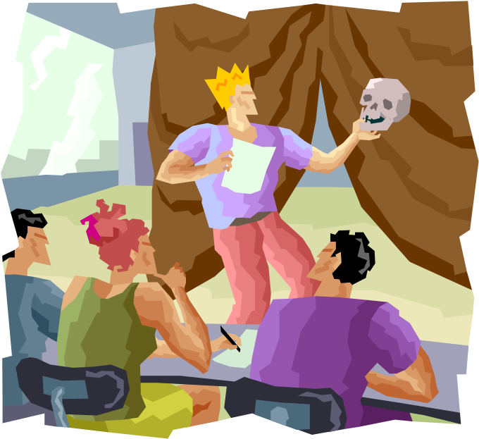

|  |
| --- |
| **EXTENSION**   1. Read *As You Like It*. Write a review of the play, as if you had seen it at the theatre. 2. Write your own poem about life. What could you compare the stages of life to? School subjects? Weather? Animals? |

### READING 3: ‘England 1819’

*Read the passage below. Look up any words you don’t understand in a dictionary or on dictionary.com. Complete the task that follows.*



This poem was written by **Percy Bysshe Shelley** (1792-1822). In it, he describes the social and political situation of his time. People were much less free than they are today. King George III was, indeed, mentally ill. His successor, the Prince Regent, was a fat, ridiculous waste of space.

• The difficulty of this passage is: HARD

#### England 1819

An old, mad, blind, despised, and dying king,

Princes, the dregs of their dull race, who flow

Through public scorn, mud from a muddy spring,

Rulers who neither see, nor feel, nor know,

But leech-like to their fainting country cling,

Till they drop, blind in blood, without a blow,

A people starved and stabbed in the untilled field,

An army, which liberticide and prey

Makes as a two-edged sword to all who wield,

Golden and sanguine laws which tempt and slay;

Religion Christless, Godless a book sealed;

A Senate, Time's worst statute unrepealed, Are graves, from which a glorious Phantom may Burst, to illumine our tempestous day.

Percy Bysshe Shelley

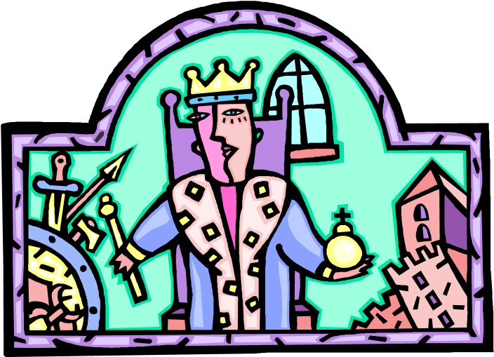

GRADE 4: Select an example of alliteration from the poem.

GRADE 5: How many negative words can you find in the poem?

GRADE 6: How many metaphors can you spot?

GRADE 7: Select the strongest image from the poem. Why did you choose it?

INFER AND DEDUCE

GRADE 4: What did Shelley think of the king?

GRADE 5: What did Shelley think about the world in which he lived?

GRADE 6: What did Shelley want to happen?

GRADE 7: What would Shelley think about our political situation today?

STRUCTURE

GRADE 4: Why did Shelley start with the images in the first line?

GRADE 5: What kind of poem is this? How can you tell?

GRADE 6: How many sections would you divide the poem into?

GRADE 7: How does the poem rise to a climax?

LANGUAGE

GRADE 4: How many examples of alliteration can you find?

GRADE 5: Select three examples of strong vocabulary. Explain their effect on you.

GRADE 6: How would you describe the language of the poem?

GRADE 7: Which techniques does Shelley use? To what effect?

OVERALL EFFECT

GRADE 4: What were Shelley’s feelings when he wrote this poem?

GRADE 5: What is Shelley’s message?

GRADE 6: Who is the poem aimed at? How can you tell?

GRADE 7: What did Shelley believe in?

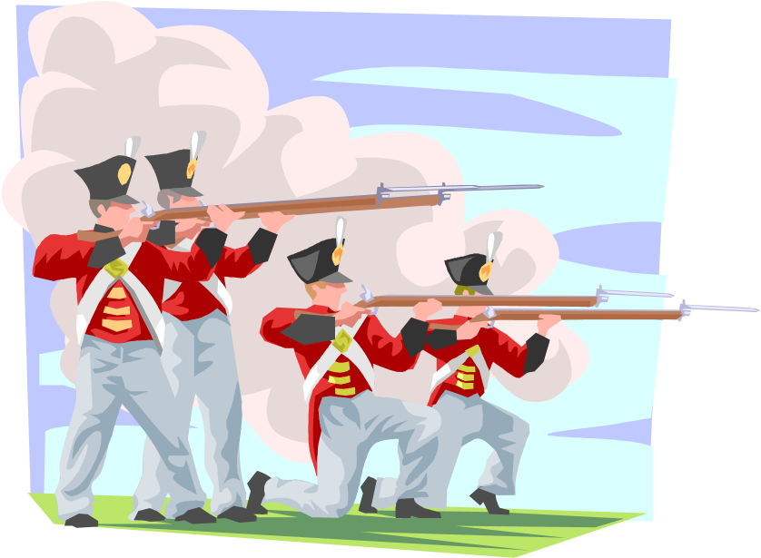

|  |
| --- |
| **EXTENSION**   1. Write your own poem about the problems that we face in our world today. 2. Do some research into life in England in 1819. Write a chapter for a Horrible History book about those times. |

### READING 4: ‘The Tyger’

*Read the passage below. Look up any words you don’t understand in a dictionary or on dictionary.com. Complete the task that follows.*



In this poem, **William Blake** (1757-1827) describes the animal, the tiger. He asks: who could have made such a fierce creature? Could it have been made by the same God who made the lamb? He describes how the tiger must have been made in a furnace and twisted out of hot metal.

• The difficulty of this passage is: EASY

#### The Tyger

Tyger! Tyger! burning bright

In the forests of the night,

What immortal hand or eye

Could frame thy fearful symmetry?

In what distant deeps or skies

Burnt the fire of thine eyes?

On what wings dare he aspire?

What the hand dare seize the fire?

And what shoulder, & what art.

Could twist the sinews of thy heart? And when thy heart began to beat, What dread hand? & what dread feet?

What the hammer? what the chain?

In what furnace was thy brain? What the anvil? what dread grasp

Dare its deadly terrors clasp?

When the stars threw down their spears, And watered heaven with their tears, Did he smile his work to see?

Did he who made the Lamb make thee?

Tyger! Tyger! burning bright

In the forests of the night,

What immortal hand or eye

Dare frame thy fearful symmetry?

William Blake

SELECT AND RETRIEVE

GRADE 4: Which part of the poem is repeated?

GRADE 5: Which lines suggest that the tiger is evil?

GRADE 6: Which lines suggest that the tiger was made by some kind of blacksmith?

GRADE 7: Select five key words from the poem. Why did you select these?

INFER AND DEDUCE

GRADE 4: What does Blake think of the tiger?

GRADE 5: Is Blake a Christian?

GRADE 6: Why does Blake mention the Lamb?

GRADE 7: Is Blake afraid? What of?

STRUCTURE

GRADE 4: Why does Blake repeat most of one of the verses?

GRADE 5: What is different about the end from the beginning?

GRADE 6: What is the topic of each separate verse?

GRADE 7: How does the poem rise to a climax?

LANGUAGE

GRADE 4: Which words suggest strength?

GRADE 5: How does Blake’s language create an impression of evil?

GRADE 6: How does Blake use rhythm in the poem?

GRADE 7: Which techniques does Blake use? To what effect?

OVERALL EFFECT

GRADE 4: What is Blake’s impression of the tiger?

GRADE 5: What is Blake’s message?

GRADE 6: What is Blake saying about good and evil?

GRADE 7: Is Blake impressed by the tiger? Why? How can you tell?

|  |
| --- |
| **EXTENSION**   1. Read Blake’s book *Songs of Innocence and Experience* . 2. Write your own poem about an animal. |

### READING 5: ‘Daffodils’

*Read the passage below. Look up any words you don’t understand in a dictionary or on dictionary.com. Complete the task that follows.*

In this poem,

**William Wordsworth**

(1770

-

185

0)

describes his thoughts and feelings about seeing a

field full of daffodils.

•

The difficulty of this passage is: MEDIUM

#### Daffodils

I wandered lonely as a cloud

That floats on high o'er vales and hills,

When all at once I saw a crowd,

A host, of golden daffodils; Beside the lake, beneath the trees, Fluttering and dancing in the breeze.

Continuous as the stars that shine

And twinkle on the milky way, They stretched in never-ending line Along the margin of a bay:

Ten thousand saw I at a glance,

Tossing their heads in sprightly dance.

The waves beside them danced, but they

Out-did the sparkling leaves in glee; A poet could not be but gay, In such a jocund company!

I gazed—and gazed—but little thought What wealth the show to me had brought:

For oft, when on my couch I lie

In vacant or in pensive mood,

They flash upon that inward eye

Which is the bliss of solitude; And then my heart with pleasure fills, And dances with the daffodils.

William Wordsworth

SELECT AND RETRIEVE

GRADE 4: In verse 1, what were the daffodils doing?

GRADE 5: How many similes can you spot in the poem?

GRADE 6: How can you tell this poem was written about the Lake District?

GRADE 7: What does Wordsworth tell us about his mood?

INFER AND DEDUCE

GRADE 4: How does Wordsworth feel about the daffodils?

GRADE 5: How do the daffodils help Wordsworth?

GRADE 6: What kind of person is Wordsworth?

GRADE 7: What does Wordsworth think about nature?

STRUCTURE

GRADE 4: Why does Wordsworth start with the idea in the first line?

GRADE 5: How does Wordsworth create contrasts?

GRADE 6: What is the topic of each verse?

GRADE 7: How does Wordsworth structure the poem?

LANGUAGE

GRADE 4: What are the key words in the poem?

GRADE 5: What images do you get from the poem?

GRADE 6: How does Wordsworth’s language affect the reader?

GRADE 7: Which techniques does Wordsworth use? To what effect?

OVERALL EFFECT

GRADE 4: What is Wordsworth’s message?

GRADE 5: What does Wordsworth tell us about what is important in life?

GRADE 6: What does Wordsworth expect us to feel as we read the poem?

GRADE 7: What is Wordsworth’s philosophy?

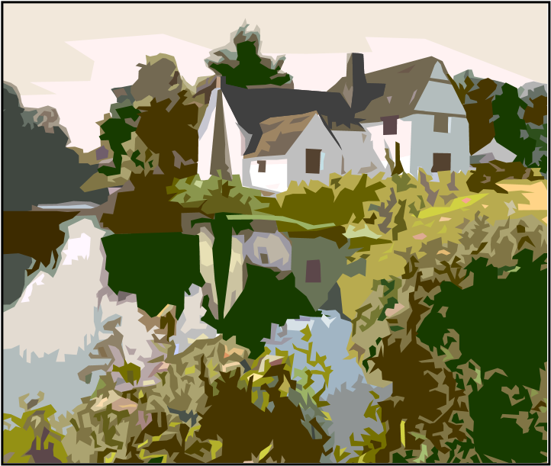

#### EXTENSION

1. Write your own description of a natural scene.
2. Do some research into Wordsworth’s life and works. Write an entry for a children’s encyclopaedia about him.

### READING 6: ‘The Kraken’

*Read the passage below. Look up any words you don’t understand in a dictionary or on dictionary.com. Complete the task that follows.*



In this poem **Alfred Lord Tennyson** (1809-1892) describes a mythical sea-monster. It rises from the bottom of the ocean a nd dies at the surface.

• The difficulty of this passage is: MEDIUM

#### The Kraken

Below the thunders of the upper deep,

Far, far beneath in the abysmal sea,

His ancient, dreamless, uninvaded sleep

The Kraken sleepeth: faintest sunlights flee

About his shadowy sides; above him swell

Huge sponges of millennial growth and height;

And far away into the sickly light,

From many a wondrous and secret cell

Unnumber'd and enormous polypi

Winnow with giant arms the lumbering green.

There hath he lain for ages, and will lie

Battening upon huge sea-worms in his sleep,

Until the latter fire shall heat the deep;

Then once by man and angels to be seen, In roaring he shall rise and on the surface die.

Alfred Lord Tennyson

SELECT AND RETRIEVE

GRADE 4: Which word suggests a noise in the first line?

GRADE 5: What is the Kraken doing at the start of the poem?

GRADE 6: What other creatures are mentioned in the poem?

GRADE 7: How long has the Kraken been asleep for?

INFER AND DEDUCE

GRADE 4: What is the mood of the poem?

GRADE 5: Why did Tennyson write the poem?

GRADE 6: What might the Kraken symbolise or represent?

GRADE 7: What effect is Tennyson trying to create?

STRUCTURE

GRADE 4: How does the poem end?

GRADE 5: Is the end a surprise? Why?

GRADE 6: What contrasts does the poem include?

GRADE 7: How does the poem lead towards the conclusion?

LANGUAGE

GRADE 4: Which words are powerful?

GRADE 5: How does Tennyson’s language create a strange effect?

GRADE 6: Select one descriptive phrase. Say how it makes you feel.

GRADE 7: Which techniques does Tennyson use? To what effect?

OVERALL EFFECT

GRADE 4: What is your response to the poem?

GRADE 5: What does the poem tell you about Tennyson’s way of thinking?

GRADE 6: What is Tennyson’s message?

GRADE 7: What does Tennyson want us to think or feel?

|  |
| --- |
| **EXTENSION**  a) Write your own description of a monster.  b) Write an encyclopaedia entry about the Kraken. Explain why it wakes and why it must die. |

#### READING 7: *The Diary of a Pre-Teen Prom Queen*

*Read the passage below. Look up any words you don’t understand in a dictionary or on dictionary.com. Complete the task that follows.*



This is from a funny and dramatic story a

bout a 12 year old British girl who organises a party (or

prom) for her year group at school.

•

The difficulty of this passage is: MEDIUM

OMG! I thought I would be writing something like: “I just want to curl up in a ball and cry. How could I be such an idiot!? I had my chance to make a real impression today and what happened? I blew it.” But then … something miraculous happened, something so perfect and unexpected that has changed everything and means that I can write: this might just have been the best day of my life!

Here’s how it all started: Jenny, Emma, Kylie and me were just hanging about at break when HE came along with his mates and started kicking a ball against the wall nearby. We all did the giggly girlie act, and the lads started showing off, doing clever flicks and kicks and belting the ball real hard.

So what did I do? I don’t know whether to laugh or cry really. You see, the football bounces over towards us and HE – my greatest ever crush, the lush, cool, too-gorgeous-to-look-at Terry Casper – calls over to me: “Kick it back Frenchy, will you?” he shouts. He knows my name! What a triumph! What a day! So, there I go over to the ball, feeling so wanted, so inwith-the-in-crowd, so excited. And what did I do? Well, I swung my delicate little leg, but missed the ball altogether, carried on swinging until I lost my balance and fell flat on my back! Of course, my loyal friends – green with jealousy about Terry knowing that I exist – laughed like drains. I just shut my eyes tight and lay there wondering how long it was until the end of break.

Suddenly, I felt a hand touch mine. I opened one eye suspiciously and looked up, and there he was: his sweet smile, his emerald eyes, his perfect face looking sympathetically down on mine: Terry! “Let me help you,” he purred as he lifted me back to my feet. But it doesn’t end there. Here’s what he said: “Looks like you could do with some footy lessons. You should come down the park sometime. I could teach you.”

I just gawped and nodded and tried to keep breathing. Was he, well, kinda asking me out on a date? I mean, I’m not imagining it, am I? I can hardly dare say it or write it or think it, but it must be right: Terry Casper likes me!

SELECT AND RETRIEVE

GRADE 4: How can you tell the narrator is a young girl?

GRADE 5: What is Terry Casper like?

GRADE 6: Why is the narrator so excited?

GRADE 7: What feelings does the narrator express?

INFER AND DEDUCE

GRADE 4: What does the narrator think of Terry Casper?

GRADE 5: How does the narrator feel about what happened in the day?

GRADE 6: Why do the narrator’s friends laugh at her?

GRADE 7: What sort of person is the narrator?

STRUCTURE

GRADE 4: What is the effect of the very start: “OMG”?

GRADE 5: How does the writer make the reader keen to read on?

GRADE 6: How does the writer use the first sentences in the paragraphs to create tension and drama? GRADE 7: What is the effect of the opening paragraph?

LANGUAGE

GRADE 4: How does the narrator describe her feelings?

GRADE 5: How does the writer’s language make the piece funny?

GRADE 6: How does the language appeal to the passage’s key audience?

GRADE 7: Which techniques does the writer use? To what effect?

OVERALL EFFECT

GRADE 4: What is your response to this passage?

GRADE 5: Can only girls enjoy this passage? Why? Why not?

GRADE 6: How does the writer make us sympathise with the narrator?

GRADE 7: What do you like or dislike about this passage?

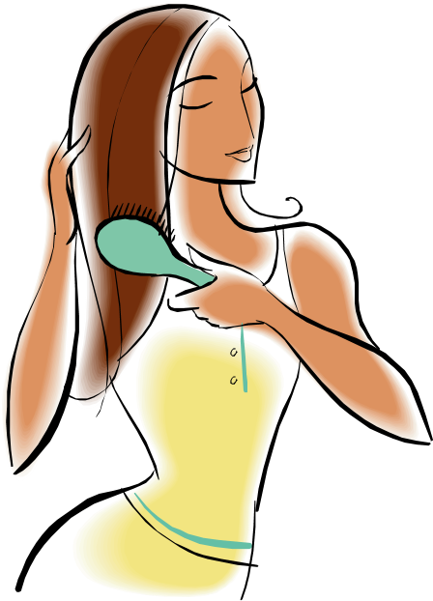

|  |
| --- |
| **EXTENSION**  Write the next part of the story. |

#### READING 8: *The Galaxy of a Thousand Earth-like Planets*

*Read the passage below. Look up any words you don’t understand in a dictionary or on dictionary.com. Complete the task that follows.*

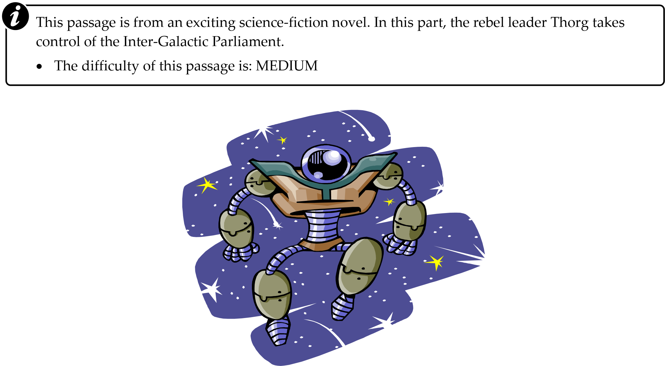

The Mighty Thorg marched into the council chamber accompanied by three guard droids, each carrying a battle-class laser rifle. The Pro-consul rose slowly to his feet, trying to assert some sort of authority, but his wizened frame cut an unimpressive figure next to Thorg’s massive, armour-plated bulk.

“As the voice of the people of the outer regions,” bellowed Thorg, “I hereby proclaim an end to the Fourth Era and the beginning of the Fifth. We are in control!”

As he said this, a dozen coldly metallic robot warriors silently, smoothly slipped through the great chamber doors. One Boolian delegate, its single eye starting out of its purple forehead, made as if to leave its bench. It slithered to the floor and extended its five twisting, rubbery tentacles, but it had no time to move: in an instant, a droid raised its rifle and fired off three bursts of red energy. The unlucky Boolian froze, shivered, glowed as red as the laser, then evaporated.

There was a brief buzz of shocked and nervous chatter about the hall, but this was quickly silenced by Thorg’s glaring sweep of the chamber with his proud, defiant, threatening eyes. As his purposeful stare fell upon each of the councillors in turn, so they fell into intimidated silence.

Thorg let out a cruel laugh. “Yes, gentlemen, ladies, androgynoids,” he barked, “we are in charge.”

How many droids accompany Thorg?

What does the Pro-consul look like?

Which details tell you that this is a science-fiction book?

Which is the key word to describe Thorg?

INFER AND DEDUCE

GRADE 4: What kind of person is Thorg?

GRADE 5: What does Thorg’s language tell you about him?

GRADE 6: What are the robots like?

GRADE 7: Whose side are you on? Why?

STRUCTURE

GRADE 4: What did you expect after you read the first sentence?

GRADE 5: How does the first sentence create expectations?

GRADE 6: Why does the writer start new paragraphs where he does?

GRADE 7: How does the writer create tension and drama?

LANGUAGE

GRADE 4: Which words seem powerful?

GRADE 5: Which descriptive details are most memorable?

GRADE 6: How does the author’s language manipulate the reader?

GRADE 7: Which techniques does the author use? To what effect?

OVERALL EFFECT

GRADE 4: How do you respond to this passage?

GRADE 5: What do you think will happen next?

GRADE 6: What was the author’s main aim for this passage?

GRADE 7: How did the author expect us to react to this passage?

|  |
| --- |
| **EXTENSION**  Write the next part of the story. |

### READING 9: ‘Ramble On’

*Read the passage below. Look up any words you don’t understand in a dictionary or on dictionary.com.*

*Complete the task that follows.*



This passage is from a newspaper opinion

piece about what it’s like to be a walker or rambler. The

last part of the piece is not printed here.

•

The difficulty of this passage is:

EASY



OK, I admit it: I’m a walker; a rambler; a hiker – one of those boring old so-and-sos who actually enjoys tramping through the countryside with a rucksack on his back. I like the fresh air, the exercise, the company of my fellow strollers, the chance to get up close and personal with the natural world. “OK,” I hear you say, “what’s your problem? Just get out there walking. What have you got to complain about?”

Well, nothing’s that simple, is it? I have three crows to pluck: Firstly, there’s the fact that I’m regarded as some sort of geeky weirdo because I like walking; secondly, there’s the trouble I have with dogs and their owners; lastly, there is the old standard – litter.

I object. I object to the snide, sneering, cynical comments that are whispered behind my back; I object to the sniggering and the raised eyebrows; I object to being bullied because I like to use my legs in the way God intended them to be used. What’s so ridiculous about going for a pleasant stroll in the country? The way some people react, you’d think I was proposing to swim the Atlantic underwater, naked. “You do what?” they groan. “You walk! What’s wrong with your car then?” Nothing is the matter with my car, thank you very much. My 1985 Trabant Deluxe is still running as well as it was on the day it was stapled together in the former East Germany. I walk because I like it: it’s healthy; it’s relaxing; it gives you a chance to notice and appreciate things, like birds, flowers, trees. Remember them? They’ll be those blurred fuzzy things that you go speeding past in your turbo-charged gas guzzler. Why not get off your high horse power and give walking a try? You’ll be amazed at what it does for you.

However, having extolled the virtues of a good walk, I have to say that I often find that my own rambling pleasure is rather spoilt by one particular curse: dogs, or rather their excrement. It’s impossible to set out on a walk from a town or village of any sort of size, without having to pick your way through a carpet of little brown messages. It seems that dog owners think that every public footpath within staggering distance of a car park is, in fact, a dog’s toilet, and since it’s in the countryside, you don’t have to clean it up – do you? You just let your mutt poop right on the path where we all of us – even the dog walkers themselves –

have to walk. How hygienic! How considerate!

What does the author like about walking?

What are the three problems he has?

What does he notice whilst walking?

Which details reveal the writer’s personality?

INFER AND DEDUCE

GRADE 4: Is the author being serious?

GRADE 5: What kind of person is the author?

GRADE 6: What is the author’s aim in this passage?

GRADE 7: What does the author think about cars?

STRUCTURE

GRADE 4: Which part of the article is missing here?

GRADE 5: How does the author establish a clear structure for his piece?

GRADE 6: Why does the author include the opening paragraph as it is?

GRADE 7: How does the author link his paragraphs?

LANGUAGE

GRADE 4: What positive words does the author use to describe walking?

GRADE 5: How does the author’s vocabulary create contrasts and humour?

GRADE 6: How does the author use sentence structure for effect?

GRADE 7: Which techniques does the author use? To what effect?

OVERALL EFFECT

GRADE 4: What are the author’s main points?

GRADE 5: How does the author persuade us to share his views?

GRADE 6: How does the author portray himself in the article?

GRADE 7: How does the author manipulate his readers?

|  |
| --- |
| **EXTENSION**   1. Write your own piece about things that annoy you. 2. Write a response to the author’s piece, telling him that he’s wrong. |

#### READING 10: *Stacey Treebling and the Demolition Man*

*Read the passage below. Look up any words you don’t un*

*derstand in a dictionary or on dictionary.com.*

*Complete the task that follows.*



This passage is from a young teen’s book about a resourceful girl’s attempts to block a plan to

knock down the houses in her street.

•

The difficulty of this passage is:

EASY



Stacey was a feisty little ball of flames. She was tough, determined and loud. She would blow through the house like a hurricane when the mood took her, so everyone was wary of her moods. If she was heard to cry out in anger or in pain, her brothers would run for cover, her mother would find something in the garden that she just had to look into, and her dad would make a dash for the bathroom, hoping to be able to lock himself in there until the storm had passed.

So when Stacey came home from school one day in a foul mood, slamming the door behind her, stomping up stairs, hurling her bag against her bedroom wall and generally making an almighty row, none of her family was at all surprised; they were all ready to make a run for it. However, before they could find their hiding places, Stacey was at the top of the stairs shouting: “Don’t any of you move! I’m calling a family meeting!”

In the lounge, Paul gave a quizzical look to his brother: “Family meeting? Since when did we have those?” Before Phil could answer, the lounge door had been kicked open, and there in the doorway – her black-as-night hair looking even more spiky than usual, her dark piercing eyes flashing threateningly – was their “little” sister. Her hands on her hips, her mouth screwed up in a grimace, she looked like a pocket-sized Armoured Personnel Carrier, with attitude.

* Select one detail that describes Stacey.
* Select a simile that describes Stacey.
* Select a metaphor that describes Stacey.
* Which is the best phrase that describes Stacey? Why did you choose it?

INFER AND DEDUCE

GRADE 4: What kind of person is Stacey?

GRADE 5: What do her family think of her?

GRADE 6: What do you think she’ll do to stop her street being demolished?

GRADE 7: How does the writer make us interested in Stacey?

STRUCTURE

GRADE 4: What is the first paragraph about?

GRADE 5: What are the topics of the second and third paragraphs?

GRADE 6: How does the first paragraph link to what follows?

GRADE 7: How can you tell that this is the start of the book?

LANGUAGE

GRADE 4: How does the author describe Stacey?

GRADE 5: How does the author describe Stacey’s family?

GRADE 6: How would you describe the writer’s style?

GRADE 7: Which techniques does the author use? To what effect?

OVERALL EFFECT

GRADE 4: How does the passage make you want to read on?

GRADE 5: What kind of story is this?

GRADE 6: Who is the intended audience? How can you tell?

GRADE 7: What were the author’s aims in this passage?

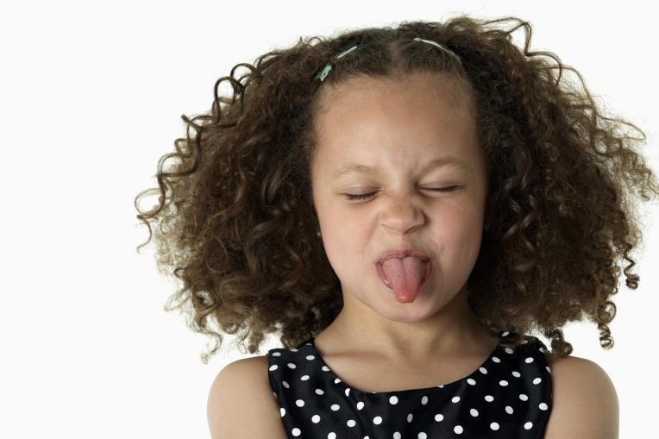

##### EXTENSION

1. Write the next part of the story.
2. Invent your own character for a teenagers’ book.

# SECTION 3: WRITING

## *What you need to do*

* Be **IMAGINATIVE**

* Write for particular **AUDIENCES** and **PURPOSES**

* **ORGANISE** the whole text: beginning, middle, end, etc.

* Use and link **PARAGRAPHS**

* Vary **SENTENCE** lengths and structures

* **PUNCTUATE** accurately

* Use a wide **VOCABULARY**

* **SPELL** accurately



**WRITING TASKS**

**1**

|  |  |
| --- | --- |
| **TASK:** | **Write the opening to a detective novel.** |
| **AUDIENCE:** | Crime fiction fans of all ages. |
| **FORM:** | Opening chapter of a novel – make the reader want to read on. |
| **PURPOSE:** | To entertain, interest, intrigue! |

### ASSESSMENT CRITERIA

### GRADE THREE

* Simple sentences will be correct.
* Some full stops will be used.
* There may be some sense of an opening section.
* There will be basic descriptive words, perhaps setting the scene briefly.

### GRADE FOUR

* Some long sentences will be used.
* A few commas will be included.
* There may be an opening paragraph and some other sections.• The vocabulary will be more descriptive and detailed.

### GRADE FIVE

* A variety of sentences will be used: long and short.
* Commas will be used to divide different clauses.
* There will be clearly marked paragraphs.
* A variety of words that fit the detective genre will be used.

### GRADE SIX

* Longer sentence structures will be used accurately.
* Commas will be used effectively.
* Paragraphs will start with link words.
* The vocabulary will be strong, descriptive, engaging.

### GRADE SEVEN

* A full range of sentence types and structures will be included.
* Commas will be used to create interesting effects.
* There will be lots of variety in length and structure of paragraphs.
* Vocabulary will include sophisticated words, combined in various ways.

1. **Write a description of your idea of a perfect birthday party.**

Boys or girls of your age – make it appeal to one particular gender.

This would go in a collection of descriptions published as a book.

**PURPOSE:** To entertain and describe – make it detailed.

### ASSESSMENT CRITERIA

### GRADE THREE

* Simple sentences will be correct.
* Some full stops will be used.
* There may be a sense of an opening and conclusion.
* The vocabulary will include obvious objects appropriate to a party.

### GRADE FOUR

* Some long sentences will be used.
* A few commas will be included.
* There may be an opening paragraph that sets out key points.
* The vocabulary may include references to feelings.

### GRADE FIVE

* A variety of sentences will be used: long and short.
* Commas will be used to divide different clauses.
* Paragraphs will be used to show changes in topic.
* Interesting vocabulary about personal interests will be included.

### GRADE SIX

* Longer sentence structures will be used accurately.
* Commas will be used effectively.
* Paragraphs will focus on opinions and emotions.
* Vocabulary will be clever and personal.

### GRADE SEVEN

* A full range of sentence types and structures will be included.
* Commas will be used to create interesting effects.
* Paragraphs will be used to create expectations and surprises.
* Impressive vocabulary about people, places and ideas will be used.

1. **Write a description of a setting for a horror story.**

Young teenagers – don’t make it too scary.

Story – a descriptive section.

**PURPOSE:** To entertain, frighten, thrill – make it powerful.

### ASSESSMENT CRITERIA

### GRADE THREE

* Simple sentences will be correct.
* Some full stops will be used.
* There may be a clear opening section.
* The vocabulary may include basic references to what is happening.

### GRADE FOUR

* Some long sentences will be used.
* A few commas will be included.
* There will be some paragraph breaks.
* The vocabulary will be more mature and serious.

### GRADE FIVE

* A variety of sentences will be used: long and short.
* Commas will be used to divide different clauses.
* Paragraphs will be used to structure the section and round it off.
* A variety of vocabulary will be used to give a vivid picture of the place.

### GRADE SIX

* Longer sentence structures will be used accurately.
* Commas will be used effectively.
* The paragraphs breaks will be used for dramatic effect.
* The vocabulary will be appropriately atmospheric.

### GRADE SEVEN

* A full range of sentence types and structures will be included.
* Commas will be used to create interesting effects.
* Paragraphs will be of varied lengths, with clear topics.
* Vocabulary will be varied in conveying the mood and creating excitement.

1. Write a description of your ideal home.

Aim it at either boys or girls.

Magazine article – a teenage magazine that shows what teenage life is like.

**PURPOSE:** To inform and entertain – make it detailed and lively.

### ASSESSMENT CRITERIA

### GRADE THREE

* Simple sentences will be correct.
* Some full stops will be used.
* There may be a sense of a beginning and conclusion.• The vocabulary will give the basic facts.

### GRADE FOUR

* Some long sentences will be used.
* A few commas will be included.
* Paragraphs will be used to show different parts of the description.
* The vocabulary will include some descriptive details

### GRADE FIVE

* A variety of sentences will be used: long and short.
* Commas will be used to divide different clauses.
* Paragraphs will be used when the topic changes.
* Vocabulary will be used to create a sense of enthusiasm.

### GRADE SIX

* Longer sentence structures will be used accurately.
* Commas will be used effectively.
* Paragraphs will be linked to show the progress of ideas.
* Vocabulary will reflect feelings and create atmosphere.

### GRADE SEVEN

A full range of sentence types and structures will be included.

Commas will be used to create interesting effects.

Paragraphs will be used to add to the interest and enjoyment.

• Vocabulary will hook the readers and control their reactions.

1. **Write a letter to a pen-pal describing your school.**

A pen-pal of your age.

Letter – set it out quite formally to show that you can do this.

**PURPOSE:** To inform, to entertain – make it detailed and lively.

### ASSESSMENT CRITERIA

### GRADE THREE

* Simple sentences will be correct.
* Some full stops will be used.
* There may be an introduction and conclusion.
* The vocabulary will feature simple facts about the school.

### GRADE FOUR

* Some long sentences will be used.
* A few commas will be included.
* There will be some paragraphing, marking off different points.
* The vocabulary will be more informative and memorable.

### GRADE FIVE

* A variety of sentences will be used: long and short.
* Commas will be used to divide different clauses.
* Paragraphs will mark the changes in topic and the inclusion of anecdotes.
* Vocabulary will be strong and specific.

### GRADE SIX

* Longer sentence structures will be used accurately.
* Commas will be used effectively.
* Paragraphs will be linked to show how the description progresses.
* Vocabulary will make the audience react emotionally to the points raised.

### GRADE SEVEN

* A full range of sentence types and structures will be included.
* Commas will be used to create interesting effects.
* Paragraphs will be varied in length and will be used to create expectations and surprises.
* Vocabulary will be powerful and addressed directly to the pen-pal.

1. **Write a description of your ideal job.**

Your parents or guardians – try to tell them what you want for the future.

An email – set it out like an email.

**PURPOSE:** To explain and inform – tell your family about what you’d like to do when you're older.

### ASSESSMENT CRITERIA

### GRADE THREE

* Simple sentences will be correct.
* Some full stops will be used.
* There may be some separate sections.
* The vocabulary may simply record basic information.

### GRADE FOUR

* Some long sentences will be used.
* A few commas will be included.
* There will be some paragraphs for different sections.
* The vocabulary will be more descriptive and detailed.

### GRADE FIVE

* A variety of sentences will be used: long and short.
* Commas will be used to divide different clauses.
* Paragraphs will be used to mark off different ideas.
* Vocabulary will be friendly and enthusiastic.

### GRADE SIX

* Longer sentence structures will be used accurately.
* Commas will be used effectively.
* Paragraphs will be linked as they describe different aspects of the job.
* The vocabulary will suit the audience, being personal and clear.

### GRADE SEVEN

A full range of sentence types and structures will be included.

Commas will be used to create interesting effects.

Paragraphs will vary according to purpose.

• Vocabulary will be specific and detailed

### Write a guide to a theme park.

Families – make it appeal to parents and kids.

Leaflet – vary presentation.

**PURPOSE:** To persuade, advise, inform – make them want to come.

#### ASSESSMENT CRITERIA

#### GRADE THREE

* Simple sentences will be correct.
* Some full stops will be used.
* There may some sense of an opening and conclusion.
* The vocabulary may be too basic for the task.

#### GRADE FOUR

* Some long sentences will be used.
* A few commas will be included.
* There will be some paragraph breaks.
* The vocabulary will be more suitable for the purpose.

#### GRADE FIVE

* A variety of sentences will be used: long and short.
* Commas will be used to divide different clauses.
* Paragraphs will mark changes in topic – there will be headings and boxes.
* Interesting vocabulary will appeal to parents and kids.

#### GRADE SIX

* Longer sentence structures will be used accurately.
* Commas will be used effectively.
* Paragraphs will be linked into a coherent overview of the park.
* More varied and exciting vocabulary will be used to impress the visitors.

#### GRADE SEVEN

• A full range of sentence types and structures will be included.

Commas will be used to create interesting effects.

Paragraphs will be used in creative ways to create surprises and emphasis.

Very impressive vocabulary will be included to persuade the parents and kids to come.

1. **Describe a wizard.**

Fans of Harry Potter and similar books.

A novel – make it descriptive and entertaining.

**PURPOSE:** To entertain and give a clear picture of the character.



#### ASSESSMENT CRITERIA

#### GRADE THREE

* Simple sentences will be correct.
* Some full stops will be used.
* There may some sense of different sections.
* The vocabulary will give simple facts about the person.

#### GRADE FOUR

* Some long sentences will be used.
* A few commas will be included.
* There will be some signs of paragraphing to show different topics.
* The vocabulary will be more specific.

#### GRADE FIVE

* A variety of sentences will be used: long and short.
* Commas will be used to divide different clauses.
* Paragraphs will show changes in focus and topic.
* Vocabulary will be descriptive.

#### GRADE SIX

* Longer sentence structures will be used accurately.
* Commas will be used effectively.
* Paragraphs will be linked by an overall feeling or idea.
* Vocabulary will vary as different aspects of the character are described.

#### GRADE SEVEN

* A full range of sentence types and structures will be included.
* Commas will be used to create interesting effects.
* Paragraphs will create interesting contrasts and twists.
* Vocabulary will be vigorous, exciting, varied.

1. **Write a description of a seaside town in summer.**

Aim it at readers who are interested in taking a holiday in this place.

A travel article for a newspaper.

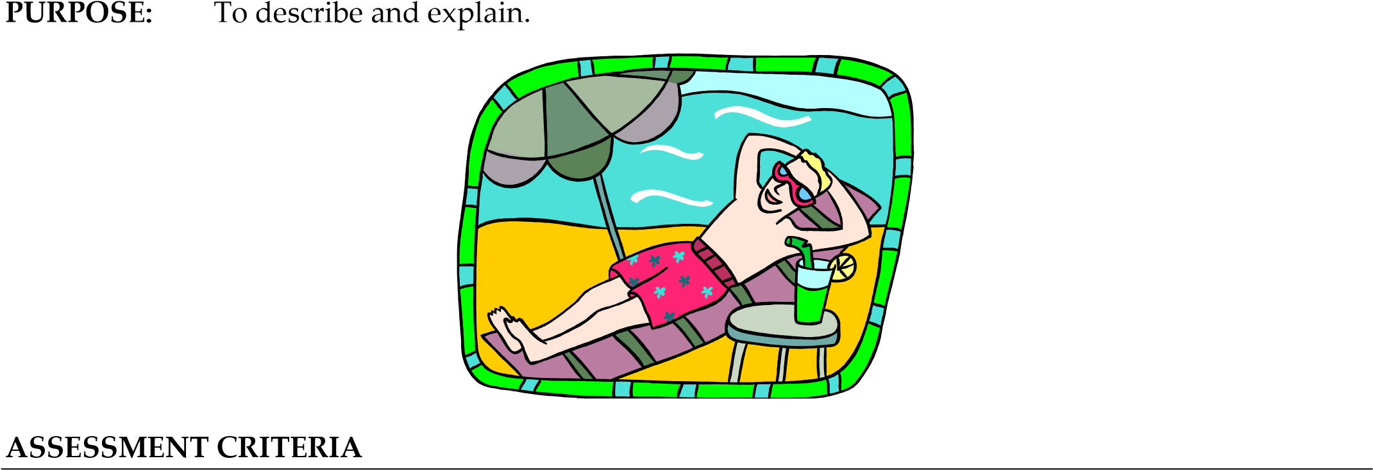

#### GRADE THREE

* Simple sentences will be correct.
* Some full stops will be used.
* There may some sense of different sections.
* The vocabulary may be factual.

#### GRADE FOUR

* Some long sentences will be used.
* A few commas will be included.
* There will be some paragraph breaks.
* The vocabulary will be more descriptive.

#### GRADE FIVE

* A variety of sentences will be used: long and short.
* Commas will be used to divide different clauses.
* Paragraphs will be clearly used to shape the article.
* Vocabulary will attract attention and shape responses.

#### GRADE SIX

* Longer sentence structures will be used accurately.
* Commas will be used effectively.
* Paragraphs will be varied – with boxes and lists, etc.
* More detailed and descriptive language will be used.

#### GRADE SEVEN

* A full range of sentence types and structures will be included.
* Commas will be used to create interesting effects.
* Paragraphs will be used to create memorable, surprising effects.
* Vocabulary will appeal to the audience’s interests and concerns.

#### Write a story set in a railway station.

Aim it at 13 year olds.

Make it a complete short story.

**PURPOSE:** To entertain – so make it surprising, interesting.

##### ASSESSMENT CRITERIA

##### GRADE THREE

* Simple sentences will be correct.
* Some full stops will be used.
* There may some sense of structure – a beginning, for example.• The vocabulary may be mostly basic and factual.

##### GRADE FOUR

* Some long sentences will be used.
* A few commas will be included.
* There will be some use of paragraphs to show topic changes.• The vocabulary will be more descriptive.

##### GRADE FIVE

* A variety of sentences will be used: long and short.
* Commas will be used to divide different clauses.
* Paragraphs will structure the story, dividing description from action.
* Interesting vocabulary creates emotional responses.

##### GRADE SIX

* Longer sentence structures will be used accurately.
* Commas will be used effectively.
* Paragraphs will show how the story progresses, whilst being linked.
* Varied and mature vocabulary will excite and surprise the readers.

##### GRADE SEVEN

* A full range of sentence types and structures will be included.
* Commas will be used to create interesting effects.
* Paragraphs will be used to create suspense and surprises.
* Very impressive vocabulary will engage and grip the readers.

### SECTION 4: SPELLING

*What can you do to improve your spelling? Here are some strategies for you to use and a task which will let you try them out.*

#### 1. Look/Say/Cover/Write/Check

This is the most efficient way to learn a spelling. Look at the correct spelling. Say it out loud – perhaps emphasising the letters used by pronouncing the word in an exaggerated way. Cover up the correct spelling. See if you can write out the correct spelling without looking. Check if you got it right. Repeat the process to make sure that it wasn’t a fluke! The more often you do this, the more likely it is that the word will stick.

#### 2. Common patterns

Look for common letter patterns in words and try to learn them. Look at –tion endings; -ed endings; double letters, etc. The exercises here will help with this.

#### 3. Learn your phonics

You need to know which letters make which sounds. Most letters can make a range of different sounds, especially the vowels – a, e, i, o, u. Think also about clusters of letters that make particular sounds – sh, sn, ch, ght, and many more!

#### 4. Look for words within words

Sometimes long words can be broken down into sections of smaller words. If you know how to spell the short words, then you can piece together the long one. The famously long word

“antidisestablishmentarianism” is basically the word “establish” with lots of prefixes and suffixes, for example.

#### 5. Mnemonics

These are sentences that you use to help you remember something. For example, you might give a word to each letter in a difficult spelling: **B**ig **E**lephants **C**annot **A**lways **U**se **S**mall **E**ntrances – BECAUSE! Try inventing some of your own for words that you have struggled with.

#### 6. Play word games

Crosswords, wordsearches, anagrams, Scrabble, and any number of other word games can be a fun way to expand your vocabulary and get you thinking about spelling.

#### TASK

1. Take the information here and turn it into a bright and interesting leaflet that could be given out to Year 8 students to help them with their spellings.
2. Look back over all your English work from Year 7. Try to learn how to spell any words that you got wrong back then.

#### SPELLING 1: –ible or –able

**TASK**

Choose the correct spelling of each word below and write it.

Check your answer in a

dictionary or at dictionary.com.



There is no simple rule to help you

decide whether to use '

–

ible' or '

–

able

'

. All

you c

an do is try to

learn examples.



1. a) iritabl 6. a) incredable



* 1. irritibel b) incredible
  2. irritible c) incredibull
  3. irritable d) incredibel

1. a) sensible 7. a) accessible b) sensable b) ascescible
   1. senseible c) accessable
   2. sensabel d) acesabel

1. a) invisibel 8. a) indespensible
   1. invisible b) indespensable
   2. invisable c) indispensible
   3. invisoble d) indispensable

1. a) exitable 9. a) admirable
   1. excitible b) admiraibel
   2. excitable c) admirible
   3. ecxitabel d) admiribel

1. a) responsable 10. a) incurabel
   1. responsabel b) incurible
   2. responsibel c) incurable
   3. responsible d) incuroble

#### SPELLING 2: Drop the –e

**TASK**

Choose the correct spelling of each word below and write it .

Check your answer in a

dictionary or at dictionary.com.



When you add a suffix to a word ending in '

–

e', you sometimes drop the '

–

e'.

The rule is: if the suffix begins with a vowel ('

–

ing', '

–

ish'), you drop the '

–

e'.

If the suffix begins with a consonant ('

–

ful', '

–

ness'), you keep the '

–

e'.



1. a) excitement 6. a) desireable
   1. excitment b) desirable
   2. ecxitement c) dezirable
   3. excitemant d) disireable

1. a) senseible 7. a) lateness
   1. sensible b) latness
   2. sensable c) leightness
   3. sensubel d) latenes

1. a) raceing 8. a) safety
   1. raccing b) safty
   2. raicing c) saffty
   3. racing d) savety

1. a) moveing 9. a) commencement
   1. moving b) commencment
   2. mooving c) commensement
   3. movng d) comensement

1. a) motivation 10. a) sliccing b) motiveation b) sliceing



* 1. motifation c) slicing Add any new words
  2. motivasion d) slising to your vocab book!

##### EXTENSION

1. Design some posters to illustrate the rule.

1. Think of some mnemonics to help students remember the correct spellings. Remember, a

mnemonic is a sentence which helps you remember a spelling – e.g. **G**eorge **E**liot's **O**ld

**G**randfather **R**ode **A** **P**ig **H**ome **Y**esterday – GEOGRAPHY!

#### SPELLING 3: Prefixes and Suffixes

**Prefixes**

are the letters that go on the start of

words.

For example:

*pre*

*fix*

*whole word*

anti

-

➔

antibody

semi

-

➔

semidetached

dis

-

➔

dishonest

under

-

➔

underrated

**Suffixes**

are the letters that go on the end of

words.

For example:

*suffix*

*whole word*

-

less

➔

ageless

-

ness

➔

friendliness

-

ance

➔

reassurance

-

age

➔

wastage

##### TASK

1. Add the prefix or suffix indicated to the words below, writing the whole word out .
2. List as many other examples as you can of whole words which use each prefix or suffix (e.g. for the prefix *anti-*, you could list anticlimax, antiseptic, antihero, etc.).

|  |  |
| --- | --- |
| 1. Dis-   appear advantage satisfy  similar     1. Un-   necessary natural encumbered | 1. -ness   sleepy foolish hopeless idle  careless     1. -ary   function caution |

sophisticated

example

3. Under-

achieve represent state rehearse ground



##### EXTENSION

1. Below are five common **prefixes**. For each one, think of two or three examples of whole words which use them and write them . *Hint*: a dictionary might help you! ex- fore- micro- non- pro-

1. *-ish* and *-ment* are two common **suffixes**. For each one, think of as many examples of whole words which use them and write them .
2. Make a list of any other suffixes and prefixes you can think of.
3. For each one you listed in c), list as many examples of whole words as you can find.

|  |  |
| --- | --- |
| **EXTENSION**    Design a poster to illustrate this rule. |  |

#### SPELLING 4: Change y to i



When you add a suffix to a word that ends in '

–

y', you sometimes change the '

–

y' to an '

–

i'.

The rule is: if the letter before the '

–

y' is a consonant, the '

–

y' becomes '

–

i'.

*Example:*

duty

➔

dutiful

If the letter before the '

–

y' is a vowel, the '

–

y' stays as a '

–

y'.

*Example:*

convoy

➔

convoys

##### TASK

Add the suffixes indicated to each of the following words, writing out the whole word .

1. -ment

employ enjoy merry

1. -ness

silly jolly shy busy

1. -ed

carry worry play dismay hurry

fry

1. -ful

beauty pity

play

1. -s

boy

folly baby

lady

#### SPELLING 5: Double Letters



Another common problem in spelling is the use of double letters in the middle of words.

For short words, double the final letter when you add '–ed', '–ing' or '–er' (*except* when the word

ends in '–x', '–w', or '–y').

##### TASK

Add the suffixes indicated to each of the following words, writing out the whole word .

|  |  |  |  |  |
| --- | --- | --- | --- | --- |
| 1. -er  hit fit sit blot fat spit split bat mat | 2. -ing | | 3. -ed | |
|  | stop crop cut shut  fit  sit  pat drop |  | top tip flip flop snog flog plot prop trap |

|  |
| --- |
| **EXTENSION**  Design a poster to illustrate this rule. |

#### SPELLING 6: Plurals

**TASK**



A plural is a word that shows that there is more than one of something.

Most plurals are formed by adding an '

–

s' to the singular word.

*Example*

:

cat

➔

cats

Easy! But some words take a different kind of plural: Words ending with '

–

f' sometimes change

the '

–

f' to a '

–

v', then you add '

–

es'.

*Example*

:

wolf

➔

wolves

Words ending in '

–

s', '

–

x', '

–

z', '

–

ch', '

–

sh' take '

–

es' as the ending.

*Exa*

*mple*

:

church

➔

churches

Some words change quite a bit and have an irregular plural.

*Examples*

:

man

➔

men

child

➔

children

mouse

➔

mice

Some words are the same in the plural and the singular.

*Example*

:

sheep

➔

sheep

For each of these words, write the plural .

1. school 14. fish

2. snake 15. fox

3. sneeze 16. louse

4. catch 17. house

5. latch 18. woman

6. wish 19. calf

7. quiz 20. kiss

8. search 21. dish

9. miss 22. guess

10. swindler 23. fez

11. box 24. wash

12. elf 25. cash

13. catcher 26. business

|  |
| --- |
| **EXTENSION**  Make a poster to illustrate the rules for making plurals. |

#### SPELLING 7: Problem Words

*Some spellings cause special problems. Try to learn which spelling to use from the examples below.*

**TASK A**

##### Advise, advice



**Advise** with an ***s*** is the verb. You use it to depict the act of advising. Advisewill be seen with a subject: I, he, she, it, people’s names.

*Examples*: I advise you. I am advising you. He advised you. Paul will advise you.

**Advice** with a ***c*** is the noun. You use it to depict the substance: a piece of advice. Advice will be seen with verbs: gave, is, was, received, got.

*Examples*: I gave you advice. This advice is free. Advice is welcome.

Complete the sentences below. Is the missing word “advise” or “advice”?

1. The ___________ you gave me was very valuable.
2. I ___________ you to listen to your teachers.
3. My __________ is: stay positive.
4. He ___________ me to make the most of life.
5. They ____________ us to listen to more music.
6. The best ___________ I ever had was: think of others too.

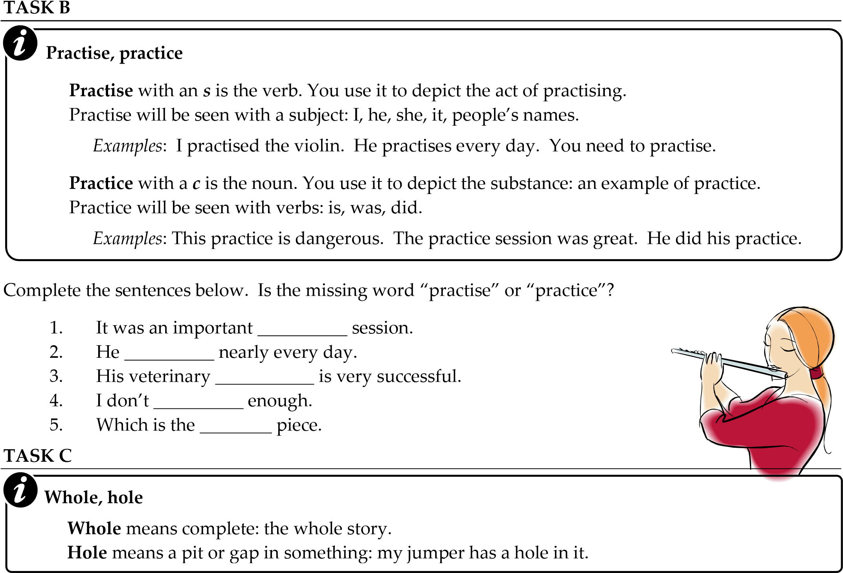

1. Write five sentences that would feature **whole**.
2. Write five sentences that would feature **hole**.

#### SPELLING 8: Your Own List

*As you might have learnt in Year 7, the best way to improve your spelling is to work on your own mistakes.*

##### TASK A

Look back over all your writing from recent months. Look back at work from primary school if you have any. Look in books for all subjects, not just English.

* List all the spelling errors that you made.
* Use a dictionary or dictionary.com on the internet to check what the correct spelling is.
* Try to spot patterns in your mistakes. Do you have problems with particular patterns – like '-tion'? Do you get your double letters wrong? Do you mix up vowels or consonants?

* Use the *look, say, cover, write, check* method to learn the correct spellings.
* Get someone to test you.
* Spend time learning any words that you still get wrong.
* Try to invent mnemonics to help you remember some of these words. A mnemonic is a sentence which helps you remember a spelling – e.g. "**Fin**ally, something de**fin**ite" might help you to spell "definite".

**IMPORTANT:**

* Once you know the spellings, you need to make an effort to use it in some of your writing. Otherwise, you will probably forget the spelling again.
* Get someone to test you again after a week or so. You need to make sure that you haven’t forgotten any spellings.

Now you need to keep an eye on your spelling all the time. Every time you make a mistake in any

writing for any subject, you need to check what the correct spelling is and learn it.

Occasionally, get someone to test you on words that you have made mistakes on over the recent months.

If you do a little work on spelling each day – 5 minutes, for example – you will make a difference to your spelling.



**TASK**

**B**

Here are some words that people often find difficult to spell.

playwright

alcohol

assess

harass

embarrass

business

definite

separate

deliberate

manoeuvre

women

soldie

r

ca

rriage

government

environment



|  |  |  |  |  |
| --- | --- | --- | --- | --- |
| technical | sincerely | violence | possess | obsession |
| awkward | aisle | appalling | disappear | committee |
| commitment | exaggerate | exceed | succeed | success |
| advantage | excite | bicycle | behaviour | dissatisfy |

1. Try to make up a way to remember them.
2. Learn them and learn what they mean.
3. Get someone to test you on them.

### SECTION 5: VOCABULARY

#### Introduction



Now that you are in Year 8, you should be looking to develop your vocabulary further. You need

to be able to deal with more complex and subtle ideas.

This means that you will need to be confident with words that you may not have used much in Year 7.

So what can you do?

1. **Look it up!**

Did you use a dictionary much last year? Reading will not help with your vocabulary if you don’t actually look up words when you are not sure what they mean. You need to develop



your curiosity to the point where you feel impelled to look up a word whenever you come across a new one. What exactly does “impelled” mean? Look it up!

1. **Not sure? Look it up!**

Sometimes you will see a word that you recognise and sort of understand, but if pressed to define it, you’d struggle. These are words that you need to look up as well. You’re not likely to use the word yourself if you are not exactly sure what it means.

1. **Use it or lose it!**

Once you have worked out what a word means, you need to start using it, or you’ll be likely to forget what it means. So start amazing and amusing your friends and family, by slipping the odd new bit of vocabulary into your conversations. The same goes for writing: make a real effort to write words that you have just learnt – this will help you to fix the spelling in your mind.

##### 4. Read for vocabulary

Your reading should be moving forward now that you are in Year 8. This means you’ll be reading some challenging texts, so you are likely to find difficult words in them. When you come across new words, work at making sense of them. Ask your parents or teachers about them. Try using them in conversation. Keep reading news reports and feature articles from the so-called broadsheet newspapers – *The Guardian*, *The* *Independent*, *The* *Times*, *The* *Observer*. They all have websites, so you don’t have to spend any money to get their articles. Another website that might help would be Wikipedia, which is an online encyclopaedia – but be aware that Wikipedia is not checked to the same Grade as an ordinary encyclopaedia. Of course, you could look into a real encyclopaedia, which any library will have if you don't have one at home.

##### 5. Use a thesaurus

One reason that your writing may not have progressed much last year would be the lack of interesting vocabulary. Get used to using a thesaurus to make your writing varied and colourful. If you didn’t do this much last year, start now!

##### 6. Listen

Teachers, parents, newsreaders, everyone really: they all use interesting words at times. Get used to asking about or looking up words that are new to you. Then challenge yourself to use the word as many times as possible in the next few days.

#### VOCABULARY 1: Vocabulary Book



One way to expand your vocabulary is to keep a notebook, in which you jot down any new words that you come across. Next to each word, write the dictionary definition.

Perhaps write a few trial sentences that include the word.

When you have gathered a few words, you could try the following:

* Play some games with them: hangman, scrabble, anagrams, etc.
* Write a story or an article in which you use all the words in your journal.
* Keep a diary, in which you reflect on what examples of language you have encountered during that day.
* Challenge your friends and family with a quiz based on your words in your notebook.
* Challenge your teachers at school: “Morning Mr Leatherpatches, can you tell me exactly what dissipates means?”

Perhaps your tutor could be encouraged to have a word of the week for your tutor group. This could provide a source of challenges, quizzes and activities for your group.

##### TASK

Here’s an exercise you could do in your vocabulary notebook.

1. Think of a scene that you want to describe.

* 1. List all the objects in the scene.
  2. List all the parts of the objects: tree – branches, twigs, leaves, etc. Try to get a real close-up focus on everything.
  3. List a range of adjectives that could go with each of your object words. Use a thesaurus to help you. Aim for as many alternatives as you possibly can get.

1. Write several alternative descriptions of the scene, using different words each time.

#### VOCABULARY 2: Subject Words

Here’s a list of some key words for each subject in school.

|  |  |  |  |  |  |
| --- | --- | --- | --- | --- | --- |
| **Art** |  |  |  |  |  |
| acrylic | collection | dimension | exhibition | gallery | impasto |
| palette    **and T** | portrait |  |  |  |  |
| brief | design | evaluation | flour | ingredient | linen |
| mineral    **Drama** | polyester | production | sew | tension |  |
| character | director | exit | inspire | perform | rehearse |
| script    **Geography** | stage |  |  |  |  |
| amenity | climate | county | erosion | globe | international |
| location    **History** | physical | provision | settlement | transport | weather |
| bias | Catholic | civilisation | constitution | defence | dynasty |
| government trade    **ICT** | independence | parliament | propaganda | reign | revolution |
| byte | cartridge | connection | delete | electronic | icon |
| interface | keyboard | modem | multimedia | password | program |
| server    **Mathematics** | virus |  |  |  |  |
| adjacent | amount | axis | circumference | decimal | diameter |
| equilateral | fraction | horizontal | kilometre | metre | parallel |
| percentage | positive | radius | reflection | rotation | symmetry |
| vertices    **Music** | weight |  |  |  |  |
| chord | crotchet | instrument | major | minor | orchestra |
| pitch    **PE** | scale | synchronise | ternary | vocal |  |
| agile tactic    **RE** | exercise | hamstring | medicine | personal | qualify |
| biblical | celebration | commandment | disciple | festival | hymn |
| Israel | miracle | parable | prejudice | shrine | special |
| synagogue    **Science** | worship |  |  |  |  |
| acid | apparatus | combustion | digestion | exchange | friction |
| hazard vessel | liquid | nutrient | particles | reproduce | temperature |

##### TASK



Choose three of your favourite subjects and look up the meanings of each of the words in a dictionary or on dictionary.com. Write the definitions.

#### VOCABULARY 3: Multiple Choice

**TASK**

Learn and use the words below.

a)

Write each word and its

meaning.

Check your answer in a dictionary or at

dictionary.com.



b) For each word, write a sentence. Make sure you use the word correctly.

1. abominable

* 1. Able to explode
  2. Hateful, unpleasant
  3. Unable
  4. A snowman

1. baffle

* 1. To confuse
  2. To fight
  3. To fill a bath
  4. To play a musical instrument

1. campaign

* 1. An organised series of activities
  2. A type of tent
  3. A twisted ankle
  4. A window

1. egregious

* 1. Talkative
  2. An egg farm
  3. Greedy
  4. Notorious

1. hiatus

* 1. A tower
  2. Hatred
  3. A gap
  4. A map

1. lambent

* 1. A baby sheep
  2. A twisted sheep
  3. Lazy
  4. Flickering

1. nemesis

* 1. A book in the Bible
  2. An opponent that can’t be beaten
  3. A name that is false
  4. A farm implement from Ireland

#### VOCABULARY 4: Define and Use

**TASK**

Find the definitions for these words and try to speak them at least 10 times this week. Write

them once in the next two weeks.



* Use a dictionary or dictionary.com to check the meaning.
* Make sure that you understand how you use the word in a sentence.
* Try out the word with family and friends.
* Put the word into a piece of writing for any subject.

Next to each word is a clue about how you might use it, but you’ll still need to find out the precise definition.

abject ................ a descriptive word that will be impressive if used correctly

basilisk ............. a word to get the imagination going

capacity ............ a precise term that will be useful in various contexts

delicate ............. you know what this means, but do you ever use it?

elaborate .......... a descriptive word that is more impressive than simpler alternatives

fascinate ........... again, a useful alternative to obvious words

gratitude .......... you know about being grateful, but do you use this word?

homage ............ a word that refers to a rather old-fashioned, but elegant idea

identical ........... better than saying similar to, like, etc.

juxtaposition .... a great word – very useful; use it!

kowtow ............ a specific idea that you should know about

languish ........... a descriptive word that will be impressive

malapert ........... a new insult with which to confound your friends

nostalgia ........... a rather beautiful concept

obstinate ........... an unhelpful attitude in some situations

panache ............ an admirable quality

quincunx .......... a great word for something familiar

rational ............. an important word: use it; think about it

sagacious ......... another important concept

tepid ................. a descriptive word that will be impressive if used correctly

#### VOCABULARY 5: Alternatives for Common Words

Below are some words that tend to be over-used. Some of them are too general or vague.

##### TASK

Find at least three interesting alternatives for each of these common words, other than the examples given. You should use the alternatives as much as possible in your writing.

1. small

*Try*: tiny, minute

What else?

1. fast

*Try*: rapid, urgent

What else?

1. slow

*Try*: laboured, snail-like

What else?

1. beautiful

*Try*: attractive, stunning

What else?

1. take the mick

*Try*: ridicule, mock

What else?

1. excited

*Try*: thrilled, energetic

What else?

1. bad

*Try*: terrible, awful

What else?

1. good

*Try*: virtuous, wonderful

What else?

1. drank

*Try*: slurped, sipped

What else?

1. whatever

*Try* … NOT USING THIS WORD – EVER! Take an interest in life; be explicit and specific; look for something to engage your interest. In short, be positive!

#### VOCABULARY 6: Senses



Descriptive language is useful for all kinds of writing. Being able to describe things precisely and in detail is a key skill. Vividly descriptive writing is memorable. One way to develop your descriptive skills is to think of the five senses – five ways in which we receive key messages about the world.

##### TASK

For each of the five senses, spend a few minutes listing as many words as you can to describe various scenes, situations, encounters.

1. Sight
   * What words can you think of to describe sights?
   * Think of words for: colours, textures, shapes, sizes.
   * Try to develop the skill of looking at the minute details of things: Imagine various scenes; imagine the fine details in them.

1. Sound
   * What words can you think of to describe sounds?
   * Think of the different noises that surround you.
   * Try really listening. We tend to block out a lot of sounds. Pay attention.
   * Think about different kinds of sound, different volumes and pitches.

1. Touch
   * There are fewer words to describe touch than sight or sound.
   * Think about textures, temperatures, Grades of comfort and pleasantness.
   * Try closing your eyes and touching common objects.
   * Get your friends to test you out: can you guess what something is just by touch?
   * Don’t touch sharp or burning objects!!

1. Smell
   * Smell is often thought to be the best sense for triggering memories.
   * If you smell the smell of your baby food, you’ll be overcome with vague feelings about being a little kid. Try it!
   * What words can you think of to describe smells?
   * Think of good and bad smells. What thoughts and feelings do smells inspire?

1. Taste
   * What taste words can you think of?
   * Pleasant and disgusting flavours?
   * Favourite flavours?
   * How do you feel when you eat?

1. Other senses?
   * Are there only five senses?
   * What about the sense of time; the sense of balance?
   * Try to think of other possible senses.
   * Decide how they are similar and different to the five key senses.

#### VOCABULARY 7: Fill in the Missing Words

**TASK**

Complete these sentences

.

The first letter or two

of each missing words has

been given for

you.



The sentences below suggest the meaning for a useful, interesting

word. Try to think what the

missing word might be. A thesaurus might help.

Check your answer in a dictionary to make sure that it is right. Ask for help from your family if

you are stuck.



1. To be worthless is to be ab____.

2. Another word for a home is an ab____.

3. To be kind is to be b_____.

4. A small case or little space ship is a c______.

5. To stroke someone is to c______ them.

6. To come to an agreement is to co_______.

7. A riddle-like crossword clue is called cr_____.

8. To argue against something is to de______ it.

9. A very rundown house would be described as d_______.

10. To beg is to e______.

11. To be very careful, difficult to please, easily disgusted is to be f________.

12. Another word for leaves is f______.

13. To be distinguished and noble is to be ill_________.

14. Money left in a will is a l______.

15. To speak evil of someone is to m_____ them.

16. Another word for weak or thin is m______.

17. To be a liar is to be m_________.

18. A word for a total change is a m___________.

19. A word that sounds like what it means is an example of on___________.

20. To be thoughtful is to be p________.

21. To set out on a foolish mission is to be q________.

22. To be unwilling is to be r__________.

23. To be slow and dignified is to be s______.

24. Something strange or underhand might be called s________.

25. To put up with something is to t________ it.

26. Enthusiasm might be called z___.

|  |
| --- |
| **EXTENSION**  Try to write a story that uses all of the words you had to find. |

#### VOCABULARY 8: Semantic Fields



A semantic field is an area of language. For example “farming” could be a semantic field. It would

include vocabulary such as: tractor, sheep, fence, plough, harvest, veterinary surgeon, till, hoe, etc.

##### TASK

1. Look at the general topics below, and list as many words as you can that would go with that topic.
2. Use a thesaurus to expand your list and check the meaning of the words in a dictionary. Follow up on chains of vocabulary, looking up more and more words in the thesaurus and so finding more words to look up.
3. Write a paragraph about each topic, using as many of your words as you can.

##### 1. Mechanics

Find words for: cars; engines; parts; tools; types of work; machines; faults; repairs; instructions; etc.

##### 2. Fashion

Find words for: different types of clothing; designers; models; trends and styles; the history of clothing and fashion; etc.

##### 3. Money

Find words for: banks, other institutions; stockbrokers, conmen, thieves, greedy individualists, cynical manipulators, shameless wasters of national resources, etc.; currencies; ways that money can be used.

##### 4. Literature

Find words for: novels, stories, non-fiction texts, plays, other types of literature; writers; equipment; publishers; literary styles; literary techniques.

##### 5. Food and drink

Find words for: ingredients; dishes; meals; soft drinks; hot drinks; chefs; restaurants; equipment; etc.

##### 6. Science

Find words for: chemicals; equipment; experiments; theories; discoveries; animal behaviour; natural cycles; etc.

**7. What else?**

Think of some of your own semantic fields and make vocabulary lists to go with them.

##### EXTENSION

a) Choose one of your lists of words and divide it into two sections: those words that seem powerful, interesting and unusual; and those words that seem predictable and obvious.

b) Write sentences using each of the powerful, interesting and unusual words.

#### VOCABULARY 9: PSHE Subject Words

**TASK**

a)

Choose ten words

from the list below

to l

ook up in a dictionary to check

their

precise

meaning

s

.

b)

Write a sentence

for each

of these

word

s

.



Below are some words that you might need to use in your PSHE and tutor group work

.

These are

important words in your development as a person, so they are really worth thinking about.



c) Try to use each word at least once in discussion or in writing this year. There are some clues about how they might be relevant to you.

ability .................... try to recognise your own abilities and strengths

achievement ......... try to celebrate your own achievements

addiction ............... don’t lose control of your own life

approval ................ how important is this to you?

communication .... the key to successful relationships

control ................... who controls you?

dependant ............. are you overly reliant on someone or something?

discipline .............. success often requires self-discipline discussion ............. the way to achieve things with others effort ...................... all good things require some of this emotional .............. a key aspect of our experience encourage ............. do you encourage others?

gender ................... part of your developing identity generosity ............. a quality that many look for in others involvement ......... do you get involved?

preference ............. can you justify your likes and dislikes?

pressure ................ we all have pressures: how do we cope with them?

racism .................... an ugly attitude

reality .................... can you tell what is real and what is not?

relationship .......... different kinds of relationship require different approaches representative ...... who represents you?

reward ................... what do you need to do to gain long-term rewards? sanction ................. which sanctions are fair? Which are effective?

sexism .................... another unacceptable attitude

stereotype ............. do you feel limited by what people expect of you?

##### EXTENSION

Write a leaflet that explains some of the key terms involved in your Personal, Social and Health Education. Define and explain the words above. Try to do it in a lively style that will appeal to readers of your own age.

### READING WITH OTHERS

How much do you read? What kind of books do you read?

One way to get more out of reading is to share what you read with others.



Here are a few ideas about how you can get enthusiastic about reading by sharing your reading with others.

#### 1. Magazines

There are lots of great magazines out there. Too many really. Why not make a pact with some friends? Each of you might buy a different magazine at the start of the week. Then you can swap the magazines when you have read them. This means you get three or four magazines for the price of one. It also means that you can talk about the magazines with each other – this will make them much more enjoyable.

#### 2. Pass the book

If you really enjoy a book, pass it on! Lend the book to your friends, or advise them to borrow the same book from the library. You can talk about the book together as your friend reads it. Try not to be tempted to give too much away. Pass the book around to all your friends, widening the conversation to include more and more people.

#### 3. Start a book group

Many adults these days like to join reading groups. Here, a group of friends will decide to read the same book at the same time, then meet to discuss it. This requires that you all get a copy of a certain book. These days, you can order a book over the internet and receive it within a few days, so it’s not such a difficult thing to do. Meet regularly to discuss the book as you read it. Agree where you’ll get up to before each meeting. Try to widen your group: get more people involved; extend your group of friends.

#### 4. Read with your family

A good way to have some quality family time is to discuss a book that you have all read. Pass the book around the family and talk about it whilst each person reads it.

**5. E-asy does it!**

Email and other forms of internet communication can be a fun way to exchange ideas about reading. You can keep in touch constantly, racing your friends to get to the end of the next chapter. Internet communications, of course, should be carried out between friends; you should be wary of strangers whom you “meet” on the net – they might not be what/who they seem to be. However, chatting with friends over the internet is, of course, absolutely fine.

### CROSSWORD PUZZLES



Crossword clues give you a description of a word. You have to guess the word.

Clues follow a set format:

* The first or last part of the clue should be a synonym for the answer – so, if the answer was “football”, then the first or last word of the clue might be “game” or “sport” or something less obvious like “what's played at Wembley”.

* The rest of the clue will help you to guess just what “game” or “sport” or “cause of depression” the answer might be.

#### THE MAIN TYPES OF CLUE 1. Anagram

In these clues the answer is in the clue, but the letters have been rearranged. You have to unscramble the letters to find the answer.

*Example*: ladder = red lad

You can usually tell when it’s an anagram because the clue will contain a word that means unscramble, move or rearrange.

*Example:* Shake red lad to help him climb.

Answer: Ladder

*Explanation:* “Shake” means move, so tells you it’s an anagram.

“Red lad” is the anagram.

“To help him climb” is the synonym for “ladder”.

#### 2. Hidden Word

In these clues, the answer is hidden inside a word or across two words.

*Example*: wet all = tall

You can usually tell this type of clue by the use of the word “in” or some other suggestion that you need to look inside the words.

*Example*: In the wet all look big.

Answer: Tall

#### 3. Homophone

In these clues the answer is a word that sounds like another.

*Example*: raw = roar

You can usually tell this type of clue by the use of references to hearing and sound.

*Example*: Hear lion’s call in uncooked meat.

Answer: Roar

**4. Other types**

There are many other types of clue. If you get into crosswords, you’ll start to learn about them.

#### CROSSWORD CLUES

Here are some clues for you to work out. Doing crosswords is good mental exercise. It can also help develop your vocabulary.It gets you thinking about spelling and it’s very satisfying when you get the answer!

##### TASK

Work out the answers to these clues and write them. All the answers are words that come from the subject vocabulary list in this booklet.

1. Clue: Story is found in confused rap label (7 letters)

Answer: _ _ _ _ _ _ _

1. Clue: Blueprinted singed, changed (6 letters)

Answer: _ _ _ _ _ _

1. Clue: Sword sap arranged code (8 letters)

Answer: _ _ _ _ _ _ _ _

1. Clue: Stop I’m a mixed up artistic technique (7 letters)

Answer: _ _ _ _ _ _ _

1. Clue: Get material from line narrowing (5 letters)

Answer: _ _ _ _ _

1. Clue: To act in super form (7 letters)

Answer: _ _ _ _ _ _ _

1. Clue: E-blog misread reveals the whole world (5 letters)

Answer: _ _ _ _ _

1. Clue: Hold up a goose? Sounds like official lies (10 letters)

Answer: _ _ _ _ _ _ _ _ _ _

1. Clue: Pit choir holds particular note (5 letters)

Answer: _ _ _ _ _

1. Clue: Movement found in a tin root decaying (8 letters)

Answer: _ _ _ _ _ _ _

|  |
| --- |
| **EXTENSION**   1. Invent some of your own clues. 2. Try to construct a complete crossword, making the grid work so that the overlapping letters fit. |