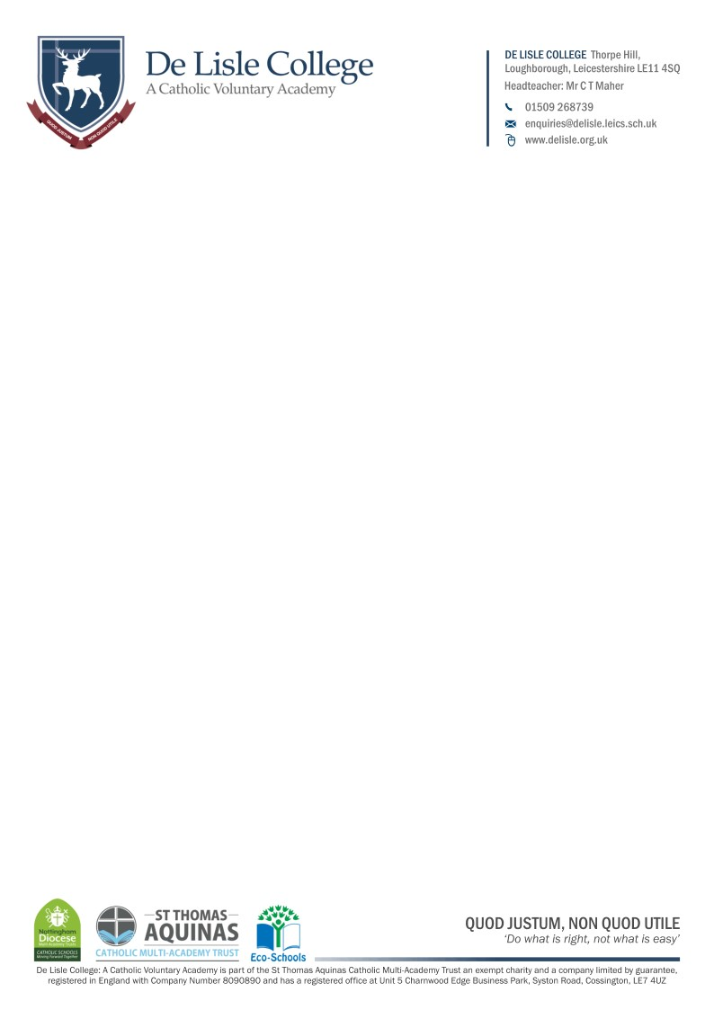

16 to 19 Bursary Continuation Form
Note: This form should be completed by students progressing from Year 12 to 13, who have previously been awarded the 16 to 19 Discretionary Bursary.

Personal Details:
Student name & tutor group

I declare that my household income and personal circumstances have not changed since Year 12, and that I meet the previously assessed eligibility criteria for the 16-19 Discretionary Bursary (typically, household income <£30,000).

I am aware that information and evidence previously provided was correct. I am aware that giving false or incomplete information that leads to incorrect/overpayment may result in any incorrectly paid funds being recovered.

By signing this declaration, I confirm agreement to the conditions and eligibility criteria of the scheme as outlined in the 16 to 19 Bursary Fund Policy.

Student Declaration:
Signature |  |  | Date
Full name (in block capitals)

Parent/Carer Declaration:
Signature |  |  | Date
Full name (in block capitals)

For College Completion:

__I declare that the bursary criteria and funding rules continue to have been met.

Authorised by bursary award panel:
Signed by:
Date:

